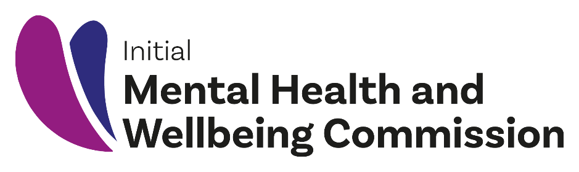

A check-in from the
Initial Mental Health and Wellbeing Commission

Upholding the wero from the
He Ara Oranga

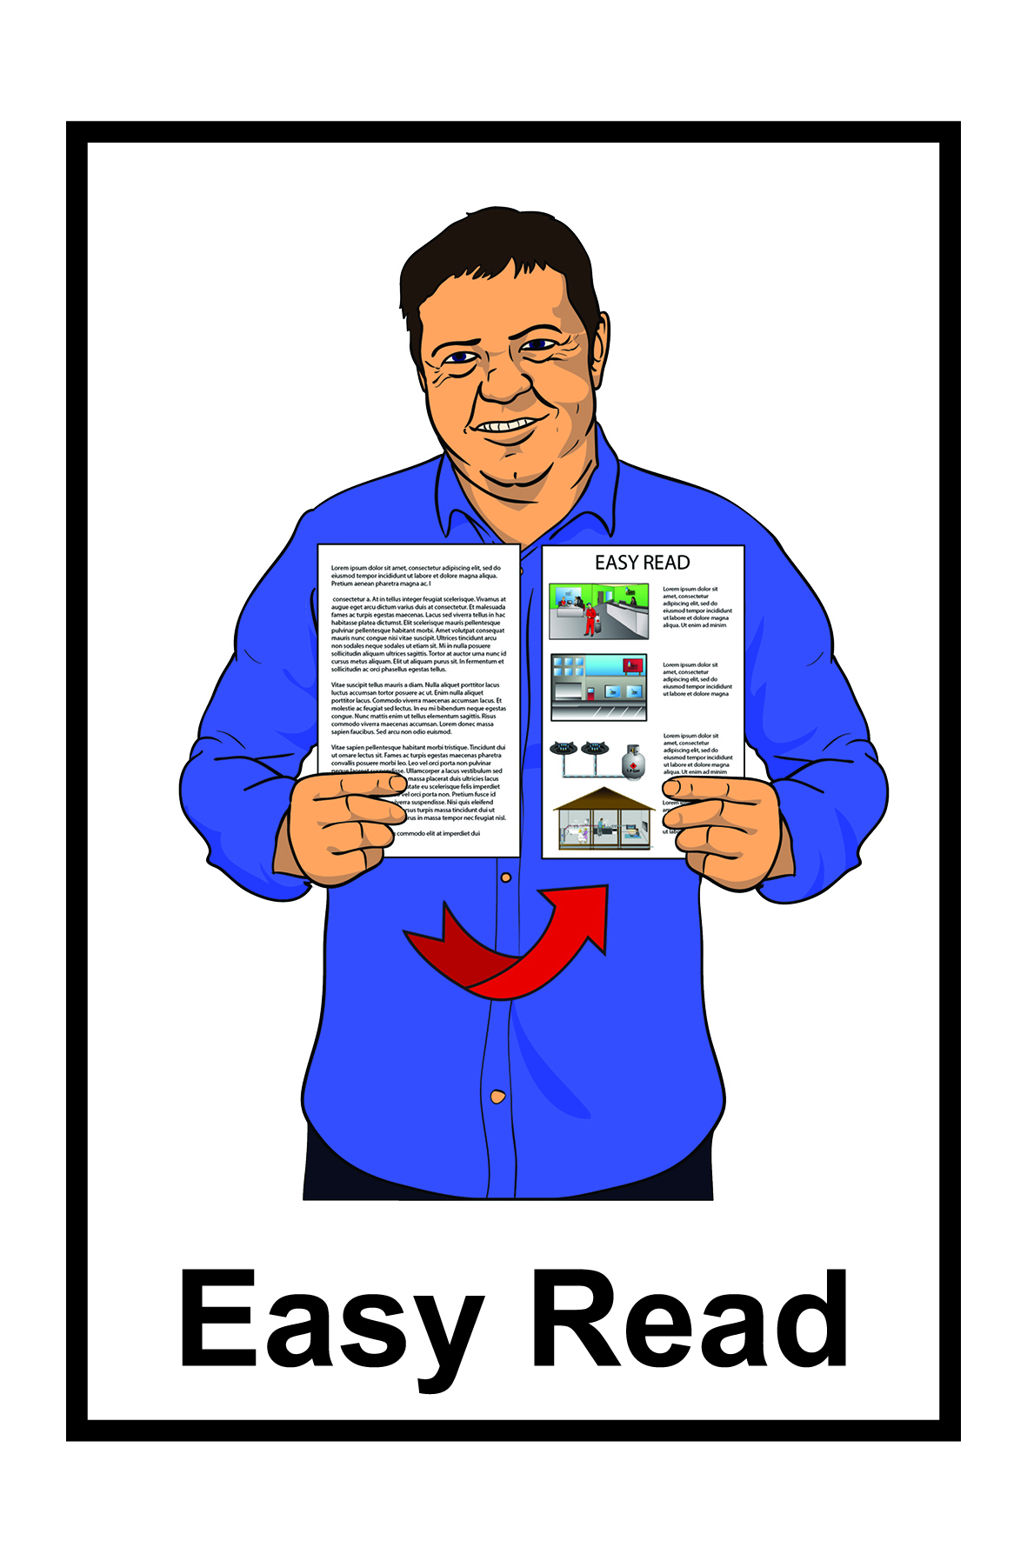
June 2020

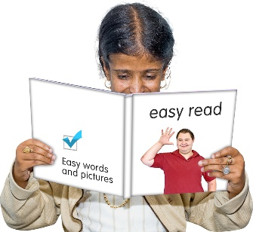
This is an Easy Read document about:

- mental health and addiction

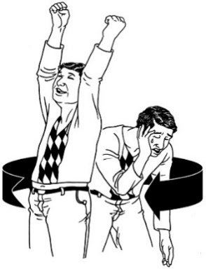
- the Initial Mental Health and Wellbeing Commission

- the He Ara Oranga report
- the things that are happening to make our mental health and addiction services better for everyone.

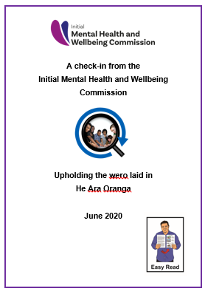
In this document we will explain what all of these words in the list above mean.

Mental health and addiction

Mental health is about how you feel.

The feelings you have can change:

- how think about things

- the things you do.

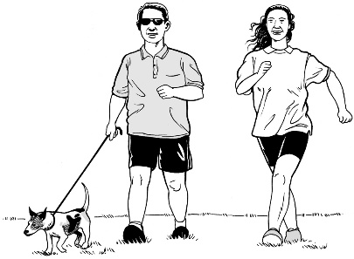
When you feel good you can enjoy the everyday things you do.

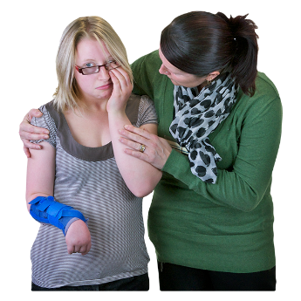
When you do not feel good it can be hard to do these things.

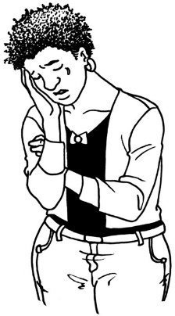
Having a mental illness means having conditions like:

- depression

- anxiety

- bi-polar disorder

- schizophrenia

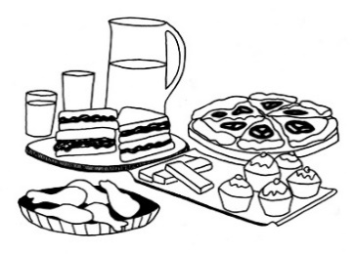
- post traumatic stress disorder

- eating disorders.

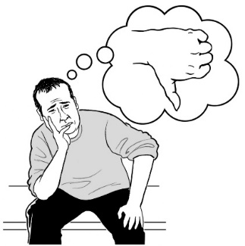
There are many other conditions.

These are just some of them.

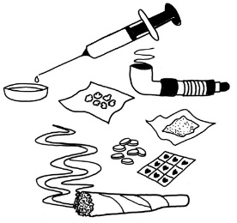
Addiction means not being able to stop yourself from using things like:

- drugs

- alcohol

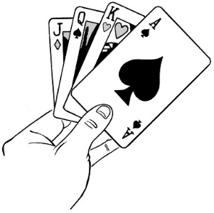
- gambling money – like:

  - betting on the horse racing

  - going to a casino.

There are many other things that people can be addicted to.

These are just some of them.

20 percent of people in New Zealand live with:

- mental health issues

- addictions.
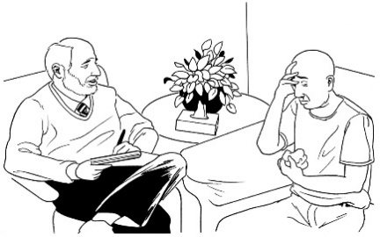

Many of people do not ask for support.

He Ara Oranga

In 2018 the Government looked at what it is like for people living with:

- mental health

- addictions.

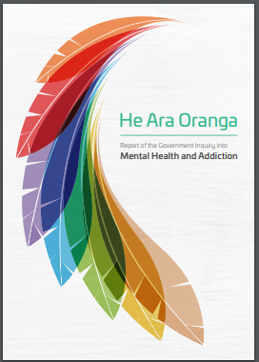
In 2018 there was a report called He Ara Oranga.

The report made 40 recommendations to the Government of what needs to change to mental health services support better for everyone.
Recommendations are things that should be done.

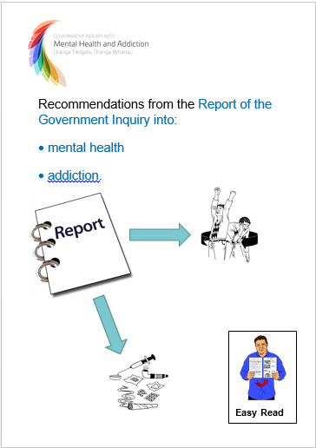
There is an Easy Read document about the recommendations from the He Ara Oranga report.

You can find the Easy Red document on this website:

https://mentalhealth.inquiry.govt.nz/inquiry-report/ recommendations-easy-read/

1 of the recommendations from the He Ara Oranga was to set up a Mental Health and Wellbeing Commission.

What is the Initial Mental Health and Wellbeing Commission?

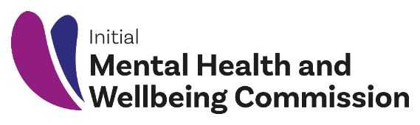
Initial means that a group of people have come together to start on the work of the Mental Health and Wellbeing Commission.

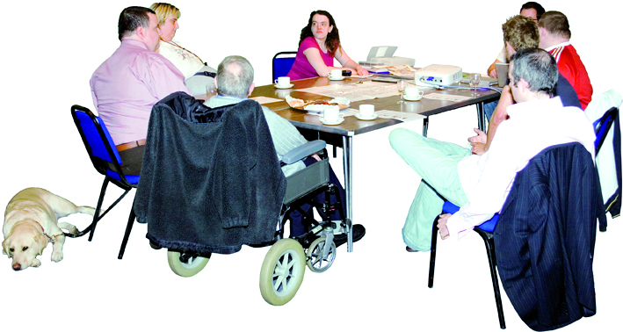
A Commission is a group of people the government asks to look after something.

In this document will call the Health and Wellbeing Commission the Commission.

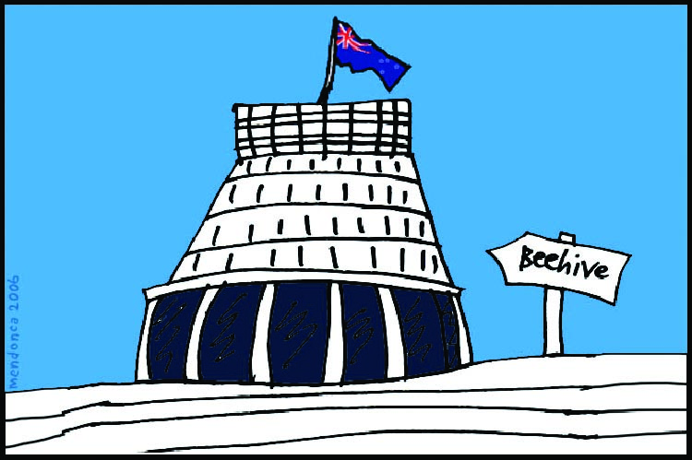
The Commission will tell the Government and people:
- what is happening with mental health services in New Zealand
  - what changes are needed to make things work better.

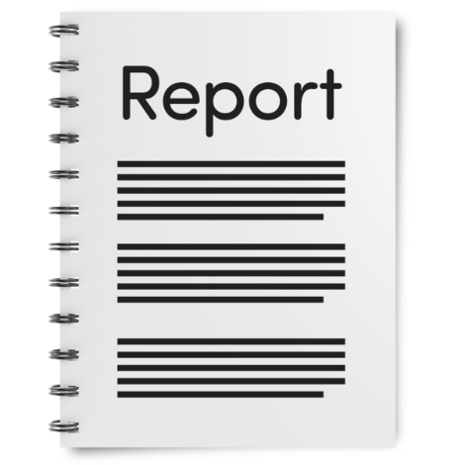
The Commission has written a report called:

Upholding the wero laid in He Ara Oranga.

Wero means challenge.

Challenge means saying we can do things better.

The report looks at how things are going with putting in place the recommendations that were in He Ara Oranga.

This Easy Read document will look at some of the things that have been happening so far.

What has been happening so far?

Wellbeing means you are able to live a good life.

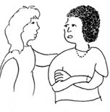
Wellbeing is about what is important to you.

It may be things like:

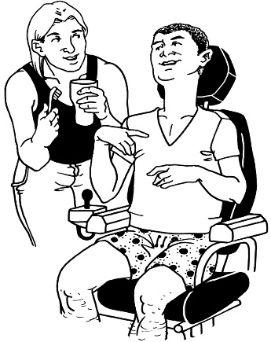
          - being with friends and family you are close to

          - feeling like you have things to do in your life that you enjoy

          - have a place to live where you feel happy
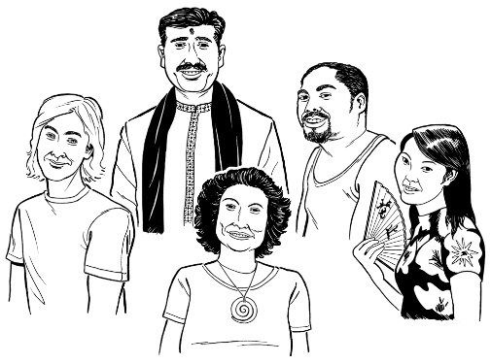
          - able to part of your culture

          - able to decide what is important to you.
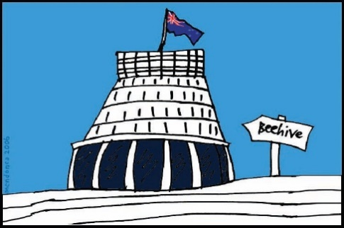
The Government wants mental health and addictions services that look after the wellbeing of everyone.

In 2019 the Government agreed to 38 of the 40 recommendations that were in the He Ara Oranga report.

In June 2020 the Commission did its first check-in.

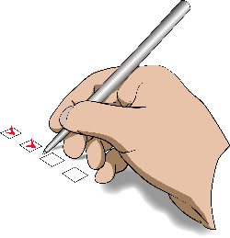
A check-in is when the Commission looks at how things are going with getting the recommendations done.

The Commission looked at 4 important things as part of their check-in:

- The setting up of a Mental Health and Wellbeing Commission.

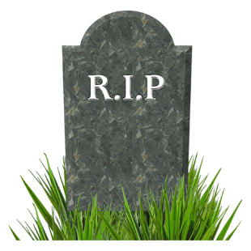
- The work being done to stop the high number of people who suicide.

Suicide is when someone ends their own life.

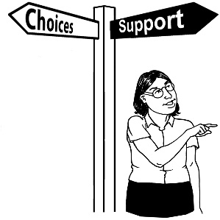
- The work being done to have more mental health services to support the different needs that people have.

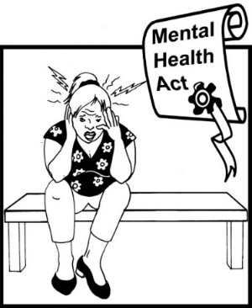
- The changes needed to the Mental Health Act

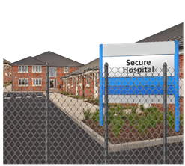
The Mental Health Act is a law that means doctors can make people
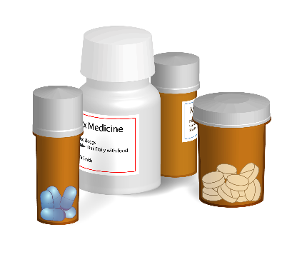
    - go to hospital
    - take medicine.

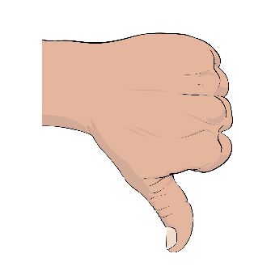
Many people think the Mental Health Act is not good.

What happens next?

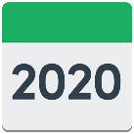
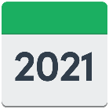
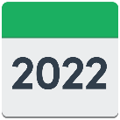
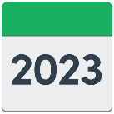
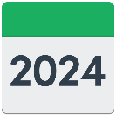
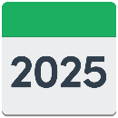
It will take some time to make all the changes that are needed.

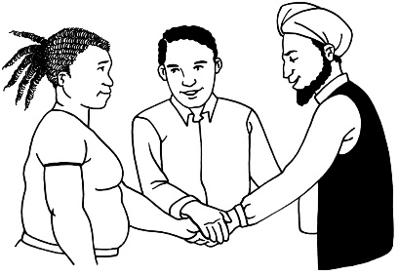
There are some changes that we can make now by working together.

Some changes we can do now to make our mental health and addiction service better are:
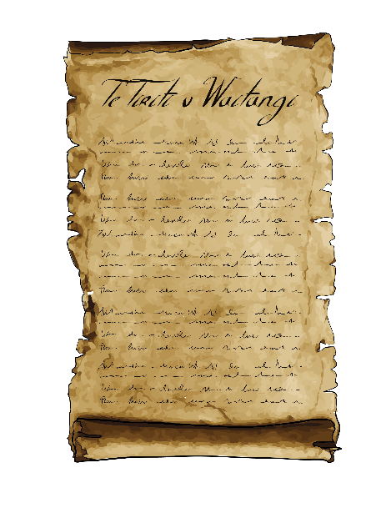
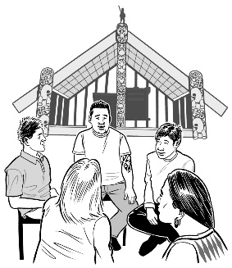
- Make sure that Te Tiriti o Waitangi is part of our mental health and addiction services.

Some more changes we can do now are:
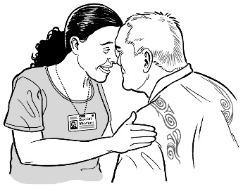
- Start having more services for Māori and those who need services the most.

- Build strong mental health and addiction services that:
                - puts people / whānau needs first

                - can meet everyones needs.
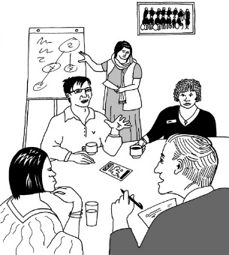

- Make sure that our mental health and addiction services:

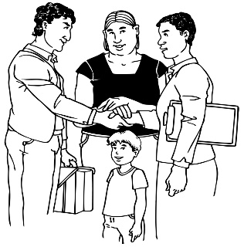
- have good people leading the changes

- work together better.
Some more changes we can do now are:

- That there is a plan that say what people want from their mental health and addiction services.

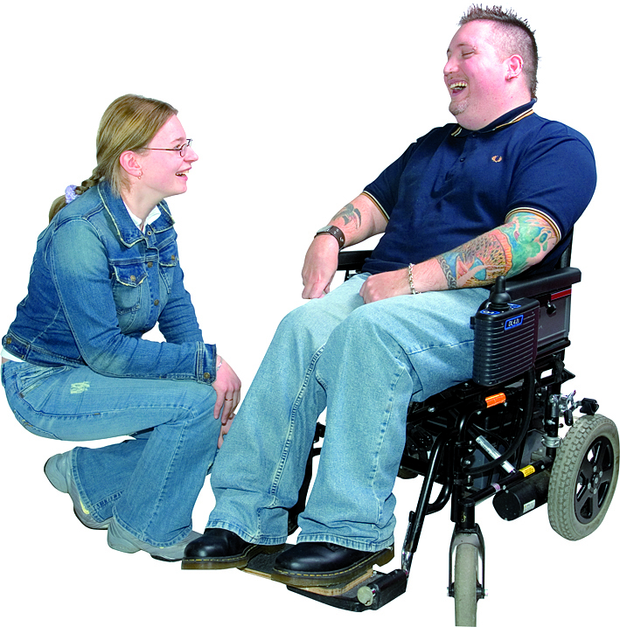
- That we make sure we have good people working in mental health and addiction services.

Where to find more information

There is more information about the Initial Mental Health and Wellbeing Commission on this website:

www.mhwc.govt.nz

You can also send us an email:
kiaora@mhwc.govt.nz

This information has been translated into Easy Read by the Make It Easy service of People First New Zealand Inc. Ngā Tāngata Tuatahi.

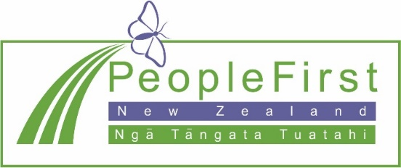
The ideas in this document are not the ideas of People First New Zealand Ngā Tāngata Tuatahi.

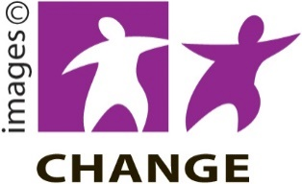
Make It Easy uses images from:

- Changepeople.org

- Photosymbols.com
- Sam Corliss

All images used in this Easy Read document are subject to copyright rules and cannot be used without permission

