Access and Choice
Programme:
Report on the first three years

Te Hōtaka mō
Ngā Whai Wāhitanga me
Ngā Kōwhiringa:
He purongo mō ngā tau tuatahi e toru

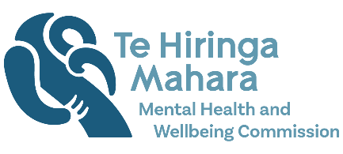

Access and Choice Programme: Report on the first three years – Te Hōtaka mō Ngā Whai Wāhitanga me Ngā Kōwhiringa: He purongo mō ngā tau tuatahi e toru
A report issued by Te Hiringa Mahara – the New Zealand Mental Health and Wellbeing Commission (Te Hiringa Mahara).
Authored by Te Hiringa Mahara.
This work is protected by copyright owned by the Mental Health and Wellbeing Commission. This copyright material is licensed for re-use under the Creative Commons Attribution 4.0 International License. This means you are free to copy, distribute and adapt the material, if you attribute it to the Mental Health and Wellbeing Commission and abide by the other license terms. To view a copy of this license, visit https://creativecommons.org/licenses/by/4.0/legalcode.
ISBN: 978-0-473-66021-5 (online version and docx)
Te Hiringa Mahara – the New Zealand Mental Health and Wellbeing Commission – was set up in February 2021 and works under the Mental Health and Wellbeing Commission Act 2020. Our purpose is to contribute to better and equitable mental health and wellbeing outcomes for people in Aotearoa New Zealand.
For more information, please visit our website: www.mhwc.govt.nz
The mission statement in our Strategy is “Whakawāteatia e tātou he ara oranga / clearing pathways to wellbeing for all.” Te Hiringa Mahara acknowledges the inequities present in how different communities in Aotearoa experience wellbeing and that we must create the space to welcome change and transformation of the systems that support mental health and wellbeing. Transforming the ways people experience wellbeing can only be realised when the voices of those poorly served communities, including Māori and people with lived experience of distress and addiction, substance or gambling harm, are prioritised.
Te Hiringa Mahara New Zealand Mental Health and Wellbeing Commission (2022). Access and Choice Programme: Report on the first three years – Te Hōtaka mō Ngā Whai Wāhitanga me Ngā Kōwhiringa: He purongo mō ngā tau tuatahi e toru. Wellington: New Zealand.

Kupu whakataki | Foreword
This report is the second by Te Hiringa Mahara on the Access and Choice programme, providing a three-year perspective since the allocation of funds from the 2019 Wellbeing Budget. We are past the halfway point in the programme. This represents a period long enough to see whether this investment into community and primary care is making the difference for people and whānau identified in the landmark He Ara Oranga report.
We can see where the programme is making genuine progress, and we can see with more clarity the areas where progress is lagging, and more needs to be done. There are more services and capacity in areas that were previously under-supported. The diversity emerging in the types of services available, such as the growth of Kaupapa Māori services, is heartening. These developments show the programme is moving in the right direction.
The growing number and range of services tell an important story, but not the whole story. Access to services is about not just service availability, but also the trust and confidence of people and whānau using services or seeking support. People using services need to feel listened to and valued. They need to feel that they are in a safe and familiar setting with people with whom they have some affinity. This sense of confidence is the ‘human’ aspect of the access and choice equation.
In the adjunct report into youth access and choice, we are reporting tangible progress in young people accessing support. New service types and locations, often outside of clinical settings, are providing culturally appropriate support, leading to an increasing number of young people accessing services. Youth services are just one part of the mental health sector, yet it is likely that such learnings from here have a much wider application.
Also, as access to services increases and choice improves, the demand for a stable and well-trained workforce increases and those staff require the right training to do the job. Workforce capacity improvements are uneven: improvements in Kaupapa Māori services are evident, but vacancy levels in Pacific and Youth services are high.
We can and should take satisfaction from the achievements to date. We need to look beyond the present and ensure that the services being developed, represent real access and choice, providing people with hope and confidence about their futures. I would like to acknowledge those who are working at the front line to make access and choice real and tangible.
I would urge those reading this report to think about where we are up to in the transformation journey and what we still have to do.

Hayden Wano – Board Chair, Te Hiringa Mahara

Ngā mihi | Acknowledgements
Te Hiringa Mahara prepared this report with the help, advice, and expertise of many people, without whom this report would not have been possible. We thank them for their input and acknowledge them here.
We are grateful to the networks of whānau and people with lived experience of distress, addiction, and gambling harm who shared their knowledge and understanding of the Access and Choice programme services with us:
- Addiction Consumer Leadership Group
- disability and whānau group
- people who provided feedback on our framework He Ara Āwhina
- Preventing and Minimising Gambling Harm Advisory Group
- National Association of Mental Health Service Consumer Advisors (NAMHSCA)
- National Youth Consumer Advisor Network (NYCAN)
- Yellow Brick Road peer workers
- Yellow Brick Road whānau group.
We would like to thank our external peer reviewer Dr Julie Wharewera-Mika for her guidance and advice, and the time she gave to strengthen our report.
We acknowledge our translators Tamahou McGarvey and Nika Rua.
We are grateful to the Access and Choice programme management in Te Whatu Ora | Health New Zealand who provided the information that enabled us to prepare this report.
Finally, we acknowledge the people of Aotearoa, whose access to services this report aims to illustrate, and our important workforce whānau, who work tirelessly to establish and provide these new services.

Ngā ihirangi | Contents
Kupu whakataki | Foreword 3
Ngā mihi | Acknowledgements 4
Ngā ihirangi | Contents 6
Whakamōhiotanga whānui | Overall summary 7
Kupu arataki | Introduction 12
Ngā kitenga | Findings 17
Integrated Primary Mental Health and Addiction services 23
Kaupapa Māori services 30
Pacific services 34
Youth services 37
Workforce development 41
Enablers 47
Ngā puna kōrero | References 49
Appendix one: Overview of the Access and Choice programme 50

Whakamōhiotanga whānui | Overall summary
The Access and Choice programme is a priority initiative from the 2019 Wellbeing Budget, with funding of $664 million allocated for its rollout over a five-year period from 2019 / 20 to 2023 / 24. The programme allocated $516.4 million for four new service types (Integrated Primary Mental Health and Addiction (IPMHA), Kaupapa Māori, Pacific, and Youth services), $99.7 million for workforce development, and $48.15 million for system enablers.
Last year we published our first report, Access and Choice Programme: Report on the first two years (Te Hiringa Mahara, 2021). That report concluded the programme had put much-needed investment into primary and community care in line with recommendations in He Ara Oranga: Report of the Government Inquiry into Mental Health and Addiction (He Ara Oranga) (Government Inquiry into Mental Health and Addiction, 2018). We reported strong progress for the IPMHA services delivered in general practice settings but were concerned about the delays in the implementation of Kaupapa Māori, Pacific, and Youth services. We also found a concerning level of workforce vacancies for Māori, Pacific, and Youth services.
This year’s report provides an update on the implementation of the Access and Choice programme to 30 June 2022. The following are key findings of the report.
- Considerable progress has been made over the last year. We applaud the hard work of providers and the leadership within Te Whatu Ora | Health New Zealand, (previously Manatū Hauora | Ministry of Health) who have collectively contributed to the success in providing greater access to, and more choice of, services.
- The growth in Kaupapa Māori services is very encouraging. The establishment of an additional 17 Kaupapa Māori services over the year is commendable. Despite persistent workforce gaps in other services, the Kaupapa Māori workforce is well recruited for senior cultural, clinical, and non-clinical roles.
- We commend the success of the new commissioning approach for Kaupapa Māori services. It is particularly encouraging to see seven Teina provider services (new or smaller Māori providers) fully established over the last year, and another one partially established. The expansion of Teina providers is a very positive step that will enable more providers to participate in the expansion of Kaupapa Māori services as anticipated with the health reforms.
- More focused attention is required to support the development of Pacific services. Workforce gaps in Pacific services as of 30 June 2022 are considerable, and there has not been the increase in the number of people seen and sessions delivered that would be expected at this stage of implementation and with the additional resources.
- The rollout of Youth services has progressed well with a significant increase in funding committed over the last year, and services now available in 18 (of 20) districts. It is critical that services are developed in the remaining two districts to ensure that all young people across Aotearoa New Zealand have access to services early and without delay. As a result of new services being established, there is a large gap between the contracted (funded) and employed workforce. The estimated need for non-clinical workforce by June 2024 is substantial and meeting that need will require a huge stretch.
- The number of people accessing all Access and Choice programme services has increased over the year, however, is lower than expected at this point of the rollout. We acknowledge the challenges during the COVID-19 pandemic that may have impacted on the reach of these services. Across all Access and Choice programme services, an additional 210,000 people per year will need to be seen (from June 2024 onwards) to achieve the target of 325,000 people each year.
- Workforce issues remain a significant challenge for the programme and for the wider mental health and addiction sector. A comprehensive strategy and roadmap are needed to address the persistent mental health and addiction workforce shortages, and the pressure these shortages create for the existing workforce.
- People experiencing substance harm, gambling harm, or addiction do not appear to be accessing IPMHA services. If the services are to be accessible to people with addiction (as the name Integrated Primary Mental Health and Addiction services suggests they should), the way in which services are delivered may have to be reconsidered. This should be done in partnership with people with lived experience of substance harm, gambling harm, or addiction.
- We will be monitoring funding commitments throughout the programme rollout to determine whether the ongoing funding levels for Kaupapa Māori, Pacific, and Youth services, as of 30 June 2024, are in line with allocations reported in our 2021 report.
- The Access and Choice programme is starting to transform the landscape of primary and community mental health and addiction services. This programme only addresses some of the broader recommendations of He Ara Oranga and we encourage ongoing focus and investment to fully realise the transformation envisaged by He Ara Oranga.

The importance of everyone working in the system understanding exactly what Access and Choice is, who provides it, who can access it and for how long and what the costs are, is essential and particularly if we want to uphold and transform the system to reflect ‘Government initiatives to address He Ara Oranga.’
- Addiction Consumer Leadership Group

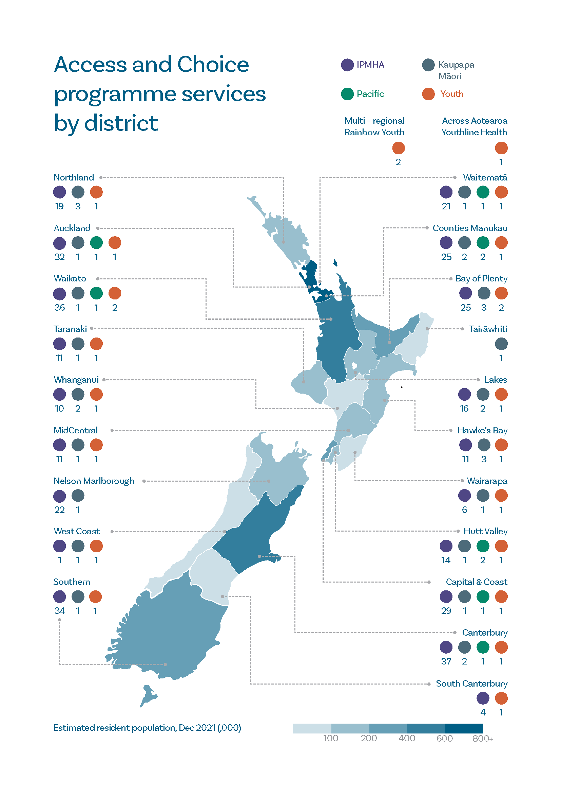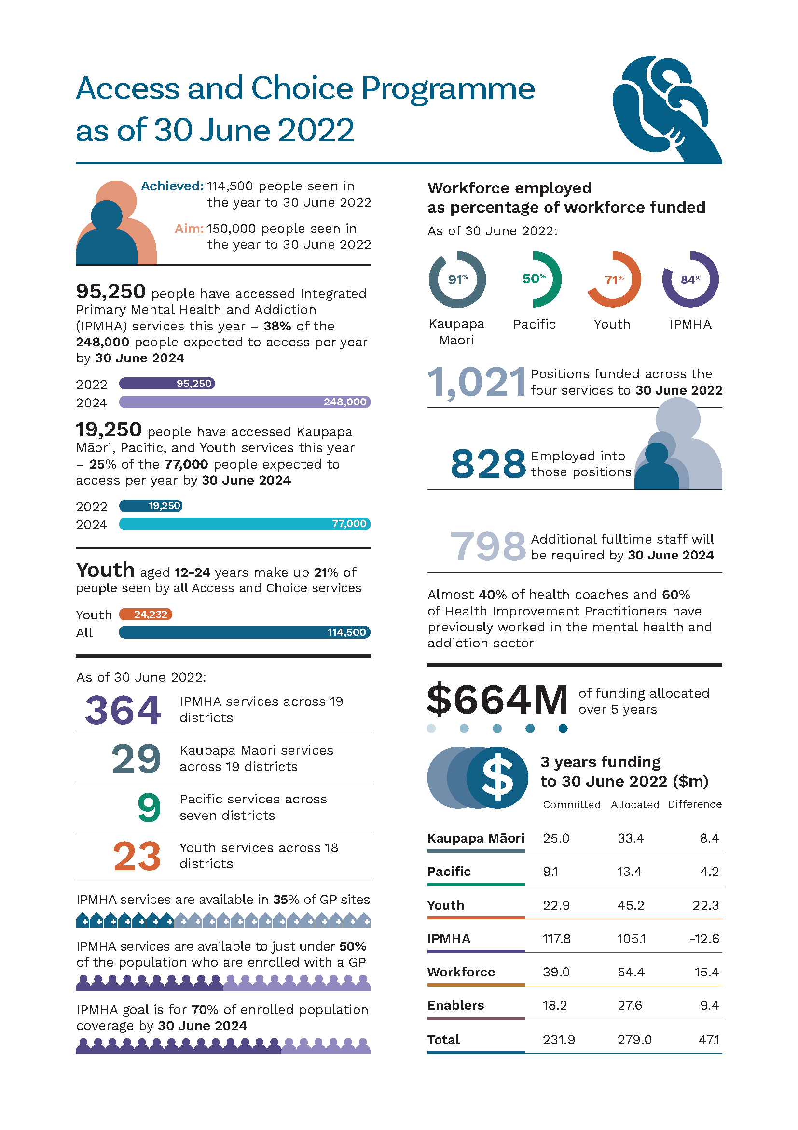

Kupu arataki | Introduction

The Access and Choice programme is a priority initiative of the 2019 Wellbeing Budget
The Access and Choice programme is a priority initiative from the 2019 Wellbeing Budget with funding of $664 million for its roll out over a five-year period from 2019 / 20 to 2023 / 24. The programme set out to provide free and immediate support for people with mild to moderate mental health and addiction needs. It is intended to change the way services are delivered, and to provide services and supports to anyone who needs them, as soon as they need them, and in a range of settings – Kaupapa Māori, Pacific, and youth settings, as well as in general practice and other community settings.

Why we are monitoring this programme
Access to mental health and addiction services and supports is of considerable importance to the people of Aotearoa. Part of our role at Te Hiringa Mahara is to provide independent scrutiny of the Government’s progress in improving mental health and wellbeing in Aotearoa. This includes progress on increasing access to services and expanding the choice of services available to people who are experiencing distress, substance harm, or gambling harm. Both the public and the health sector have significant interest in how the Access and Choice programme is performing. During this time of health reforms, transparency about resources and performance is also of strong public interest, making our role as an independent monitor of mental health and addiction services even more important.

We released our first report on the Access and Choice programme in October 2021
Our first report, Access and Choice Programme: Report on the first two yearsAccess and Choice Programme: Report on the first two years, investigated how the Access and Choice programme was performing compared with what the programme intended to deliver by 30 June 2021 (Te Hiringa Mahara, 2021). This report concluded that the programme had put much-needed investment into primary and community care in line with recommendations in He Ara Oranga (Government Inquiry into Mental Health and Addiction, 2018). We reported strong progress for Integrated Primary Mental Health and Addiction (IPMHA) services delivered in general practice settings. However, we were concerned about the delays in the implementation of Kaupapa Māori, Pacific, and Youth services. We also found a concerning level of workforce vacancies for Māori, Pacific, and Youth services.

This report provides an update on the implementation of the Access and Choice programme
This report covers the first three years of the five-year programme, with a focus on the period from 1 July 2021 up to 30 June 2022. Given the strong public interest in services and supports for youth, we include an adjunct report that explores how well the Access and Choice programme is increasing access to services for youth between the ages of 12 and 24 years.
The report answers the question of how the Access and Choice programme is performing compared with what the programme intended to deliver by 30 June 2022.
How we will know whether the programme rollout is on track
Like last year, for this report we focus on:
- the funding commitments relative to funding allocated for services, workforce development, and enablers (such as implementation support, and reporting and monitoring systems)
- employed workforce compared with contracted workforce
- population reach of services – how many districts and people have access to services
- how many people have accessed (used) services compared with the expected number.
The programme is intended to provide support for 325,000 people per year (6.5% of the total population) by 30 June 2024. Last year we reported that 185,000 people would be expected to access IPMHA services each year by 30 June 2024 and another 140,000 people would be expected to access Kaupapa Māori, Pacific, and Youth services. Our expectations were based on the proportion of funding allocated to different services – 57% of service funding for IPMHA services and 43% of service funding across Kaupapa Māori, Pacific, and Youth services. Our expectation was in line with indicative figures in the Department of the Prime Minister and Cabinet’s Mid Term Review of the 2019 Mental Health Package (Department of the Prime Minister and Cabinet, 2021).
The interim Government Policy Statement on Health (iGPS) has since set an expectation for July 2022 – June 2024 that an estimated 248,000 people will access IPMHA services each year by 30 June 2024 and an estimated 77,000 people will access Kaupapa Māori, Pacific, and Youth services (Manatū Hauora, 2022a). This means 76% of the expected 325,000 people will have access to IPMHA services, and 24% of total access will be to Kaupapa Māori, Pacific, and Youth services. We understand that the estimates have been calculated according to projected capacity of the different services, reflecting the IPMHA model of care, which involves high access / high volume with brief intervention. It may be appropriate to expect, given the holistic and whānau-focused approaches of Kaupapa Māori and Pacific services, the number of people these services see will be lower per investment dollar than for IPMHA services. Similarly, based on 2021 / 22 data, on average a person accessing Youth services will have six sessions, in contrast to IPMHA services, which currently have an average of 2.4 sessions per person. Therefore, we would expect the number of people seen per investment dollar to be lower for Youth services than for IPMHA services.
In this report we have used the iGPS targets as the benchmark to measure whether services are meeting service access expectations. It is important to note that in using these figures, we are not endorsing the relatively low numbers of people expected to access the Kaupapa Māori, Pacific, and Youth services; rather, we advocate for these services to be funded to a level that would allow much greater access than 24% of the target Access and Choice population.
Future monitoring could include productivity measures
There has been recent commentary about measures of productivity for Access and Choice services, including the number of sessions per full time equivalent (FTE) staff member per day. We consider this measure to be appropriate and useful in monitoring performance once services are established. We have chosen not to use such measures at this stage in the programme rollout because the phases involved in establishing services are by their nature non-productive. It would typically take two to three months before a new service is fully operational, given the time it takes to recruit and train staff, build relationships, embed new processes, and promote and receive referrals. Unless the calculation excludes services that are in early phases of establishment, it would artificially lower the measure for the whole of programme.
Information we have we used for this report
For the period covered in this report, Manatū Hauora was responsible for the commissioning and implementation of the Access and Choice programme. With the establishment of Te Whatu Ora on 1 July 2022, responsibility for the programme was transferred to Te Whatu Ora.
Unless otherwise stated, Te Whatu Ora provided the quantitative data used in this report.
These data are complemented by information from seven focus groups with whānau and lived experience networks who experience distress, addiction, and gambling harm., Most people who took part in the focus groups brought wider feedback and perspectives from lived experience networks and whānau groups. We have also drawn on information from our public consultation on He Ara Āwhina, our mental health and addiction service and system monitoring framework. We undertook this consultation over six weeks during March and April 2022, which is within the period that we are reporting on for the Access and Choice programme.
The data quality is improving
In our last report we noted that data quality issues limited our ability to understand if services are meeting the needs of people accessing care or are making a positive difference. The information systems for Access and Choice services have improved over the last year. We have appreciated the improvements in data availability and quality, particularly for IPMHA services, which now have National Health Index (NHI) linked data for approximately 80% of IPMHA services. This is important as it enables Te Whatu Ora to estimate how many unique people are accessing these services.
Unfortunately, an NHI linked reporting system is not currently in place for Kaupapa Māori, Pacific, and Youth primary mental health and addiction services. At the moment, providers report monthly using a template. Data capture for ‘new people seen’ by these services is considered reasonably reliable from November 2021 but is improving. ‘New people seen’ counts unique people, using prioritised ethnicity, in a rolling 12-month period and can be meaningfully added for up to 12 consecutive months. Further data collection and reporting improvements are planned for these services in 2023. These improvements must be progressed in the next year in order to assess the performance and reach of the services.

Despite our statutory powers, access to information for this report has been challenging
The Mental Health and Wellbeing Commission Act 2020 grants us statutory powers to request information. Information is critical for us to be able to perform our functions to monitor mental health and addiction services as well as to assess and report publicly on the effectiveness, efficiency, and adequacy of approaches to mental health and wellbeing – a lack of information significantly compromises our ability to fulfil our legislative functions.
We acknowledge the health reforms have been challenging for Manatū Hauora and Te Whatu Ora as their functions and people have moved from one entity to another.
What is most concerning to us is the difficulty Manatū Hauora and Te Whatu Ora reportedly had in providing the information we requested for this report – we were advised that it would take considerable effort to collate the information.
There were delays in receipt of the information required for this report which compressed our analysis and writing timelines and limited our ability to follow up queries with providers. Further, we have not been able to complete the degree of analysis and validation we would normally conduct.
We are working with the agencies concerned to ensure we have timely access to information to fulfil our future monitoring and reporting obligations.
There are gaps in the data that we received for this report
At the time of writing this report we have not received all the data we requested. This compromises transparency of the programme performance to the public. The gaps in data have meant that we are not able to report fully on the workforce development funding, the outcomes for people using IPMHA service, and differences in progress between districts.

Ngā kitenga | Findings

The Access and Choice programme is starting to transform the landscape of primary and community mental health
Last year we concluded that this programme has put much needed investment and services into primary and community care in line with many of the recommendations in He Ara Oranga. That story has continued as the programme has made considerable progress being over the last year. While there are aspects of the programme that we have concerns about, we applaud the hard work of providers and the leadership within Te Whatu Ora (previously Manatū Hauora) who have collectively contributed to the success in providing greater access to, and more choice of, services.
The number of Kaupapa Māori and IPMHA services contracted, and operational, has increased considerably across Aotearoa over the last year. Investment in Youth services has also grown significantly. This is a great achievement, and we acknowledge the effort involved in doing this while COVID-19 has continued to dominate health sector focus and resources.
As of 30 June 2022, the following services are in contract:
- 364 IPMHA services in general practice sites across 19 districts – an increase of 127 services from last year
- 29 Kaupapa Māori services across 19 districts – an increase of 17 services from last year
- 9 Pacific services across 7 districts – no change from last year
- 23 Youth services across 18 districts – an increase of 5 services from last year.

The growth in Kaupapa Māori services is a positive step forward
In our report last year, we expressed concerns that the rollout of Kaupapa Māori services was behind what was expected, so it is encouraging to see that the rollout of these critical services has progressed well in the third year of the programme. This momentum must continue, given that we are only halfway towards the full funding commitments for Kaupapa Māori services.
The establishment of an additional 17 Kaupapa Māori services over the year is commendable. Further, despite persistent workforce gaps in other services, the Kaupapa Māori workforce is well recruited for senior cultural, clinical, and non-clinical roles. Workforce requirements will increase significantly over the next two years of the programme, particularly for the non-clinical workforce, and a dedicated focus will be required to meet the estimated need.

Future commissioning should learn from the approach used for Access and Choice Kaupapa Māori services
A new approach was used in the commissioning of Access and Choice Kaupapa Māori services as we described in our 2021 report. In that report we commended the value of the co-design process but noted Kaupapa Māori providers expressed dismay about delays in the contracting process.
Despite the delays, we commend the success of this approach that has enabled more support for Teina providers. Teina providers are new or smaller Māori providers that received additional support to get established as a provider of primary Kaupapa Māori services. It is particularly encouraging that the last year has seen seven services by Teina providers fully established, and another one partially established. The expansion of Teina providers is a very positive step that will enable more providers to participate in the expansion of Kaupapa Māori services anticipated with the health reforms.

Pacific services require more focused support
Supporting the development of Pacific services needs focused attention. Despite increased funding for existing services in year three of the programme, the funding commitments are well behind what is allocated by this point in the programme rollout. Further, the increase in people seen and sessions delivered is not at a level that we would expect with the additional resources.
It is encouraging that Pacific services have employed an additional 7 clinical FTE and 5 non-clinical FTE staff over the last year. However, as at 30 June 2022, there are substantial vacancies in the employed workforce compared with the number of contracted FTEs. While the workforce status improved for a few months during the year, the progress in recruiting to Pacific services has been much slower than other services. Focused attention is required to address this issue.
It is reassuring to see some workforce development initiatives aimed at increasing the Pacific workforce in the longer term and another new initiative supporting the Pacific primary mental health and addiction services. Without more detailed information, it is not possible to assess whether that investment is appropriate to the service need.

The increase in access for youth is encouraging
The rollout of Youth services has progressed well with a significant increase in funding committed over the last year, and services are now available in 18 out of 20 districts. It is critical that services are developed in the two remaining districts to ensure that all youth across Aotearoa have access to services early and without delay.
As a result of establishing the new services, there is a large gap between contracted and employed workforce. The estimated need for non-clinical workforce by June 2024 is substantial and meeting that need will involve a huge stretch.
Youth services appear to be accessible to rangatahi Māori, who make up 35% of people accessing Youth services. Only 5% of people that Youth services see identify as Pacific peoples. However, this percentage is likely to be understated due to the reporting using prioritised ethnicity.
It is also encouraging that 26% of people accessing Pacific services and 32% of people accessing Kaupapa Māori services are aged 12–24 years.
Youth aged 12–24 years make up 21% of people seen by all Access and Choice services.

IPMHA services are available to just under 50% of the population who are enrolled with a general practice
The programme’s goal is to have 70% of enrolled population coverage by 30 June 2024. That is, once of the programme rollout is completed, IPMHA services will be available to 70% of people who have a general practitioner (GP). As of 30 June 2022, the IPMHA services are available to 50% of the enrolled population, and we consider this progress is on track to meet the 70% target.
We support the focus of the initial rollout, which was on practices with high Māori, Pacific, and youth populations, and areas with high need. However, we question how the remaining 30% of people enrolled with a general practice will have access to IPMHA services at the end of the programme rollout.

Funding commitments are higher than allocated funding for IPMHA services
The funding committed to IPMHA services has been consistently over what was allocated for those services. This raises the question of whether funding originally allocated for Kaupapa Māori, Pacific, or Youth services, all of which are ‘underspent’ over the first three years, has been reallocated to IPMHA services.
Manatū Hauora and Te Whatu Ora have assured that the final-year funding allocations are a firm expectation in their planning. We will be monitoring funding commitments throughout the programme rollout to determine whether the ongoing funding levels for Kaupapa Māori, Pacific, and Youth services, as of 30 June 2024, are in line with allocations we set out in our 2021 report.

Fewer people are accessing services than expected at this stage of the rollout
Across all Access and Choice programme services, approximately 114,500 people were seen over the year to 30 June 2022. This is 35% of the way towards the 325,000 people per year that the programme is expected to see from June 2024 onwards. It is also lower than the programme’s target for 150,000 people to be seen in the year to 30 June 2022 (Manatū Hauora, 2022b). Of note, funding commitments for the year to 30 June 2022 are at 56% of the total ongoing service funding from June 2024 onwards.
Across the programme, an additional 210,000 people per year will need to be seen to achieve the target of 325,000 people each year from 30 June 2024.
About 95,250 people accessed the IPMHA services in the year to June 2022. This is 38% of the total number of people expected to access the services per year by 30 June 2024 (248,000 people). Funding commitments at 30 June 2022 are at almost 58% of the 2023 / 24 funding allocation.
Approximately 19,250 new people have accessed Kaupapa Māori, Pacific, and Youth services (collectively) in the year from 1 July 2021 to 30 June 2022. This is 25% of the total of 77,000 people expected to be accessing these services each year from 2023 / 24. Funding commitments at 30 June 2022 are at 54% of the 2023 / 24 funding commitments.
We are cautious about drawing a conclusion as to how many more people we would expect to be seen with the current investment, as the cost per person seen is likely to be higher early in the process of establishing services. New services typically become more efficient and productive over time as relationships and processes become embedded. Furthermore, the funding commitment reported is at the end of the year, whereas the access relates to the whole year. However, for Kaupapa Māori, Pacific, and Youth services, the gap between the percentage of the 2023 / 24 target population seen (25%) and percentage of 2023 / 24 total service investment committed (54%) is particularly large. This comparison will be important to monitor as the programme reaches the end stages of implementation.
Te Whatu Ora has advised us they have developed measures of annual access to report against iGPS targets and have assured us that access rates for both components are on track.

Services must be promoted and made more visible to the public
Many people do not know where these new services are nor how to access them. This lack of awareness is reflected in the finding that fewer people are being seen than expected at this time. All services in the Access and Choice programme need to be more visible to the public. People need to know where these services are offered and how to access them for free. We are encouraged to hear that Te Whatu Ora is developing an Access and Choice programme website that will be up and running by the end of 2022. The website will provide information about the services, including where they are located and how to access them.
We would like to see greater promotion of all services, and the development of a pathway into IPMHA services that ensures all practices allow access to them without a GP co-payment. This is the only way that the services will truly be available free of charge in line with the intent of the Access and Choice programme.

Workforce remains a significant challenge, and requires a whole-of-sector approach
The recruitment of the workforce to deliver services remains a challenge for IPMHA, Pacific, and Youth services. Part of the explanation for gaps between contracted and employed staff positions is that the ongoing rollout of services constantly creates new positions that require recruitment. However, this does not explain the extent and consistency of the workforce gaps we are seeing over the three years of the programme.
As we noted in our 2021 report, the mental health and addiction sector is faced with significant workforce shortages and the additional services stretch a limited workforce across more services.
While the programme has funded 1,021 positions across the four services to 30 June 2022, 828 people have been employed into those positions and only a proportion of them are new to the workforce. Approximately 94% of Health Improvement Practitioners (HIPs) and 69% of health coaches have previously been employed in the healthcare workforce. More specifically, among these staff, almost 60% of HIPs and 40% of health coaches have previously worked in the mental health and addiction sector. The recent change that will allow credentialled counsellors into the HIP workforce is a positive step forward that, if effective in attracting counsellors, will add new workforce to the mental health and addiction sector (Little, 2022).
The Access and Choice workforce development initiatives are also aimed at growing existing workforce across the sector with additional nursing, social work, occupational therapy, and clinical psychology places (see Table 3). However, it will be a significant stretch for the sector to produce an additional 798 fulltime staff to meet the estimated need for June 2024 and ongoing. This need does not account for the additional staff likely to be required for specialist, including non-government organisation, services.
While the programme is making positive steps, the need for a comprehensive strategy and roadmap to deal with the broader mental health and addiction workforce shortages, and the resulting pressure on the workforce must be addressed.

Alternative community addiction services that are more accessible for people experiencing substance harm, gambling harm, or addiction are required
We are concerned that IPMHA services are not truly accessible for people experiencing substance harm, gambling harm, or addiction. While we don’t have presenting issues data for Kaupapa Māori, Pacific, and Youth services, the IPMHA data suggests people seeking help for substance harm or addiction, problem gambling, or addiction are not accessing current services. We note the limitations of these data, but also note that the recent evaluation of IPMHA services did not mention the services’ accessibility or effectiveness for people experiencing substance harm, gambling harm, or addiction.
The people in our focus groups with lived experience of substance harm, gambling harm, and addiction told us that they would prefer services that are free (without co-payment as a step in the referral pathway) and provided outside of medical practices. They also want a model that allows the development of relationships built on trust. The brief intervention model is challenging in this area as disclosure of substance use and harm typically requires trust – and trust doesn’t happen quickly.
The Access and Choice programme principles of early, immediate, and free services are entirely suitable for people experiencing substance harm and gambling harm, but if these services are to be accessible to people with addiction (as the name Integrated Primary Mental Health and Addiction services suggests they should), the way that services are delivered may have to be reconsidered. This should be done in partnership with people with lived experience of substance harm, gambling harm, or addiction.

Integrated Primary Mental Health and Addiction services

Evaluating progress in IPMHA services
The programme has made steady progress with the establishment of IPMHA services over the period of this report. The IPMHA services include HIPs and health coaches that are typically part of a general practice team. Some services also include support workers that have complementary skills, which enables greater choice and flexibility in the range of supports and services offered.
Over the year since our last report, the funding committed for 2021 / 22 and 2022 / 23 has not changed as all funding committed last year was for a two-year period. Funding committed up to 30 June 2022 is 58% of the way towards the total ongoing annual funding allocated of $101.175 million per year from 2023 / 24 (see Figure 1).
Figure 1: Funding committed and allocated for IPMHA services as of 30 June 2022
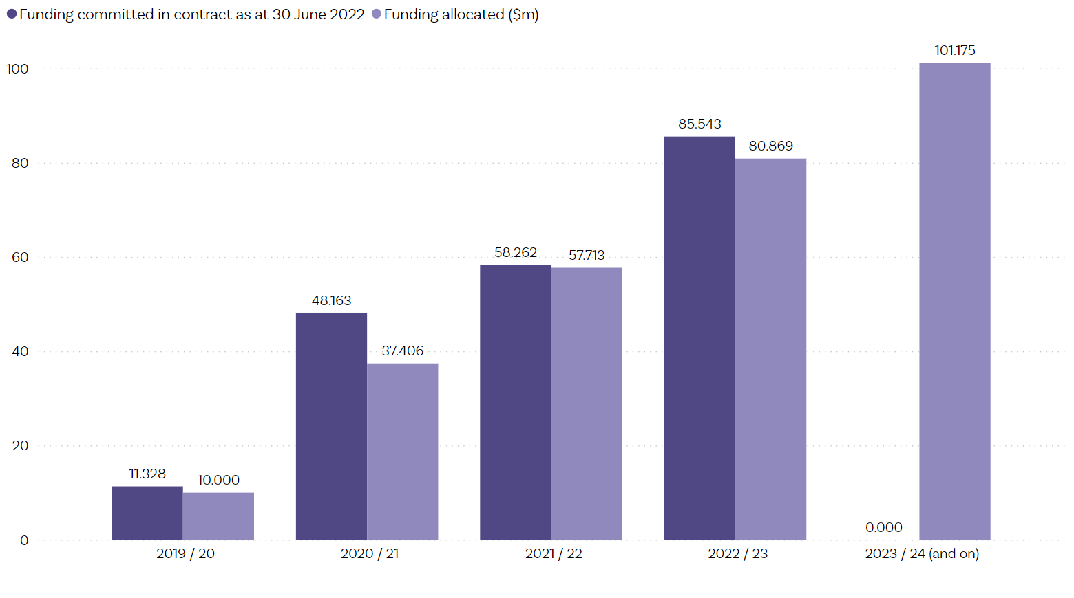

The services are available in 364 general practices across 19 districts
As of 30 June 2022, IPMHA services have been implemented in 364 general practice sites across 19 districts, an increase of 127 general practice sites and 3 districts since 30 June 2021. This represents 35% of the number of general practice sites in the country. The services are available to 49% of the population enrolled with a general practice; this has increased from 34% over the last year since 30 June 2021.
Figure 2 shows the proportion of people in Aotearoa who have access to these services through the general practice they are enrolled with, by district. The programme rollout has included general practice sites with larger enrolled populations in its early stages, which allows faster population coverage.
As of 30 June 2022, Tairāwhiti district had no IPMHA services available. Since then, however, it has been announced that a new IPMHA service is in place in one large practice, which provides services for 39% of the enrolled population in Tairāwhiti.
Figure 2: Proportion of population with access to IPMHA services by funding district as of 30 June 2022
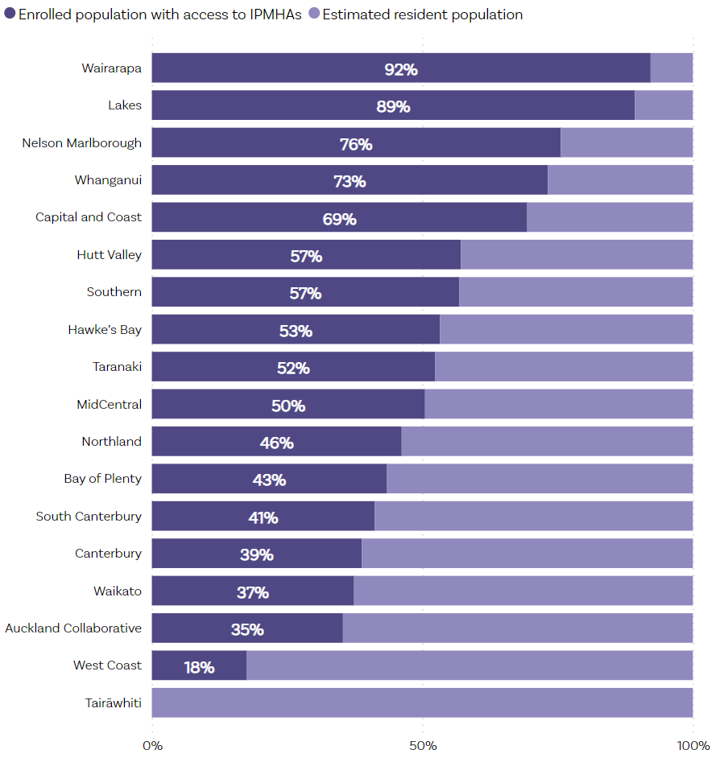

Across Aotearoa, the number of people accessing services is lower than expected
In the 12 months from 1 July 2021 to 30 June 2022, 95,273 unique people used IPMHA services. This equates to 4% of people who are eligible to access the services (people enrolled with a general practice that has an IPMHA service). The total of 95,273 unique people using the IPMHA services is 38% of the way towards the interim Government Policy Statement’s expectation that an estimated 248,000 people will access IPMHA services each year by 30 June 2024 (Mānatū Hauora, 2022a).
Figure 3 shows the number of unique people seen each month (but may be seen again across the year) and number of sessions delivered by month, based on the data that providers reported to Manatū Hauora.

Figure 3: IPMHA service activity – number of unique people seen, and sessions delivered by month, 2021 / 22
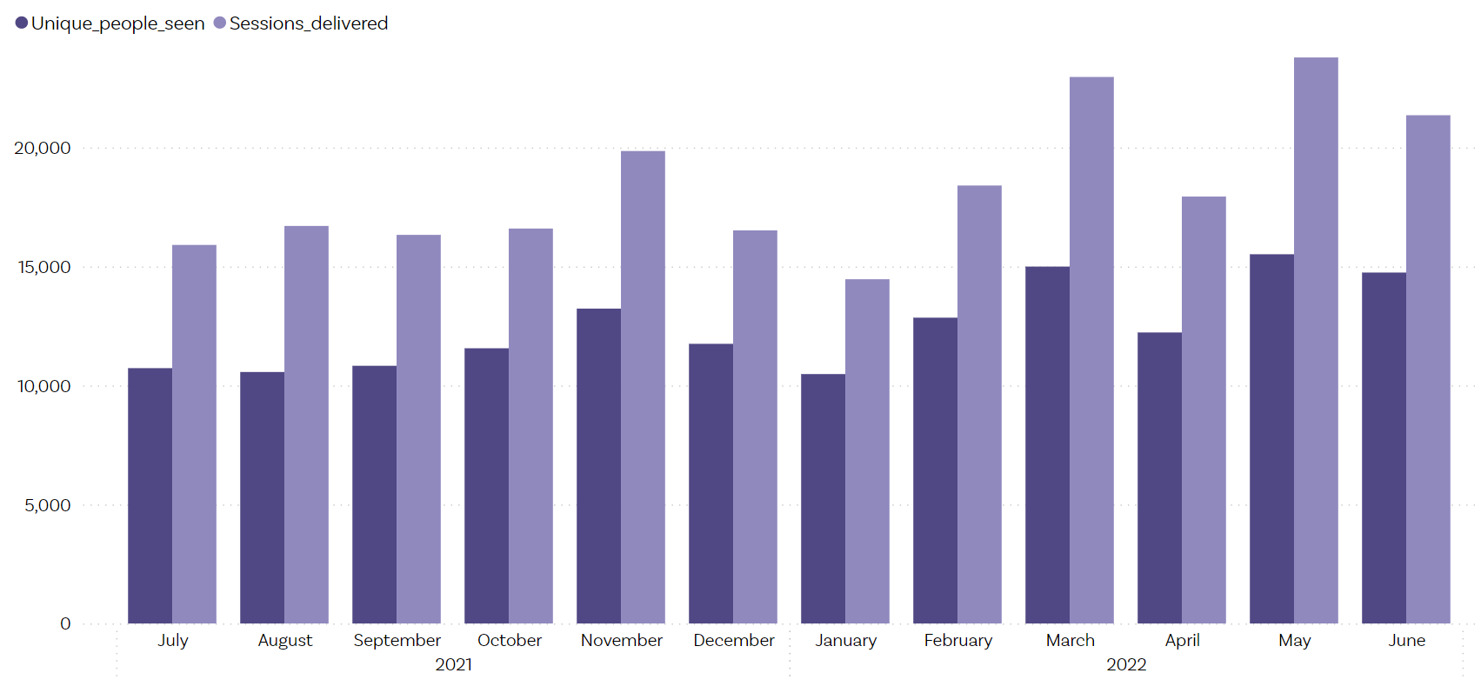

People experiencing alcohol and other drug harm do not appear to be accessing IPMHA services
We received limited data on presenting issues for three months from April to June 2022. These data show that only 1.6% of people presented to IPMHA services for alcohol and other drug (AOD) issues, gambling harm, or addiction issues.
People we talked to in focus groups stated that people experiencing gambling harm as well as alcohol and other drug harm historically do not feel comfortable discussing these experiences with their GP. They also reported that people are unlikely to open up about their experiences of substance harm with a HIP or a health coach who they have just met and not built a relationship with, especially if only seeing them for a limited time. Instead, there was a strong perspective that people were more likely to talk to peers who had had similar experiences and were knowledgeable and non-judgemental. This may explain the low rates of people presenting to IPMHA services for substance use issues or gambling harm.
But I suppose it gives me some questions around: how do you access it? Do people have to pay because it's at a general practice? Or is it free? Or what kind of cost is involved? Because I think if there is a cost, that could make it quite limiting. Because I don't know about you, but when I go see my doctor, it costs me $55 a visit. And that's quite a lot of money if somebody had to pay that to then see the health coach.
- Addiction Consumer Leadership Group

People vary in their knowledge of IPMHA services
What people in our focus groups knew about IPMHA services depended on many different factors, including whether they work within the mental health and addiction sector. People who currently work as a peer support worker or consumer advisor knew more about IPMHA services than those that do not. Furthermore, many people shared their belief that if they did not work within the mental health and addiction sector, they wouldn’t know about the Access and Choice services as their general practice clinics had not been informed them about these services.
Consumer advisors and peer support workers who work within the mental health sector knew more about IPMHA services than whānau and lived experience leaders with experience of AOD and gambling harm.

Many people we talked to did not know how to access services
A number of people we talked to were unaware that IPMHA services are based at general practice clinics. Furthermore, not everybody knew whether IPMHA services were available in their area.
I facilitated a consumer group last week. There were a dozen people that come from across the different services and residential OST [opioid substitution treatment] day programmes. And they said there’s no way that they would talk to their doctor about AOD issues. There wasn't a relationship, there wasn’t a time. It was something that they’d be more likely, definitely, not to mention rather than open a discussion.
- Addiction Consumer Leadership Group
Many people were unaware of how to access IPMHA services. Most people assumed that to see a HIP or a health coach you need to see a GP first, for which a co-payment would be needed. This was of concern to many consumer advisors and peer support workers we talked to. They stated that a requirement to pay for a GP can stop people from reaching out for support, especially if they are experiencing AOD or gambling harm.
My older son said, “Where are they?” He tried to Google it. And he couldn't find out where they are.
- Yellow Brick Road whānau group

Sessions delivered are increasing as services become established
From 1 July 2021 to 30 June 2022, 230,755 sessions were delivered. Of these sessions, 55% of the sessions were provided by HIPs and 44% by health coaches and support workers. The number of sessions delivered was trending upwards across the course of the year, in line with the increased number of people being employed to roles over time. Under the IPMHA model, a session with a HIP or health coach is an average length of 30 minutes and typically people have fewer sessions than in more traditional approaches. This allows a higher reach than could be achieved with a more traditional one-hour session or fixed (higher) number of visits, while also allowing flexibility to provide more intensive supports for those who need them over a sustained period.
Access and Choice programme management have indicated they are expecting the number of sessions per HIP to eventually be 6.5–8 per day. This number will be affected by availability of other services, such as crisis services, in a district. At times HIPs need to support a person who presents in crisis or with complex life situations, which may take some time.

Recruiting and training the workforce remains a challenge
There is a consistent gap between the number of staff contracted (funded) and the number of staff employed into positions, as Figure 4 shows. This is not unusual in the health sector as it has long-standing shortages of staff, particularly registered staff.
While the shortages in the registered workforce are likely to provide ongoing challenges, we are encouraged to see the change that will allow credentialled counsellors to take on HIP roles. The addition of new people into health coach and support worker roles is also a positive step forward in expanding the workforce.
The gap between contracted and employed workforce numbers is similar to last year, with 84% of contracted FTEs employed as of 30 June 2022 compared with 85% as of June 2021. By 30 June 2022, there were:
- 265.2 contracted and 209.5 employed HIP FTE (79% employed, a decrease from 86% June 2021) – 59 additional fulltime staff employed since 30 June 2021
- 344.7 contracted and 304.1 employed health coaches and support workers FTE (88% employed, an increase from 84% June 2021) – 108 additional fulltime staff.

Figure 4: IPMHA workforce employed, contracted, and estimated needs as of 30 June 2022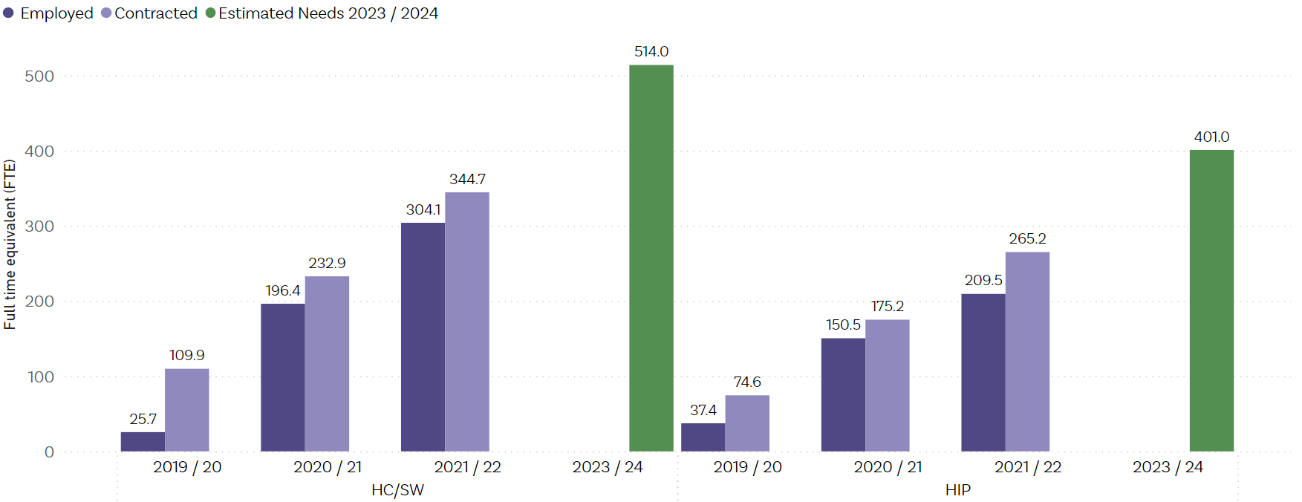
Note: HC = health coach; SW = support worker; HIP = Health Improvement Practitioner.
See the Workforce development section for information on programme initiatives to develop and grow the workforce.

Almost 60% of Health Improvement Practitioners and 40% of health coaches are from the mental health and addiction workforce
The employed HIPs and health coaches / support workers do not represent an entirely new workforce. Te Pou is contracted to deliver and coordinate training for HIP and health coach roles and are also required to report and evaluate progress. Information collected in February and March 2022 showed that for people trained before 31 December 2021, 59% of HIPs and 37% of HCs have previously been employed in mental health and addiction roles (Te Pou, 2022). Further, 94% of HIPs and 69% of health coaches have been employed in the broader healthcare workforce. The experience and knowledge of these staff are undoubtedly valuable to the IPMHA services; however, the additional positions will continue to stretch a limited workforce in the absence of a broader mental health and addiction workforce plan.

Kaupapa Māori services

The rollout of Kaupapa Māori services has progressed well in the last year but remains slightly behind what was planned
Manatū Hauora allocated funding of almost $62 million for services targeted for Māori over four years. By 30 June 2024, Manatū Hauora expects the value of funded Kaupapa Māori services to be $35.5 million each year, which represents 20% (see Table 7 in Appendix one) of the total $177.5 million Access and Choice service funding shown in Table 6 in Appendix one.
Funding committed as of 30 June 2022 is 50% of the way towards the indicative funding allocation of $35.5 million each year from 2023 / 24, as Figure 5 shows. While the rollout is still behind the indicative funding allocation, this is a significant increase from only 15% as of 30 June 2021.
Figure 5: Funding committed and allocated for Kaupapa Māori services as of 30 June 2022
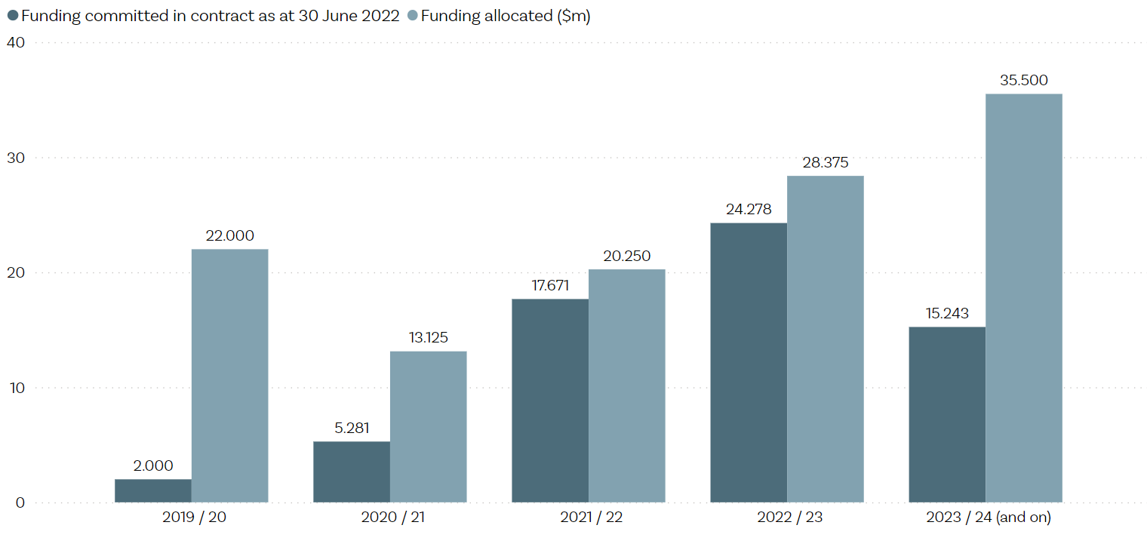Twenty-nine Kaupapa Māori services are contracted across nineteen districts
Manatū Hauora commissioned Kaupapa Māori services directly. Their new procurement approach has two streams of funding:
- Tuakana stream – for well-established Māori providers
- Teina stream – for new or smaller Māori providers, with or without previous service experience in mental health and addiction.
For the period of our report last year, there were 12 contracted providers, and these were all in the Tuakana stream. Significant progress has been made in the year since, with 29 Kaupapa Māori now services contracted across 19 districts (see Table 1). Twenty-two of these services are fully established and are defined by Manatū Hauora as operational, because they have at least 80% of staff recruited. Another four of the services are partially established, based on the Manatū Hauora definition that each service is delivering some services, but is not yet fully operational and recruitment is ongoing.
Table 1: Status of Kaupapa Māori services by stream as of 30 June 2022
Status of services
Tuakana providers:
- Fully established | 15
- Partially established | 3
Teina providers:
- Fully established | 7
- Partially established | 1
Contracted but not live as of 30 June 2022 | 3
Total | 29

While the number of sessions delivered is increasing as services are established, the number of new people seen is reasonably stable
From 1 July 2021 to 30 June 2022, Kaupapa Māori services delivered a total of 23,211 sessions and saw 8,886 ‘new people’. The sessions delivered were trending upwards across the year, in line with the increased number of people being employed to roles over time, although we are not seeing the same upward trend with ‘new people seen.’ In the month of June 2022, 4,029 sessions were delivered, and 946 new people were seen (see Figure 6).
Kaupapa Māori providers offer free, flexible, and tailored services to each person and their whānau, not pre-defined packages of care. Like last year, the number of people seen (including people seen multiple times) is higher than the number of sessions delivered, reflecting the practice of seeing many whānau in wānanga (many people in the same session). This approach will result in longer sessions and involve more than one worker supporting a session.
Approximately 40% of the 8,886 people using the services in the last year were tamariki and rangatahi Māori aged 0 – 24 years and 32% were rangatahi Māori aged 12 – 24 years. This level of access by rangatahi Māori to Kaupapa Māori services is reasonably high. Although those under 25 years comprise 48% of the Māori population in Aotearoa, we are seeing reasonably good rangatahi Māori access to Youth services.
Figure 6: Kaupapa Māori service activity – new people seen, and sessions delivered by month, 2021 / 22
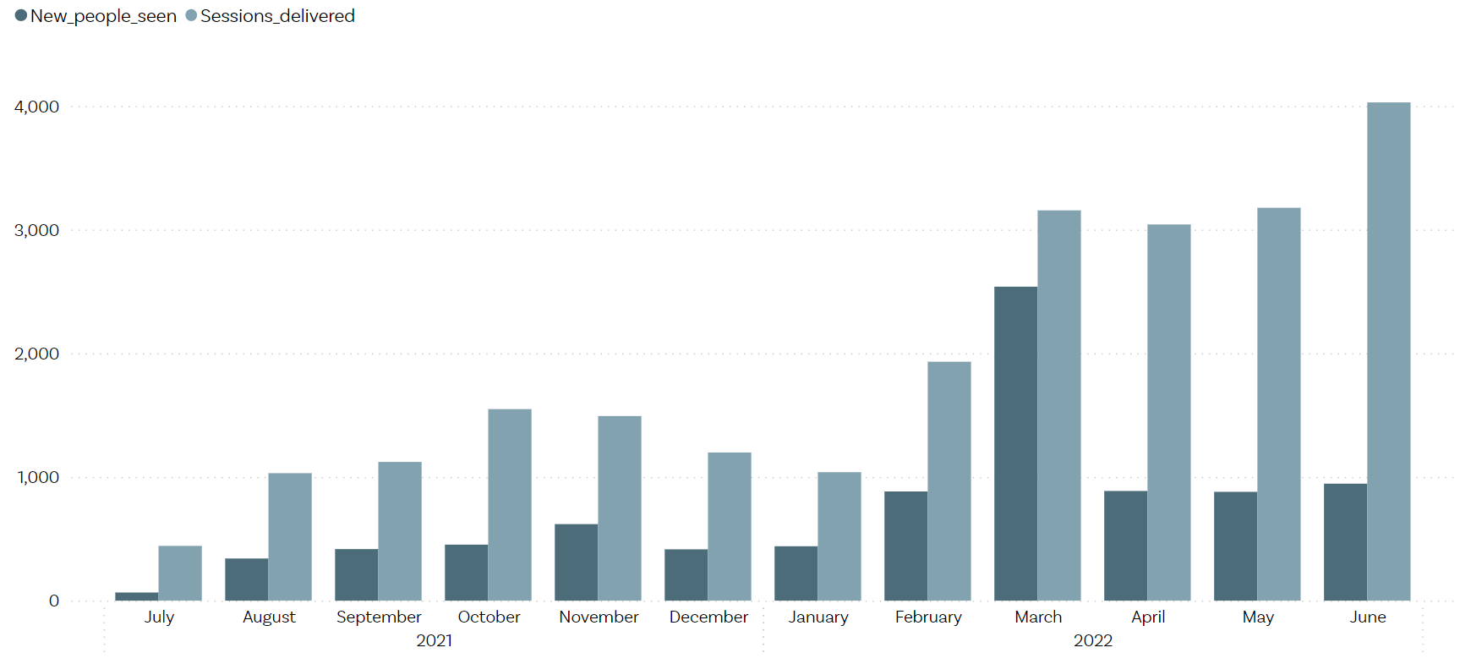

Workforce recruitment has progressed significantly
The number of people employed by Kaupapa Māori services has increased substantially over the last year. The number of people employed as a proportion of those contracted was 91% as of 30 June 2022. Please note that Manatū Hauora has retrospectively corrected the figures for people employed to 30 June 2021 to show 78% of contracted FTE were employed as of 30 June 2021 (not 42% as previously reported).
By 30 June 2022, there were:
- 47.4 contracted and 44.2 (93%) employed cultural FTE – 42 additional fulltime staff employed since 30 June 2021
- 61.5 contracted and 53.5 (87%) employed clinical FTE– 46 additional fulltime staff
- 63.7 contracted and 57.7 (91%) employed non-clinical FTE – 45 additional fulltime staff
- 17 contracted and employed FTE by Tairāwhiti district (unspecified worker types). Because the worker type is unspecified, this last group has not been included in Figure 7.
Figure 7: Kaupapa Māori workforce employed, contracted, and estimated needs as of 30 June 2022
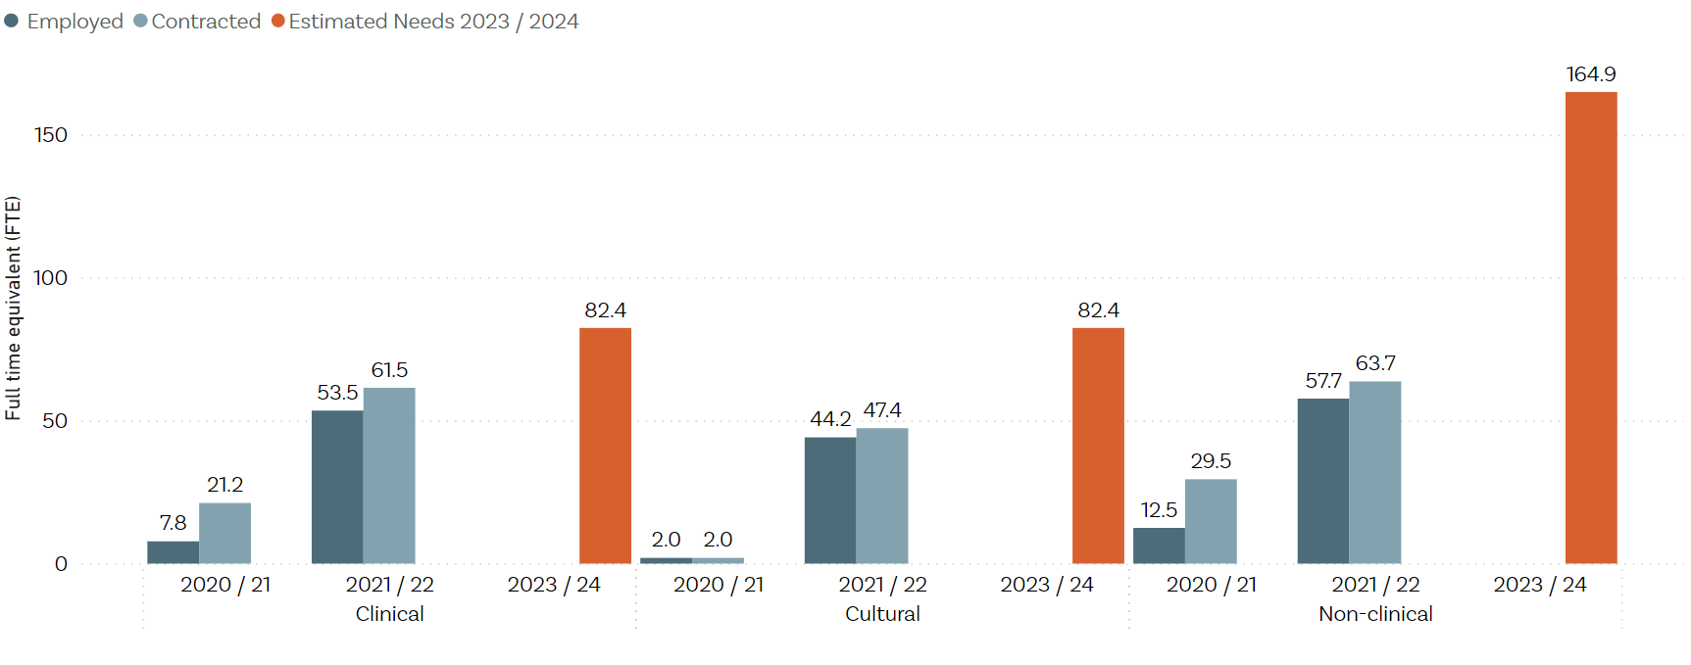
Targeted workforce development programmes for Kaupapa Māori, Pacific, and Youth services began during 2021 / 22. For each of the programmes, the workforce development centre works with each of the providers to identify and understand their workforce needs, develop a specific workforce development plan for their staff and service, and then link the staff to relevant training and support aligned with their needs. They also look across the programme to identify where there are gaps in the training and support available and then can either develop training to meet needs or work with Te Whatu Ora to look at what other options are available.

Pacific services

Evaluation progress in Pacific services
Manatū Hauora allocated funding of almost $25 million for services for Pacific peoples over four years. By 30 June 2024, Manatū Hauora expects the value of funded Pacific services to be $14.2 million a year, which represents 8% (see Table 7 in Appendix one) of the total annual $177.5 million Access and Choice service funding shown in Table 6 in Appendix one.
Funding committed has increased only slightly from 37% last year to 40%, as of 30 June 2022 for the 2021 / 22 year. The cumulative underspend from 2019 / 20 to 2021 / 22 is $4.219 million. However, funding committed for 2022 / 23 has increased to $10 million, 71% of the way towards the indicative funding allocation of $14.2 million per year from 2023 / 24. Therefore, the establishment of the Pacific services has been slow over the first three years but there appear to be plans in place to catch up in 2022 / 23.
Figure 8: Funding committed and allocated for Pacific services as of 30 June 2022
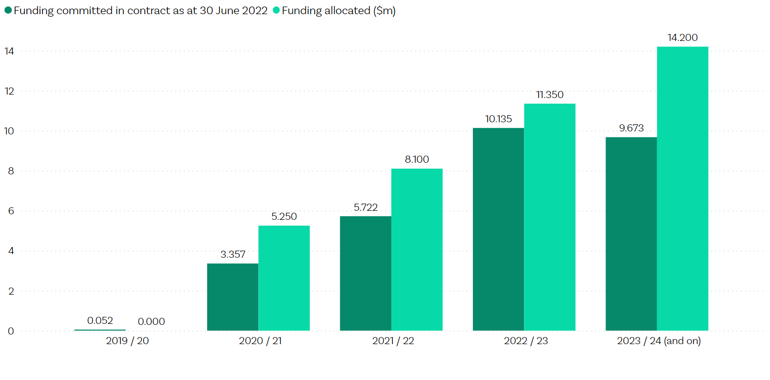

No additional Pacific services have been contracted in the last year, but existing services have grown
There has been no change in the number of service providers or districts offering Pacific services since last year’s report - there are 9 services contracted across 7 districts. Manatū Hauora has intentionally established services in the areas with the highest Pacific populations and does not intend to commission Pacific services in every district.
However, the intention is to contract services in the Hawke’s Bay and Southern districts where there are growing Pacific populations. Although Manatū Hauora issued requests for proposals in these districts in June 2020, it advises that there were no viable Pacific providers in these districts at that time. Te Whatu Ora has advised it is assisting with the development of Pacific providers in these areas.
Te Whatu Ora has also advised that there is unlikely to be another procurement process for Pacific services.

People seen and sessions delivered
From 1 July 2021 to 30 June 2022, Pacific services delivered 21,394 sessions and saw 5,829 new people. The trend across the year for both the sessions delivered, and new people seen is variable, as Figure 9 shows.
From the demographic information captured for 5,829 ‘new people seen’ we know that 30% of people using the services in the last year were children and young people aged 0 – 24 years. Of this group, 26% were youth aged 12–24 years.
Figure 9: Pacific service activity – new people seen, and sessions delivered by month, 2021 / 22
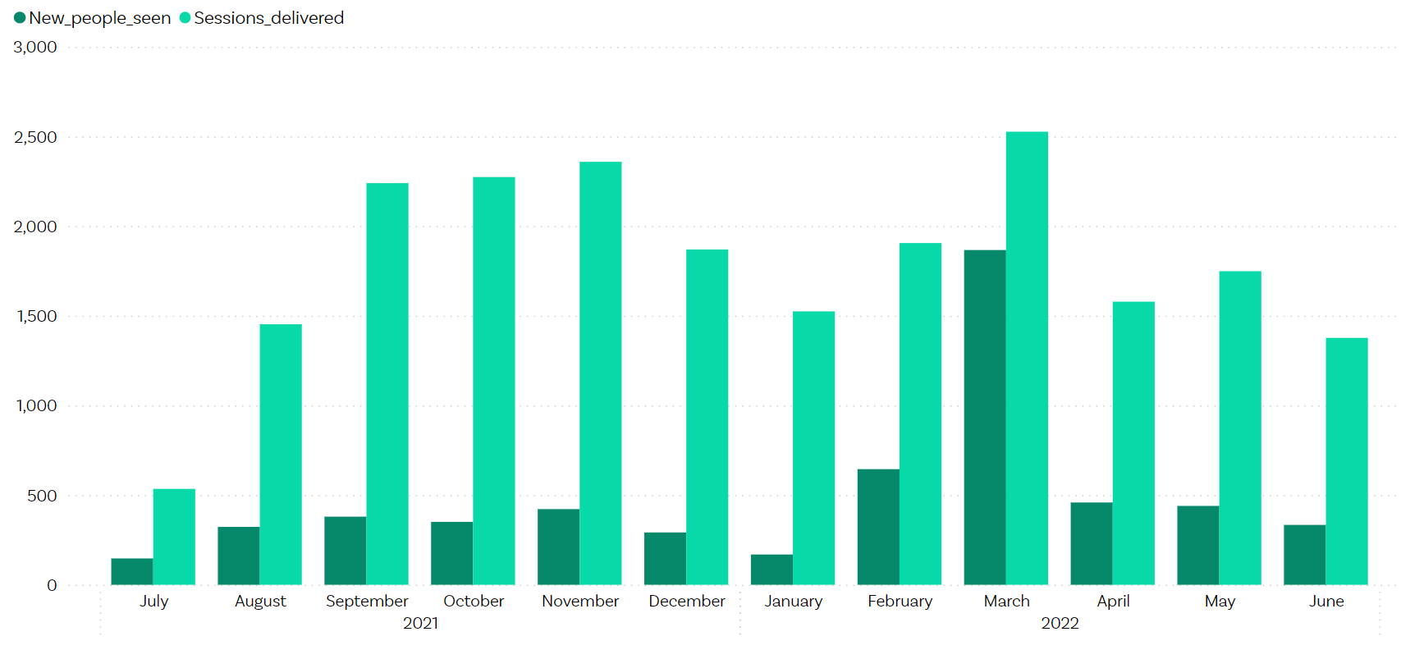

Workforce recruitment is a challenge
At the end of the 2021/22 year, there was a large gap between the number of staff contracted and the number of staff employed, with 50% of contracted FTEs employed as of 30 June 2022, down from 56% as of 30 June 2021. The proportion of people employed had increased to 80% during 2021 / 22, however contractual increases in May and June 2022 have reduced the proportion.
By 30 June 2022, there were:
- 11.5 contracted and 1.0 employed cultural FTE (contracted cultural FTE increased from 1 to 5 in May, then 11.5 in June) – 0.5 additional fulltime staff employed since 30 June 2021
- 32.4 contracted FTE and 18.0 (56%) employed clinical FTE – 7 additional fulltime staff
- 32.5 contracted and 19.3 (59%) employed non-clinical FTE– 5 additional fulltime staff (see Figure 10).
Figure 10: Pacific workforce employed, contracted, and estimated needs as of 30 June 2022
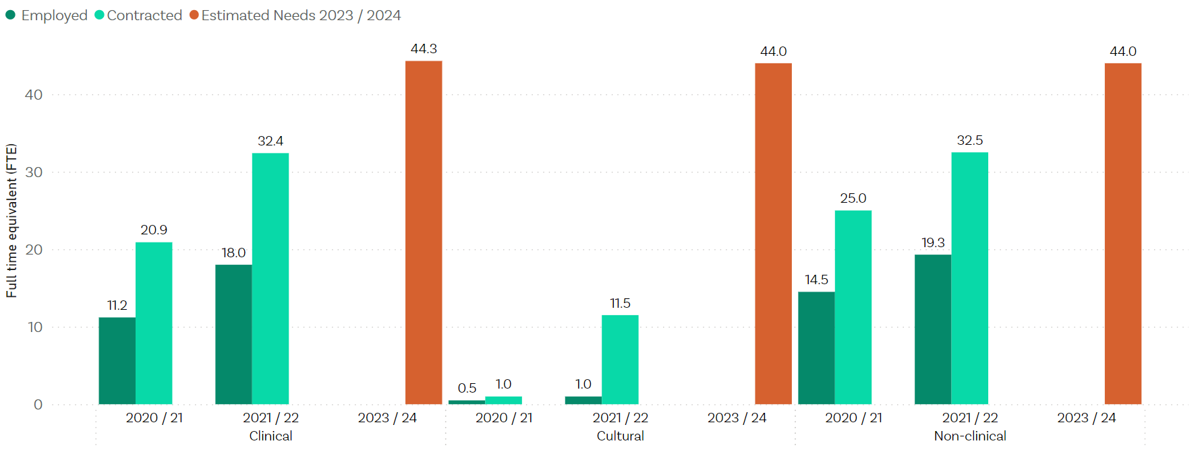
The Pacific services workforce gaps should not be ignored. Monitoring is needed to see whether more active support is required across the sector.

Youth services

Insights into progress of Youth services
For further insight into the progress of Youth services in the last year, see our adjunct report Improving access and choice for youth. That report builds on this main report to explore how well the Access and Choice programme is increasing access to services for youth between 12 and 24 years.

The rollout of the new Youth services funding is on track
Manatū Hauora allocated funding of $66.5 million for services for youth aged 12-24 years over four years. By 30 June 2024, Manatū Hauora expects the value of funded Youth services to be $26.6 million each year, which represents 15% (see Table 7 in Appendix one) of the total annual $177.5 million Access and Choice service funding shown in Table 6 in Appendix one.
Funding committed as of 30 June 2022 is 67% of the way towards the indicative funding allocation of $26.6 million each year from 2023 / 24 (see figure 11), compared with 19% as of 30 June 2021. The annual allocation for 2022 / 23 is fully committed.
Figure 11: Funding committed and allocated for Youth services as of 30 June 2022
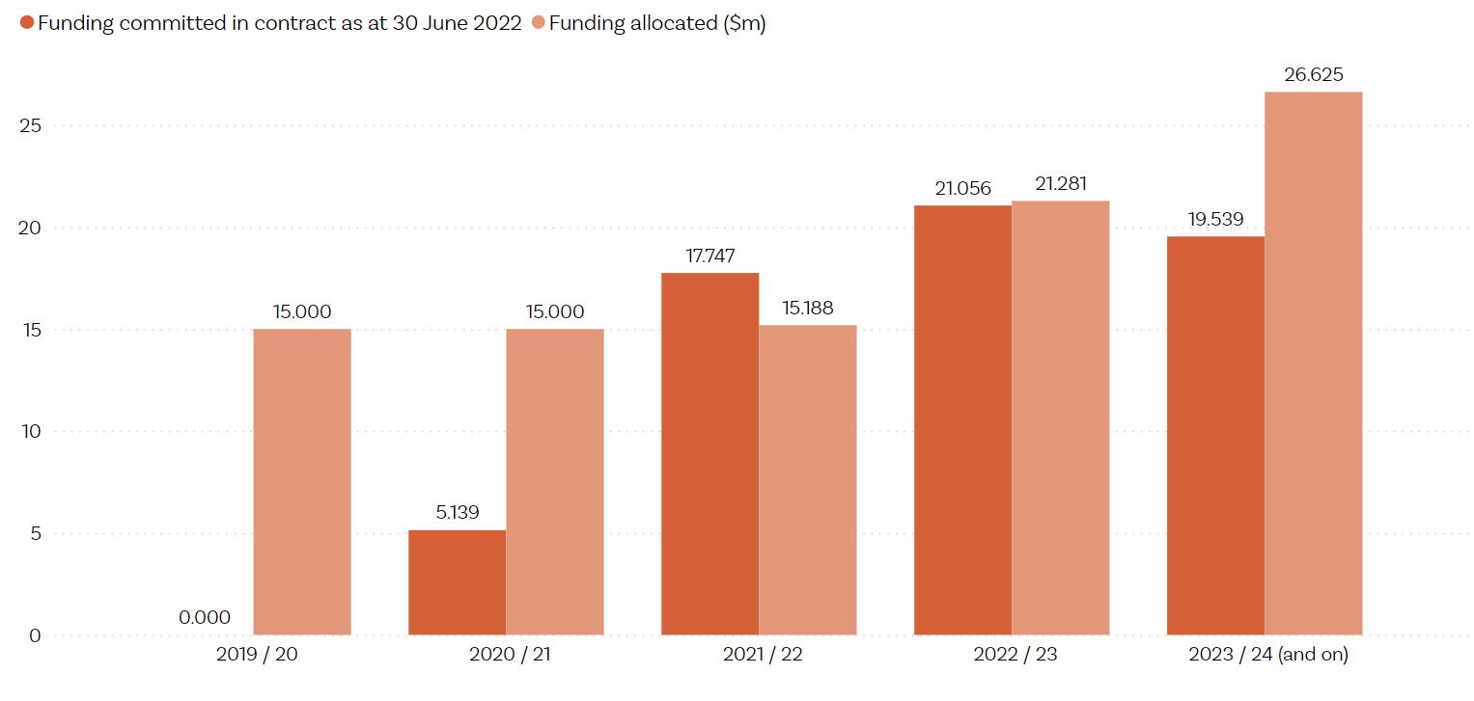

Twenty-three Youth services have been contracted across eighteen districts
Youth primary mental health and addiction services were commissioned in two phases. The first phase in 2020 resulted in 17 new services and the second phase involved a procurement for services in August 2021. As of 30 June 2022, 23 Youth services have been contracted across 18 districts, including the expansion of the national Youthline helpline and two multi-regional Rainbow youth services. Contract negotiation is underway in the remaining two districts, Tairāwhiti and Nelson Marlborough.
Thirteen of the services are fully established (operational with at least 80% of staff recruited), six services are partially established (service not yet fully operational), and four services are in the establishment phase (contract signed but service delivery yet to begin). Overall, this early stage of establishment is reflected in the workforce trends, with recruitment still under way (see Figure 13, and we would expect service activity (see Figure 12) to trend upwards in the coming year.

Young people seen and sessions delivered
From 1 July 2021 to 30 June 2022, Youth services delivered 26,835 sessions and saw 4,535 new people, of whom 4,265 were between the ages of 12 and 24 years. Both the sessions delivered, and young people seen were trending upwards across the year, in line with the increased number of people being employed to roles over time. Services delivered 3,270 sessions and saw 693 new young people in the month of June 2022. On average, Youth services delivered six sessions per new person, which is much higher than the average number of sessions per new person seen for the other three services.
Figure 12: Youth service activity – new people seen and sessions delivered by month, 2021 / 22
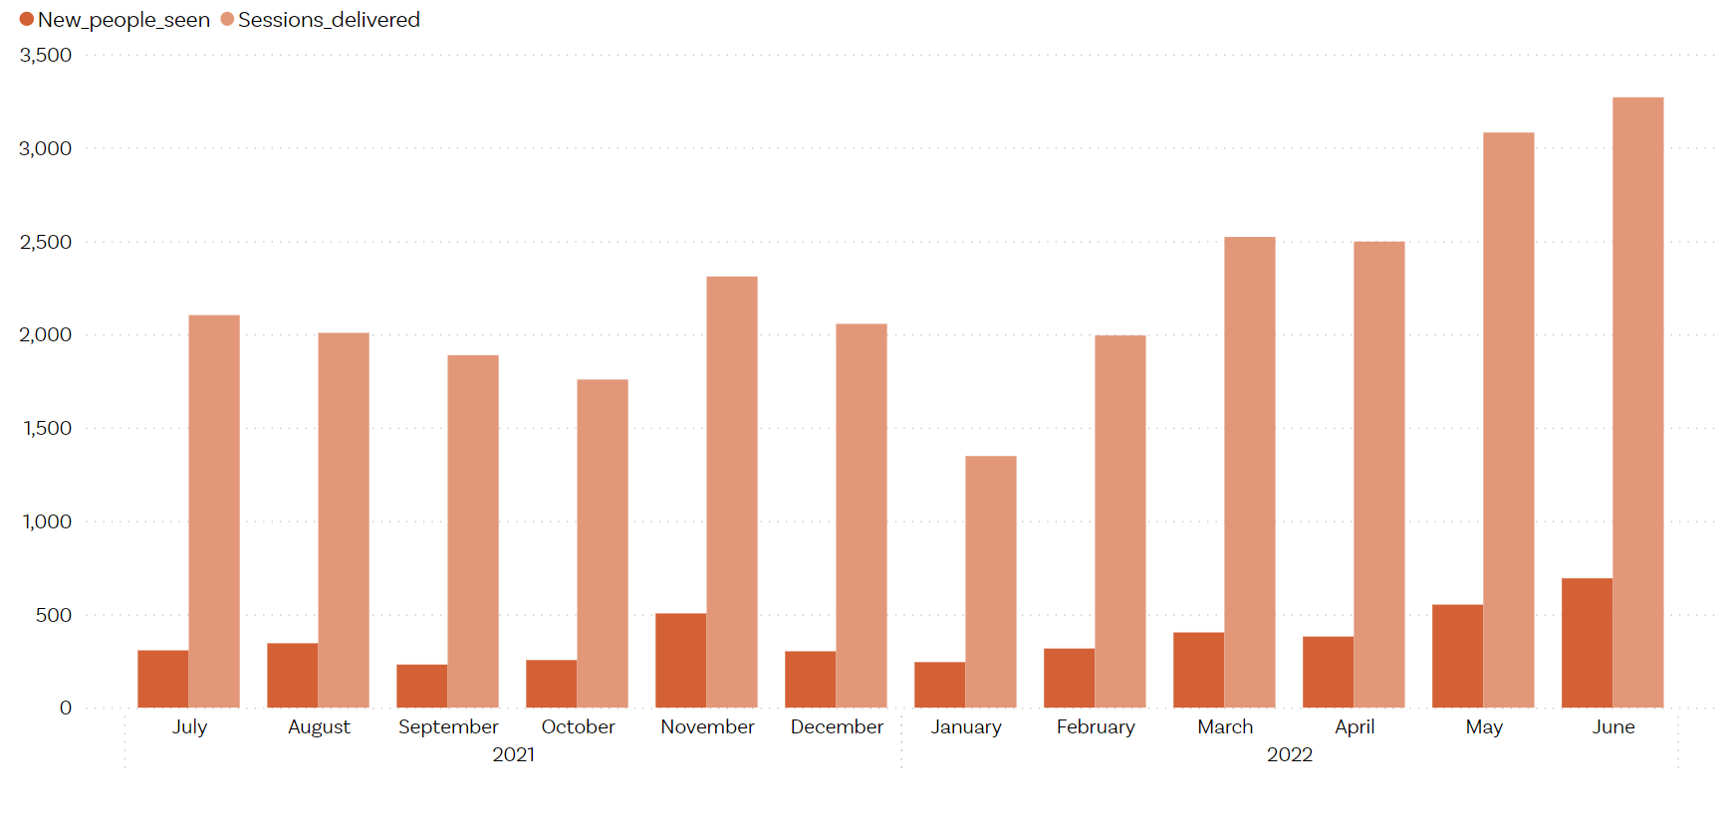
From the demographic information captured for the 4,535 ‘new people seen’, we know that 35% were rangatahi Māori, 5% Pacific peoples, 3% Asian, and 53% were other ethnicities, while ethnicity wasn’t provided or missing for 4%. It is encouraging to see the high percentage of rangatahi Māori accessing the services but disappointing that Pacific youth have relatively low access. We assume the Pacific numbers are likely to be understated due to the prioritised ethnicity reporting which will count a person of both Māori and Pacific ethnicity as Māori.

The recruitment of the workforce remains challenging
The proportion of people employed had increased to 80% of the contracted FTE during 2021 / 2022. However, contractual FTE increases in April 2022 have reduced the proportion to 71%.
By 30 June 2022, there were:
- 87.6 contracted and 62.5 (71%) employed clinical FTE – 37 additional fulltime staff employed since 30 June 2021
- 54.4 contracted and 38.0 (70%) employed non-clinical FTE – 19.4 additional fulltime staff.
Figure 13: Youth workforce employed, contracted, and estimated needs as of 30 June 2022
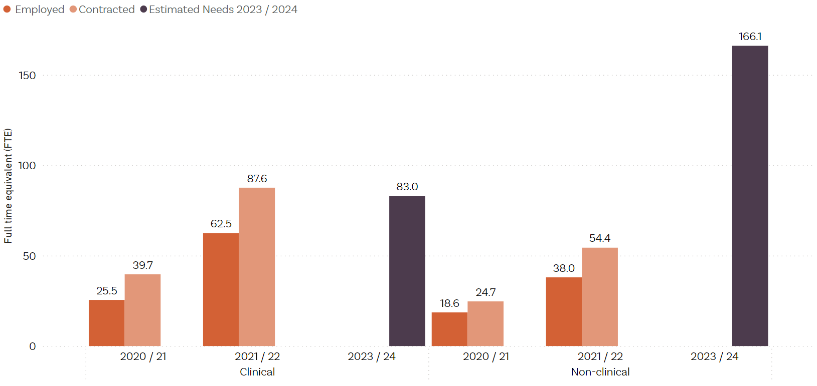

Workforce development

Workforce development delivered by 30 June 2022
Funding committed for workforce development of $17 million is behind the intended allocation of $22.3 million for 2021 / 22. Table 2 shows the investment each year and amounts contracted for the three priority areas.
Given the recruitment challenges for services and the significant need for new workforce, it is a concern that workforce development continues to be underspent each year of the programme, totalling to an underspend of $15.5 million across 2019 / 20 to 2021 / 22. Te Whatu Ora has advised that, in general, funding that was underspent has been transferred to future years for workforce development initiatives.
Almost $14.5 million has been committed to ‘Develop new workforces’ over the first three years of the programme. However, we question to what degree the new workforce funding is helping expand the workforce. A very high proportion (94%) of the HIPs appointed to IPMHA services are existing health workforce, and over two-thirds (69%) of health coaches worked in health care before undertaking health coach training.
The recent change that will allow credentialled counsellors into the mental health and addiction workforce is a positive step forward in growing workforce capacity (Little, 2022). Other workforce development initiatives are also aimed at growing the workforce across the sector through additional nursing, social work, occupational therapy, and clinical psychology places (see Table 3). We acknowledge these positive steps but note it will be a significant stretch if all services are to recruit the workforce estimated to be required over the next two years.

Table 2: Comparison of funding allocation, and funding committed, as of 30 June 2022
Workforce development  ($ millions) | 2019 / 20 | 2020 / 21 | 2021 / 22 | 2022 / 23 | 4-year  totals | 2023 / 24  and ongoing | 5-year  totals
Funding allocated: | 13.888 | 18.186 | 22.330 | 22.664 | 77.067 | 22.664 | 99.731
Funding committed:
Grow existing workforces | 2.853 | 3.378 | 5.416 | 4.002 | 15.649
Upskill / transform  existing workforces | 1.646 | 5.288 | 5.963 | 13.351 | 26.247
Develop new workforces | 5.094 | 3.725 | 5.595 | 2.916 | 17.330
Total committed | 9.593 | 12.390 | 16.974 | 20.269 | 59.226
Note that funding for 2022 / 23 does not represent a full financial year’s funding commitment. Further funding will be committed during the year because contracts for psychology intern places are annual. Contracts for intern placements in 2023 will be finalised by the end of 2022.
Table 3 shows details of the total investment and the programme components for each of the three priority areas to 30 June 2022.

Table 3: Progress to date on workforce development as of 30 June 2022
Programme | Workforce investment / initiatives to 30 June 2022 | Delivery partners
Grow existing workforces | $11.647 million
Additional New Entry to Specialist Practice places each year for nurses, social workers, and occupational therapists to practise in mental health and addiction | 2020: 98  2021: 103  2022: 126 | Te Pou coordinating across a range of education providers
Additional clinical psychology internships each year | 2020: 8  2021: 8  2022: 16 | Districts and non-governmental organisations that offer intern placements
New bursaries for Māori students pursuing a career in mental health and addiction through Te Rau Puawai programme at Massey University | 2020: 46  2021: 46  2022: 70 | Massey University
Scholarships for Pacific students pursuing a career in mental health and addiction through Le Va Futures that Work scholarships | 2019: 7  2020: 30  2021: 30  2022: 65 | Le Va
New national Nurse Practitioner Training Programme that aims to increase the currently low numbers of nurse practitioners specialising in mental health and addiction over time, and to lift the ability of all nurse practitioners to respond to mental health and addiction needs | 2020: 12 places  2021: 50 places  2022: 50 places | University of Auckland in partnership with Victoria University of Wellington and University of Otago
Scholarships to grow the number of Muslim practitioner students | TBA | New programme under development. In 2022, scholarships will be offered to Canterbury students
Psychiatry Interest Forum to support growth of Aotearoa-trained psychiatrists (focus on Māori and Pacific peoples) | No targets – agreed monitoring and interest activities
Mental Health and Addiction Nursing campaign | Campaign live
Upskill / transform existing workforces | $12.896 million
New training places for mental health practitioners to upskill with post-graduate training in Cognitive Behavioural Therapy; core skills for specialist practice in infant, child, and adolescent mental health and addiction; and assessment and management of co-existing substance use and mental health | 2020: 52  2021: 71  2022: 301 | Te Pou coordinating across a range of education providers
New places for primary care nurses to achieve credentials in mental health and addiction | 2020: 130  2021: 200  2022: 230 | College of Mental Health Nurses in partnership with Te Pou
New places per year for Māori and Pacific cultural competence training | 2020: 450  2021: 650  2022: 950 | Te Rau Ora  Le Va
A new programme to support nurse practitioners and enrolled nurses with a substantive mental health and addiction role into employment with health providers | 2020: 18–27 places  2021: 18–27 places  2022: 18–27 places | University of Auckland
Training to support the mental health and addiction workforce to better respond to the needs of Rainbow communities | From 2021 / 22: 450 training hours per year | InsideOUT
Expanding mental health and addiction literacy training available to cross-sector workforces and communities with the expansion of Mental Health 101 (MH101) and Addiction 101 (A101) training programmes | 80 additional MH101 workshops per year  80 additional A101 workshops per year | Blueprint
Pae Tata Pae Tawhiti mātauranga Māori-centred early and brief intervention framework | From 2022 / 23: 120
Puāwai4Kaimahi (P4K) kaimahi support programmes of educator-led modules and post-module follow-up sessions starting 2022 / 23 financial year | From 2022 / 23: 112
Mental Health and Addiction Education Modules for Community Pharmacy | 2021: 5 modules developed
Targeted Workforce Development Programmes for Budget19 Youth, Kaupapa Māori, and Pacific primary mental health and addiction services | 2021 and 2022: 3 support programmes via workforce development centres | Whāraurau – Youth services  Le Va – Pacific services  Te Rau Ora – Kaupapa Māori services
Develop new workforces | $14.414 million
Health Improvement Practitioner (HIP) and health coach training:  Te Pou has been leading HIP training since February 2020 and co-ordinates the delivery of health coach training. The health coach training programmes are delivered through two training providers, Tāmaki Health and Health Literacy NZ, in cohorts of 10 –12 people. HIP training is delivered by experienced HIPs who have undergone ‘train the trainer’ training.  In addition to establishing HIP and health coach training, funding is also provided for supervision and mentoring for these new workforces within general practice settings through new ‘clinical lead’ roles.  This programme of work also includes work to develop training modules for support workers who are working in primary care settings including IPMHA services | Number that started training during the year:  2020: 252  2021: 358  2022: 167 (partial year to June) | Te Pou  Health Literacy NZ  Tāmaki Health  Primary Health Organisations
Feasibility Report Psychology Asst | Report only
Support for counselling mental health and addiction accreditation process and membership management | 2 x counselling associations
We have requested more detailed information on workforce development funding commitments
In last year’s report, we advised that we had requested more detailed information on the workforce development funding commitments. At that time, Manatū Hauora advised it was not able to provide a detailed financial breakdown of the workforce development investment due to its focus on the COVID-19 response during late August and September 2021. Manatū Hauora also informed us some of the information is commercially sensitive so there were additional steps to be undertaken before determining whether these data could be released.
We requested the investment by programme initiative, by year for this report. However, to date we have only received summary financial information of the total spend for the workforce development programme and the three priority areas. This is an area that the mental health and addiction sector has expressed a strong interest in, and we hope to receive, and publish, this information early in 2023.

Enablers

Enablers have an allocation of $48 million dollars to support the programme
The Access and Choice programme includes $48 million that has been allocated over five years to enablers that are crucial for effective delivery of the programme. These include co-design with communities, implementation support, and reporting and monitoring systems. Enablers also include the tools and resources needed to roll out services as well as evaluations to assess the effectiveness of the programme and interventions.
The information on allocated in Table 4 reflects the original Budget 2019 funding allocation. This does not take in to account any funding transfers across financial years or between appropriations approved through Baseline Update processes or reprioritisation of funding directed by Ministers. For this reason, there may be variances between the original funding allocation figures and the funding committed in contract.

Table 4: Comparison of funding allocated, and funding committed, as of 30 June 2022
Enablers ($ millions) | 2019 / 20 | 2020 / 21 | 2021 / 22 | 2022 / 23 | 4-year totals | 2023 / 24 and ongoing | 5-year totals
Funding allocated | 9.250 | 8.250 | 10.050 | 11.550 | 39.100 | 9.050 | 48.150
Funding committed as of 30 June 2022 | 2.511 | 5.962 | 9.717 | 5.550 | 23.739

The funding for Access and Choice enablers covers programmes both within and external to Manatū Hauora
While enabler funding available in the 2019 / 20 and 2020 / 21 years was significantly underspent, 2021 / 22 is fully committed. Further investment is underway which is expected to result in further funding being committed in 2022 / 23. Table 5 shows the funding commitments across different enabler groups within Manatū Hauora and within the wider sector.

Table 5: Breakdown of funding commitments across different enablers as of 30 June 2022
Funding committed ($ millions) as of 30 June 2022 | 2019/20 | 2020/21 | 2021/22 | 2022/23 | 4-year totals
Within Manatū Hauora:
Uplift implementation capacity | 1.750 | 1.750 | 2.050 | 2.050 | 7.600
Evaluation | 0.050 | 0.249 | 0.400 | 0.180 | 0.879
Data and reporting | - | 0.192 | 0.150 | 0.259 | 0.600
Subtotal | 1.800 | 2.191 | 2.600 | 2.489 | 9.079
Within the wider sector:
Shared learning / leadership development, implementation supports, and hui | 0.711 | 0.772 | 0.872 | 0.388 | 2.743
District co-design and implementation support | - | 3.000 | 6.245 | 2.672 | 11.917
Subtotal | 0.711 | 3.772 | 7.117 | 3.061 | 14.660
Total | 2.511 | 5.962 | 9.717 | 5.550 | 23.739

Further investment into programme enablers includes data and reporting, implementation supports and collaborative design support
Within Manatū Hauora, $259,000 of enablers funding has been committed in 2022 / 23 to develop a portal for improved data collection and reporting for IPMHA service providers that cannot easily connect to general practice management systems, and Kaupapa Māori, Pacific, and Youth services.
Within the wider sector, a further $230,000 has been committed in 2021 / 22 for national implementation support (under collective governance) and $2.672 million has been committed to continue implementation support and collaborative design into 2022 / 23.

Ngā puna kōrero | References
Department of the Prime Minister and Cabinet. 2021. Implementation Unit: Mid-term Review of the 2019 Mental Health Package. Wellington: Department of the Prime Minister and Cabinet.
Government Inquiry into Mental Health and Addiction. 2018. He Ara Oranga: Report of the Government Inquiry into Mental Health and Addiction. New Zealand: Government Inquiry into Mental Health and Addiction.
Little, Hon A. 2022, 29 July. More counsellors to boost mental health workforce. Beehive.govt.nz. www.beehive.govt.nz/release/more-counsellors-boost-mental-health-workforce (accessed 17 November 2022).
Mental Health and Wellbeing Commission Act 2020.
Manatū Hauora. 2022a. Interim Government Policy Statement on Health 2022–2024. Wellington: Manatū Hauora.
Manatū Hauora. 2022b. Quarterly Mental Health Report to Cabinet Priorities Committee Quarter 3 2021/22. www.health.govt.nz/system/files/documents/information-release/b19-mental-wellbeing-package-quarterly-cpc-report-quarter-3-2021-22_.pdf (accessed 17 November 2022).
Te Hiringa Mahara. 2021. Access and Choice Programme: Report on the first two years. Te Hōtaka mō Ngā Whai Wāhitanga me Ngā Kōwhiringa: He purongo mō te rua tau tuatahi. Wellington: Te Hiringa Mahara.
Te Pou. 2022. Integrated primary mental health and addiction workforce: Profile May 2022. www.tepou.co.nz/resources/integrated-primary-mental-health-and-addiction-workforce-report (accessed 24 November 2022).

Appendix one: Overview of the Access and Choice programme

Programme investment covers three core components delivered over a five-year period between 2019 / 20 and 2023 / 24
Investment covers the following:
- service delivery: $516.4 million to support four new national services that provide a ‘first point of contact’ for people with mild to moderate levels of need
- workforce development: $99.7 million to grow and upskill existing workforces, and build new and emerging workforces
- enablers: $48.2 million for system enablers, including engagement and collaborative design, IT infrastructure, evaluation, implementation support, and the Ministry’s capacity and capability.
Table 6 shows the investment over five years.

Table 6: Budget 2019 – Expanding Access and Choice of Primary Mental Health and Addiction Support funding, 2019 / 20 to 2023 / 24 and ongoing
Funding stream  ($ millions) | 2019 / 20 | 2020 / 21 | 2021 / 22 | 2022 / 23 | 4-year  totals | 2023 / 24  / ongoing | 5-year  totals
Service delivery | 25.000 | 70.781 | 101.250 | 141.875 | 338.906 | 177.500 | 516.406
Workforce  development | 13.888 | 18.186 | 22.330 | 22.664 | 77.068 | 22.664 | 99.732
Enablers | 9.250 | 8.250 | 10.050 | 11.550 | 39.100 | 9.050 | 48.150
Annual totals | 48.138 | 97.217 | 133.630 | 176.089 | 455.074 | 209.214 | 664.288
The $209.214 million of funding allocated in 2023 / 24 is intended to be sustained into the future beyond 2024 to support these new services. The assumptions in Table 7 were used to calculate the funding envelope and inform the phasing of the funding for the Access and Choice programme.

Table 7: Access and Choice programme assumptions
Assumptions
Total estimated population | 5,000,000 people
Expected uptake (% of total population) | 6.5%
Expected uptake (number of people) | 325,000 people
Low levels of support | $300 to provide
% of target population expected to uptake low | 50% of people using the services
Medium levels of support | $500 to provide
% of target population expected to uptake medium | 30% of people using the services
Higher levels of support | $1,000 to provide
% of target population expected to uptake high | 20% of people using the services
Indicative allocation of ongoing service delivery funding from the end of 2023 / 24:
Māori | 20% of funding
Pacific | 8% of funding
Young people | 15% of funding
Population | 57% of funding
The assumptions about expected uptake and increasing population coverage by 30 June 2024 (up to 325,000 people seen each year) were used to calculate how much funding was needed, and how the funding should be allocated by year. They relate to the whole five-year programme and were not used to plan service implementation or to determine yearly targets.

There has been significant investment in the workforce
Most of the service funding will be used for growing the workforce needed to provide the services. The original Budget 2019 modelling estimated that approximately 1,600 FTE would be needed by 2023 / 24 to deliver these new services. Manatū Hauora assumed that 25 FTE would be required to provide support for every 5,000 people accessing the services. This number was reached by estimating how many sessions each FTE could provide to people needing low, medium, and higher levels of support to ensure the estimated 325,000 people could access the services.
As the service model has rolled out, assumptions have been revised to allow for local variation in the ratio of registered to non-registered workforce. It is now estimated that 611 clinical FTE, 889 non-clinical FTE, and 126 senior cultural FTE (1,626 total FTE) will be required by 30 June 2024.

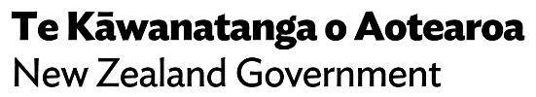

Please refer to paragraph 37, Table 2: Delivery status of components within Expanding of Access and Choice.
We invited Māori and Pacific lived experience networks to participate but, due to the timing of this project, they were unable to participate.
At the beginning of focus groups, we described the range of services that are part of the Access and Choice programme.
Many people who provided feedback on He Ara Āwhina allowed us to use their information for other relevant mahi (work).
Unique people refers to individuals that are only counted once as service users in a 12-month period, even if they use the services a number of times during that period.
Ethnicity is self-perceived; people can identify with more than one ethnic group and change their affiliations over time. ‘Prioritised ethnicity’ means that people have been allocated to a single ethnic group in an order of priority, even if they identify with more than one ethnicity. For example, if someone identifies as Māori and Tongan, they are reported as Māori only. For more detail, see www.health.govt.nz/publication/hiso-100012017-ethnicity-data-protocols.
‘In contract’ means a signed contract was in place by 30 June 2022 and contract funding is included in funding commitments.
For a summary of what IPMHA services are, see our 2021 Access and Choice programme report (Te Hiringa Mahara, 2021).
The data on enrolled population coverage were provided by Te Whatu Ora and are based on funding DHB. The Auckland Collaborative is responsible for the rollout across Auckland, Waitemata, and Counties districts – these districts are combined because Auckland DHB is funding a large number of Waitematā practices.
For 1% of sessions delivered, the worker type was not recorded.
For a summary of what Kaupapa Māori Access and Choice services are, see our 2021 Access and Choice programme report (Te Hiringa Mahara, 2021).
'New people seen' counts people uniquely in a rolling 12-month period and can be meaningfully added for up to twelve consecutive months. Data for new people seen are considered reasonably accurate from November 2021 onwards.
Based on December 2021 estimated resident population sourced from StatsNZ infoshare 16 October 2022.
For a summary of what Pacific Access and Choice services are, see 2021 Access and Choice programme report (Te Hiringa Mahara, 2021).
For a summary of what Youth Access and Choice services are, see our 2021 Access and Choice programme report (Te Hiringa Mahara, 2021).
Funding is shown for financial year. Targets such as places are by calendar year, unless otherwise stated.
www.massey.ac.nz/student-life/m%C4%81ori-at-massey/he-ringa-%C4%81whina-tauira-m%C4%81ori/te-rau-puawai-m%C4%81ori-mental-health-workforce-development-programme/
www.leva.co.nz/training-education/scholarships/
www.tepou.co.nz/initiatives/integrated-primary-mental-health-and-addiction/health-improvement-practitioners-in-new-zealand
www.tepou.co.nz/initiatives/integrated-primary-mental-health-and-addiction/health-coaching
Within Te Whatu Ora from 1 July 2022 onwards.
Further investment is under way, which is expected to result in further funding being committed in 2022 / 23.
General population (including Māori, Pacific peoples, and youth) enrolled in general practices that have IPMHA services.

