Achieving equity of Pacific mental health and wellbeing outcomes

May 2024

**Achieving equity of Pacific mental health and wellbeing outcomes**

A report issued by Te Hiringa Mahara –Mental Health and Wellbeing Commission (Te Hiringa Mahara).

This work is protected by copyright owned by Te Hiringa Mahara-Mental Health and Wellbeing Commission. This copyright material is licensed for re-use under the Creative Commons Attribution 4.0 International License. This means you are free to copy, distribute and adapt the material, if you attribute it to Te Hiringa Mahara – Mental Health and Wellbeing Commission and abide by the other license terms. To view a copy of this license, visit

<https://creativecommons.org/licenses/by/4.0/legalcode>.

Suggested citation:

Te Hiringa Mahara (2024). **Achieving equity of Pacific mental health and wellbeing outcomes.** Wellington: New Zealand

ISBN: 978-1-7385863-6-3 (online version and docx)

Te Hiringa Mahara was set up in February 2021 and works under the Mental Health and Wellbeing Commission Act 2020. Our purpose is to contribute to better and equitable mental health and wellbeing outcomes for people in Aotearoa New Zealand.

For more information, please visit our website: [www.mhwc.govt.nz](http://www.mhwc.govt.nz)

The mission statement in our Strategy is “whakawāteatia e tatou he ara oranga / clearing pathways to wellbeing for all.” Te Hiringa Mahara acknowledges the inequities present in how different communities in Aotearoa experience wellbeing and that we must create the space to welcome change and transformation of the systems that support mental health and wellbeing. Transforming the ways people experience wellbeing can only be realised when the voices of those poorly served communities, including Pacific Peoples, Māori and people with lived experience of distress and addiction, substance harm, or gambling harm, are prioritised.

# Foreword

The health and wellbeing of Pacific peoples in Aotearoa New Zealand is a priority for Te Hiringa Mahara. There is evidence to show that Pacific peoples continue to experience inequities compared to non-Pacific people, and ongoing investment in Pacific peoples is required if we want to see these inequities shift.

Aotearoa is home to more than 380,000 Pacific peoples, with Auckland serving as the Polynesian capital of the world. Our obligations, such as the Treaty of Friendship with Samoa, our Free Association with the Cook Islands and Niue, and citizenship and rights of residence for Cook Islanders, Niueans, and Tokelauans, means we have international and national obligations to Pacific peoples.

We must acknowledge our history with Pacific peoples, such as the Dawn Raids, as contributing factors for why inequities exist. We are hopeful that with significant events, such as the Dawn Raids apology, that there are shifts to acknowledge our past and move forward.

While the best time to invest in the health and wellbeing of Pacific peoples was 30 years ago, the second best time is to invest now. What we need to see is action.

We are concerned about persistent inequities, but we are hopeful that Pacific-led solutions will lead to improved outcomes for Pacific peoples. Through our research and engagement with Pacific peoples, we have seen the strength in Pacific leaders and communities. Guided by Pacific values, such as faith, community and alofa, we want to see Pacific communities being genuinely empowered to lead their own health and wellbeing.

Change is possible, and inequities can improve when we see commitments to address structural issues, such as housing, and pathways created, including education and employment. At the heart of this is enabling Pacific leadership.

We are heartened by the existing local solutions that Pacific communities are leading, and we urge Government to continue investing in, and resourcing Pacific communities to support Pacific-led initiatives.

It is our hope that the strength and potential of Pacific communities will be resourced and realised. We share this report with the intention of demonstrating, once again, that we cannot ignore inequities and we must empower our communities to lead change.

Hayden Wano

Board chair Te Hiringa Maraha | Mental Health and Wellbeing Commission

# Acknowledgements

Te Hiringa Mahara would not have been able to produce this piece of work if not for the many people who contributed their expertise, guidance, and advice.

For that we are particularly indebted to the voices from our talanoa, from the many agencies we engaged with, the community leaders and those representing Pacific health and mental health providers.

Our appreciation, thanks and acknowledgements go to the following providers, as well as the large number of individuals who spoke to us: The Fono, Le Va, Whānau Manaaki Kindergarten, TOA Pacific Inc., Pacific Homecare, Mana Ake, Mapu Maia, and Vaka Tautua. We would also like to acknowledge, Sai Lealea, Dr Jean Mitaera, Christine Nurminen and Shane Simpson for their time and effort in peer-reviewing this report.

# Overall summary

This report brings together insights about Pacific peoples wellbeing in comparison to non-Pacific people using our He Ara Oranga Wellbeing Outcomes Framework and engagement with Pacific communities.

From our insights to date, we call for ongoing investment in improving Pacific mental health by addressing the determinants of wellbeing. These include:

* Pacific peoples spoke to us of an aspiration to thrive and provide a good life for their families and future generations – sometimes referred to as the ‘Pacific dream’.
* Compared to the rest of the population, and between 2018 and 2021, many Pacific peoples are finding Aotearoa less welcoming, less understanding, with less access to the things they need to live well – factors that impact mental health and wellbeing.
* Pacific peoples are finding it harder to connect with people in meaningful ways or talk to someone, especially during times of need and when feeling down or depressed.
* Pacific young people are more recently experiencing decreased belongingness to secondary school, in contrast to previous years.
* Despite these challenges, however, Pacific peoples rate their family wellbeing higher than non-Pacific people.

We heard from Pacific leaders what potential solutions they see to realise the ‘Pacific dream’, to strengthen wellbeing in a meaningful way, and to achieve greater intergenerational wellbeing. For example:

* Education and employment are seen as pathways to future wellbeing, but multiple structural barriers prevent Pacific individuals and communities accessing these.
* Housing and income issues are major structural challenges and, if not addressed, will prevent future wellbeing improvements.
* Addressing the many inequities observed requires unlocking the potential in Pacific communities, Pacific knowledge, and Pacific ways of providing wellbeing.
* Pacific families and communities hold the keys to overcoming the barriers to wellbeing, and Pacific communities are already implementing local solutions, often alongside government, to address many of the interrelated barriers to wellbeing.

# Calls to Action

Effort will be required across the mental health and wellbeing systems to improve outcomes for Pacific peoples.

Addressing determinants will require a collaborative effort with multiple system partners. For example funders, commissioners, decision-makers, agencies, NGOs, and communities working closely together toward a similar goal.

We think all system partners have a role and must be accountable for achieving improved mental health and wellbeing outcomes.

There is an immediate need to:

1. Resource community wrap-around responses that reflect and support a wide range of Pacific families’ aspirations and needs through Pacific community organisations.
2. Make immediate changes to improve income adequacy and provide more suitable and stable housing options.

While investing in the future to:

1. Improve quality and timely Pacific data collection to adequately capture the diversity of mental health status and wellbeing outcomes within Pacific peoples to support system performance.
2. Ensure Pacific providers have the development, data, governance, and administrative support they need to be sustainable, through high-trust and long-term contracting.
3. Build competency in the broader public service to understand and support Pacific peoples, especially where Pacific-focused providers are not available, and where Pacific data is lacking.
4. Seek cross-government / cross-party commitment to taking a public health approach to improving conditions for better mental health – particularly addressing Pacific access to education and employment, to end cycles of disadvantage and encourage cycles of improvement.

Contents

Foreword 3

Acknowledgements 4

Overall summary 5

Calls to Action 6

Purpose 8

He Ara Oranga wellbeing outcomes framework 8

What we did 9

Key Findings 10

Pacific people are experiencing inequities in mental health outcomes 10

The ‘Pacific dream’ is yet to be realised 12

1. Education as a critical pathway to future wellbeing 13

Example: Talanoa Ako (Community programme supporting Pacific learners) 14

2. Meaningful employment and adequate income are required for Pacific people to thrive 14

Example: Tupu Aotearoa (community programme supporting Pacific people into employment) 17

3. There is a positive link between stable housing and better mental health 18

Example: Tupe Wise (building financial literacy and supporting home ownership) 19

Pacific communities and organisations are doing the mahi, but system support is needed 20

Enabling communities to deliver on better wellbeing outcomes works 20

Wrap around support to address wider wellbeing will achieve improved Pacific mental health outcomes 21

By Pacific for Pacific services will deliver better results 23

Devolution and sustainable contracting models work 24

All system partners need better quality and timely Pacific data 25

Appendix 1: He Ara Oranga Framework 26

Appendix 2. Indicators and results 27

Appendix 3. Definitions and notes on the data 31

References 37

# Purpose

The 2018 He Ara Oranga Report of the Government Inquiry into Mental Health and Addiction saw the creation of Te Hiringa Mahara, the Mental Health and Wellbeing Commission in 2021. Core to our role is monitoring and reporting on the status of mental health and wellbeing for the people of Aotearoa and advocating for change where there are disparities and inequities in outcomes.

Pacific peoples are a legislated priority group for Te Hiringa Mahara and we wanted to build on our previous reports highlighting disparities in mental health and wellbeing outcomes for this group, keeping a focus on how Pacific peoples are faring.

The primary purpose of this report is to shine a light on the wellbeing experience of Pacific peoples, and to push for improvement in the mental health and wellbeing systems. To do this we first to assess and monitor factors that contribute to mental health and wellbeing for Pacific peoples and report on them. Secondly, we highlight what works for Pacific organisations at a community level, to support Pacific families to flourish.

# He Ara Oranga wellbeing outcomes framework

Our He Ara Oranga wellbeing outcomes framework is the tool we use to understand and monitor wellbeing in Aotearoa. Te Hiringa Mahara developed the He Ara Oranga framework to measure and monitor population mental health and wellbeing for people with lived experience of mental distress or addiction. It shows how wellbeing will be achieved from both a te ao Māori perspective and a shared perspective (universal wellbeing). For the purposes of monitoring Pacific wellbeing outcomes, we applied the ‘shared perspective’ domains and indicators (see list below).

To develop the framework, we consulted with experts, including people with their own experience of distress or addiction, on what good looks like for their mental health and wellbeing. What they told us is that good mental health and wellbeing is holistic with many capacities contributing to overall mental health and wellbeing. For the ‘shared perspective’ the outcome domains are:

1. Being safe and nurtured – including healthy relationships and safe environments
2. Having what is needed – including the resources for financial security, healthy food, stable homes, lifelong learning, leisure and creativity
3. Having rights and dignity fully realised – including being able to participate in society, free from discrimination
4. Being able to heal, grow, and be resilient – including the skills and support to navigate challenges
5. Being connected and valued – connected to culture, language, beliefs and the environment, and valued regardless of who they are
6. Having hope and purpose – including seeing a positive future, and having the ability to decide how they reach it.

# What we did

This report brings together insights on the status of Pacific people’s mental health and wellbeing through quantitative assessment using our He Ara Oranga wellbeing outcomes framework to understand factors that contribute to wellbeing, with Pacific community and provider engagement.

We conducted analyses for 22 mental health and wellbeing indicators from a potential 31 indicators from our He Ara Oranga ‘shared perspective’ indicator set that were relevant to Pacific peoples. We report on 13 headline indicators in the accompanying infographic ‘*Pacific peoples mental health and wellbeing in Aotearoa’*. It is worth noting that we were limited in our ability to report and monitor on more indicators for Pacific mental health and wellbeing due to data gaps and availability.

We build on the quantitative assessment by drawing upon our engagement with members of different Pacific communities and organisations, to outline the pathways to improved wellbeing identified by Pacific people, and the priorities for action. We highlight a range of Pacific initiatives that are already doing the mahi to support wellbeing, including Talanoa Ako, Tupu Aotearoa, Tupe Wise, and Mana Ake.

* We held 4 group talanoa
* We engaged 12 agencies
* We talked to 7 pacific organisations
* We assessed 22 wellbeing indicators from the ‘shared perspective’ of the He Ara Oranga wellbeing outcomes framework
* We produced an infographic reporting on status of mental health and wellbeing for Pacific people (13 indicators of 22)
* We produced a report synthesising mental health indictor reporting and engagement with Pacific leaders and communities.

# Key Findings

## Pacific people are experiencing inequities in mental health outcomes

As part of our role to monitor the status of mental health for people in Aotearoa we are using a subset of indicators from our He Ara Oranga framework in this section.

The findings below show that Pacific people rate their subjective wellbeing lower than others on indicators closely linked to mental health, including lower ratings for life being worthwhile (81% of Pacific people, in both 2018 and 2021, compared to 86% and 85% for non-Pacific people in the same years) and life satisfaction (77% and 74% in 2018 and 2021 for Pacific people; 81% in both years for non-Pacific people). Within New Zealand, reduced life satisfaction is indicative of experiencing multiple mental health difficulties, including depression, anxiety, and suicidality (1).

Figure 1. Proportion of people reporting (a) life is worthwhile and (b) high life satisfaction.

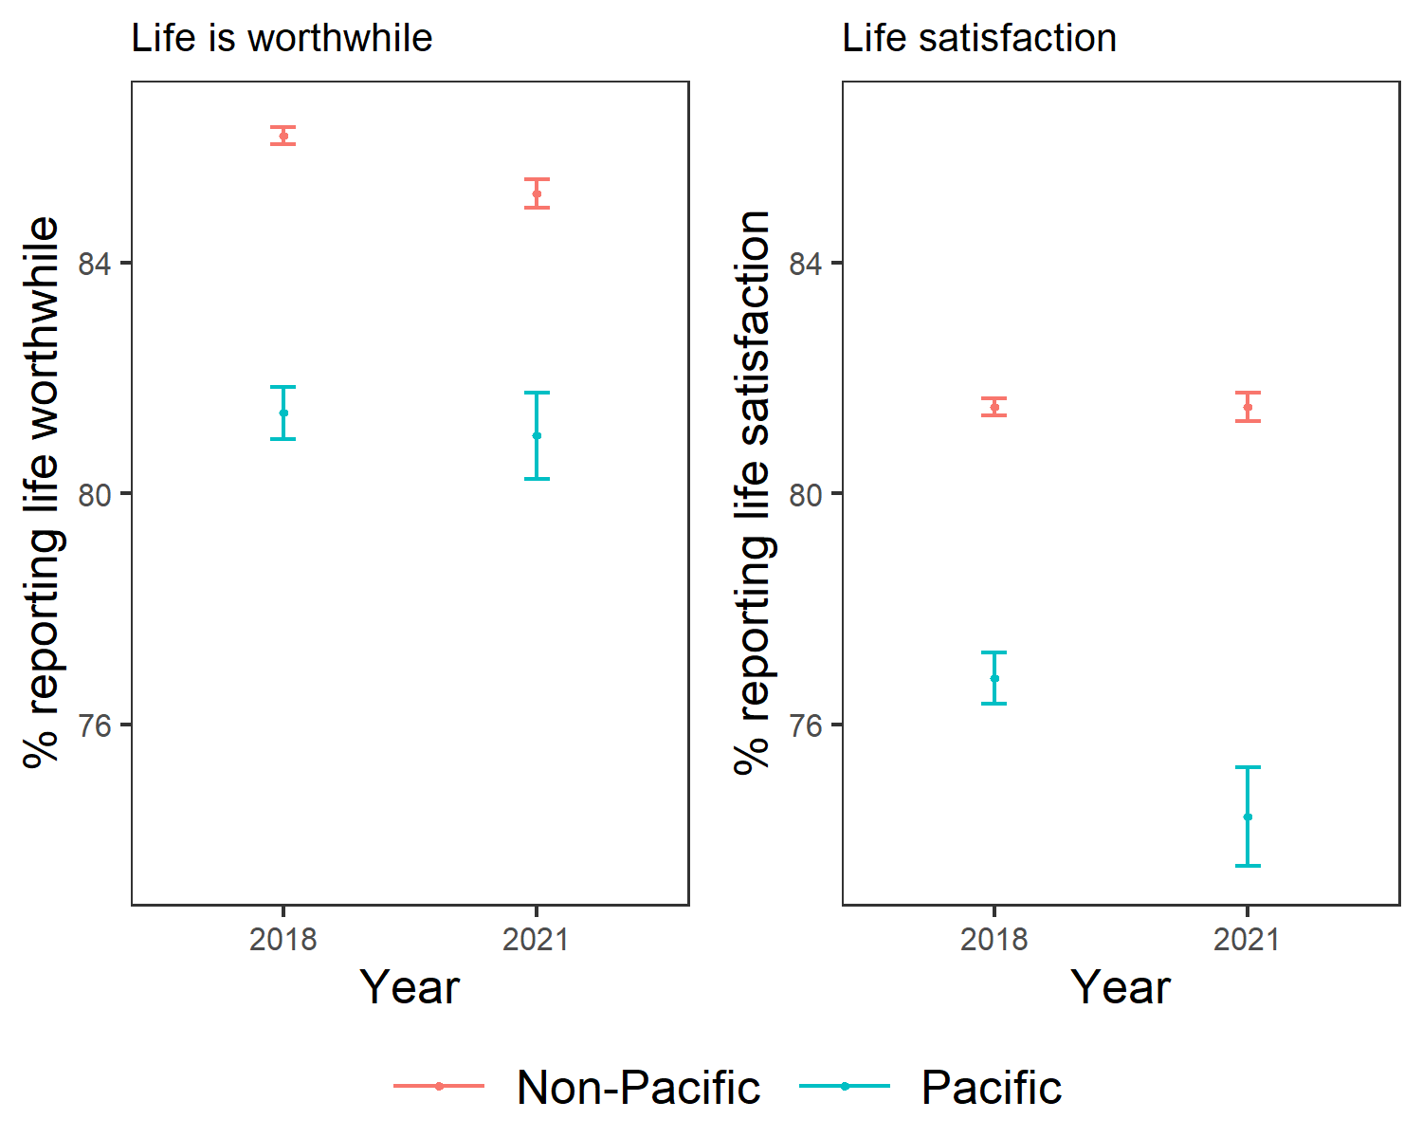

While the number of people in Aotearoa who report positive mental wellbeing has dropped overall (as indicated by respondents who scored 51 or above on the WHO-5) it has dropped more for Pacific peoples (from 78% to 70%, compared to 77% to 71% for non-Pacific people, between 2018 and 2021). Based on prior evidence which states that WHO-5 scores below 51 are indicative of elevated risk for depression, this suggests a disproportionate increase in risk of depression for Pacific peoples between 2018 and 2021 (2).

Figure 2. Proportion of people with positive self-rated mental wellbeing (score at or above 51 on WHO-5)

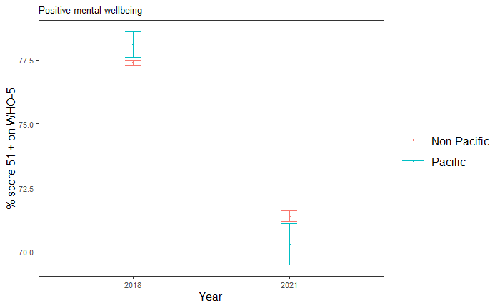

Our analyses also showed that Pacific people are increasingly more likely to report being discriminated against (16% rising to 23% for Pacific peoples, 17% rising to 21% for non-Pacific, between 2018 and 2021), including discrimination on the basis of ethnicity and skin colour (13% rising to 21% for Pacific peoples, 8% rising to 11% for non-Pacific, between 2018 and 2021). This is of concern, given that discrimination impacts subjective wellbeing and exacerbates mental health difficulties(3).

Figure 3. Proportion of people reporting discrimination, and discrimination based on either ethnicity or skin colour

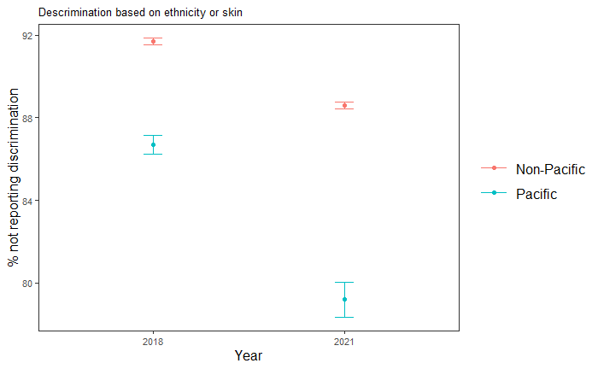

Furthermore, Pacific people’s ability to access peer support has declined, which can be protective against mental health problems (4). This includes reduced face-to-face contact with friends (from 94% to 88% for Pacific peoples, compared to 93% falling to 91% for non-Pacific, between 2018 and 2021); and ability to talk to someone about depression is decreasing (from 64% to 49% for Pacific peoples, and 69% to 63% for non-Pacific people, between 2018 and 2021).

Figure 4. Proportion of people reporting (a) at least some face-to-face contact in four weeks and (b) can easily or very easily talk with someone about depression

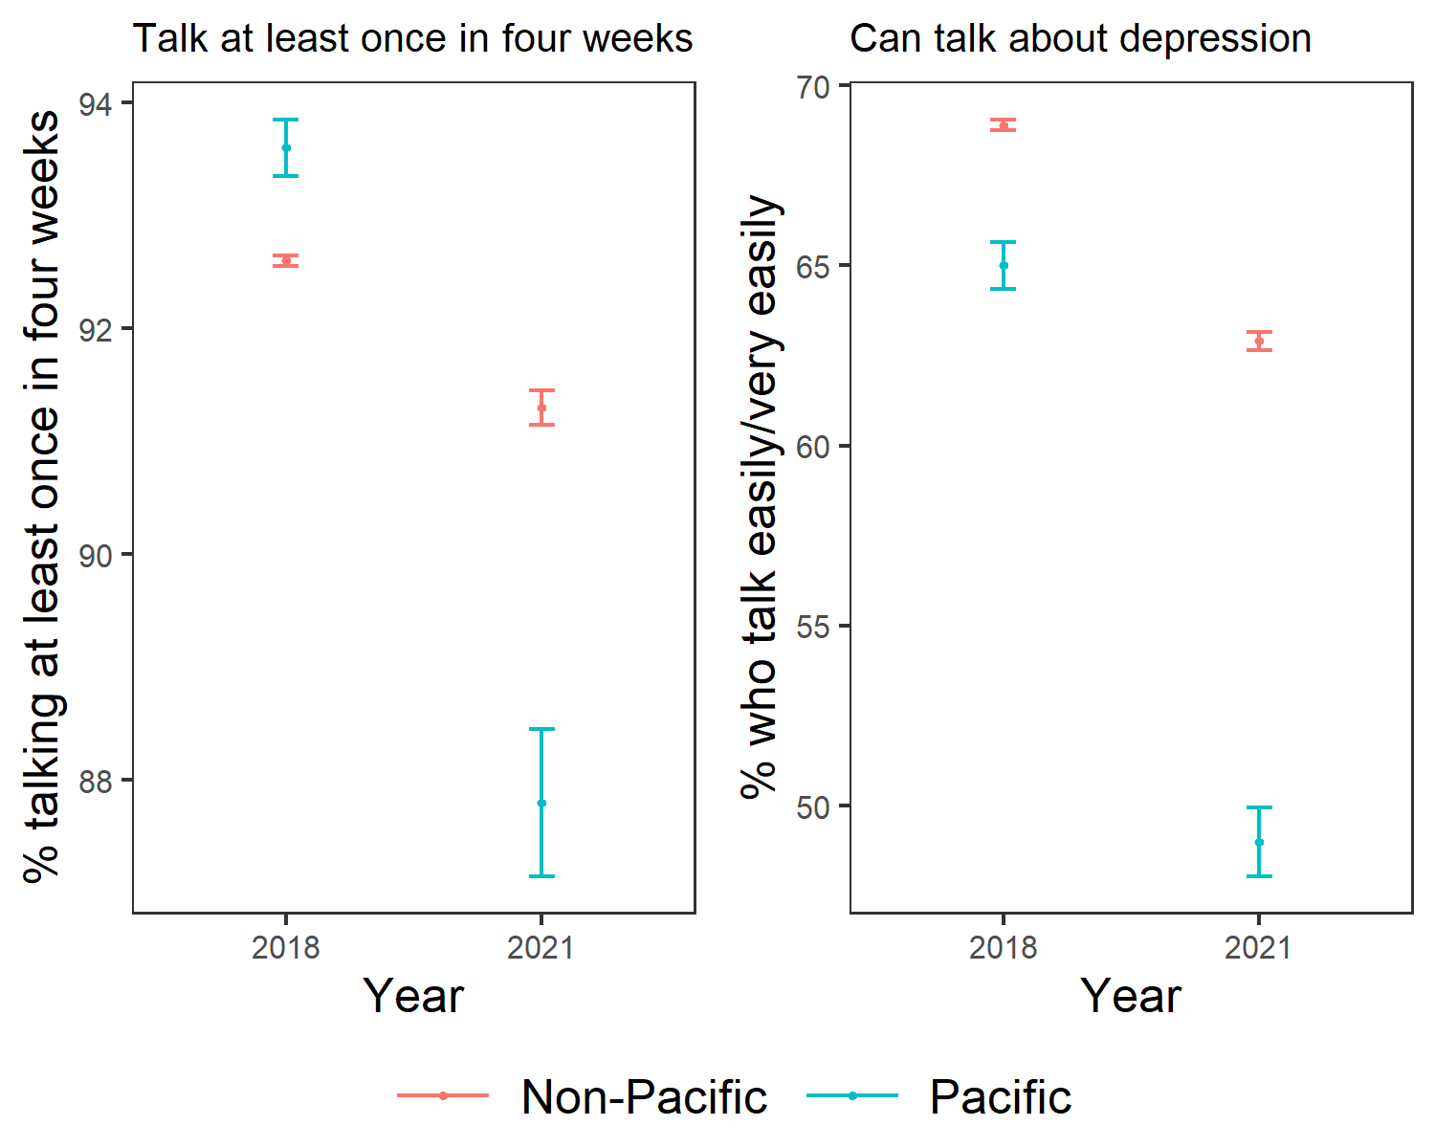

The next section provides a synthesis of key findings from our engagement with Pacific leaders and communities with contextualisation of our key quantitative findings. We focused on quantitative findings that address further understanding of the determinants of mental health and wellbeing for Pacific people. We also showcase examples of programmes that are supporting Pacific families to thrive.

## The ‘Pacific dream’ is yet to be realised

Pacific community leaders told us that the ‘Pacific dream’ is about thriving Pacific families in Aotearoa. Like many migrants, Pacific peoples expected that, by moving to Aotearoa, they would be able to work hard, provide for their children, and have opportunities that were unavailable at home. As a result, they would achieve a greater level of prosperity and wellbeing for their families, their children and for future generations.

However, it is clear from our assessment of the data and experience of Pacific people we spoke to, both migrants and generations born here, that this dream has not been fully realised. We also heard that those aspirations, that ‘Pacific dream’ differs depending on many factors, including individuals’ family circumstances, culture, age, and other aspects of their identity.

Across our engagement with members of Pacific communities and organisations, we heard the need for government to focus on three interrelated but critical determinants of wellbeing as pathways to the ‘Pacific dream’ and mental health and wellbeing. These include improved education, employment and income and housing.

### Education as a critical pathway to future wellbeing

There is a range of evidence that supports our finding that education, at all ages, is seen as a key path to prosperity, opportunities, and wellbeing (5). We have heard that it was a driving factor in the migration of many families in the past. Education builds capacity for other aspects of wellbeing, helping provide the resources needed to flourish, helping give hope and purpose for the future, and helping develop belonging and community.

“Revive the dream of why Pacific came to New Zealand and that's around education and pushing that aspirational stuff again for our kids so that becomes a common thing that binds us together that we try to uplift and uphold that for each other [...] particularly coming out of the COVID stuff you know, we have a lot of kids that have disengaged from school, so how do we reconnect and maybe launch something in that space” (Pacific provider).

However, Pacific people face greater challenges than most other groups, in accessing education. Until these inequities are addressed, “education systems in Aotearoa New Zealand are more likely to reinforce advantage, rather than acting as interventions through which equity can be achieved” (5)

More recently, Pacific young learners are having to reprioritise their learning outcomes to support the family due to challenges following the COVID-19 pandemic and increasing costs of living. Trends of further declining attendance from Pacific high school students following school closures and self-isolation protocols have been reported (6).

“I’d put some investment into increasing educational outcomes. And that's just a direct response for a large majority of our students [who] are not going to school and are not achieving. How do we improve it? What is the impact three years down the line of people not going to school?” (Pacific provider)

We also found that Pacific young people reported a significant decrease in having a sense of belonging at school from 74% in 2018 to 65% in 2021. This recent decrease in school belonging for Pacific learners is of concern and we want to ensure there is enough focus on what is driving these findings. In addition, our analyses showed that there is a significant increase in the level of racism reported by Pacific people between 2018 and 2021 which could be contributing to feeling less connected to mainstream schools. We know that a safe, non-bullying environment is key to learners’ sense of belonging (7).

Discrimination more broadly is a key driver of young people’s ability to achieve wellbeing outcomes and therefore a culturally safe learning environment is critical for Pacific learner mental health and wellbeing, (8).

### Example: Talanoa Ako - Community programme supporting Pacific learners

People we spoke to outlined the need for a range of options to support young people, including mainstream education, skills acquisition – particularly in STEM subjects, and through cultural and language competency programs. They also underscored the need to support adults to learn, through English language classes, financial literacy, skills acquisition, and wellness advice.

We have identified a community-based initiative that shows promising outcomes for educational achievement. Talanoa Ako takes a collaborative and family-focused approach to educational achievement (See Box 1. below). An evaluation was conducted in 2019 that shows good outcomes for those who are in the programme. For example, parents affirmed they had a role and responsibility in supporting their children’s education journeys, and they learnt ways to explore and master the knowledge and skills they needed to do so. This was reinforced by the fact that Pacific identities, language, and culture were valued and present.

**Box 1. Talanoa Ako – supporting families to support education**

**What:** Talanoa Ako is funded by the Ministry of Education and delivered in Pacific communities across the country, with a large number based in Auckland by community groups, Pacific churches, trusts, health providers, sports clubs, Pacific teachers, Board of Trustee collectives, and schools.

**Who:** Talanoa Ako equips and empowers parents, families and communities with the skills, knowledge and confidence they need to champion their children’s education. Parents can choose to be part of the parent-focused or the parent and child-focused programme. The Pacific parent programme involves 10 sessions covering topics such as NCEA, time management, study skills, literacy, numeracy, school reporting etc.

**Purpose:** Talanoa Ako provides the opportunity outside of school for learners, especially migrants, to regard their culture and identity as positive aids or tools, not barriers; and for learning to be a positive and empowering experience. Lack of confidence often leads to a low sense of belonging, which Talanoa Ako seeks to address by building confidence in learners, and by involving parents to support their children at school.

### Meaningful employment and adequate income are required for Pacific people to thrive

Employment, and the opportunities it provides, was another driving force behind the main waves of Pacific migration to Aotearoa in the 20th century to achieve the ‘Pacific dream’. Like education, employment is seen as a path to providing the resources needed to thrive, as well as providing a sense of purpose and control. Importantly, employment is key to wellbeing for the whole family and community. However, beyond initial employment booms, Pacific people have faced a range of barriers to employment.

Pacific people are overrepresented in unemployment rates and low paying work. As of December 2023, the Pacific unemployment rate is 6.6%, more than the unemployment rate of the total population 4.0%. The COVID-19 pandemic has further exacerbated challenges for Pacific people.

We have previously reported on the impact on mental health and wellbeing from job loss, concern of food security and home learning challenges experienced by some Pacific families because of COVID-19 (9). We are concerned that the current cost of living challenge will disproportionately impact Pacific families’ capacity for positive mental wellbeing.

Most Pacific people gain most of their income from employment, meaning that the type of work they have, the trends in unemployment and underemployment will have significant impacts on income and financial stability, which in turn impacts on mental health and wellbeing (10). Not only does income determine people’s ability to afford the basics of life, lack of income limits access to key aspects of wellbeing: opportunities, experiences, security, and participation in society, (11).

“I think the living wage should become the minimum wage and if we can have some impact around that, that would help a lot” (Pacific provider)

Pacific people earn less than their non-Pacific counterparts. While some of this is a result of history and cycles of disadvantage that make it hard to achieve better employment outcomes – a large part of the difference results from discrimination.

In 2021, the pay gap between Pacific peoples and Europeans was 24% and 14% for men and women, respectively (12)​. Analysis by the Human Rights Commission found that only 27% of the pay gap for Pacific men, and 39% of the gap for Pacific women could be explained by differences in observable factors such as job characteristics and education, meaning “the bulk of the Pacific Pay Gap can’t be explained and is at least partly due to invisible barriers like racism, unconscious bias and workplace discriminatory practices” (13).

Of key concern is the impact that these inequities have on Pacific children and young people, and their futures. Our recent analysis shows that Pacific peoples were 66% less likely than non-Pacific people to report that they have a household income that meets their everyday needs during 2021/2022; and Pacific children are also more likely than other ethnic groups to experience poverty even when an adult in their household is working (14). Pacific people we engaged with underscored the struggle that many Pacific families face, and the need for better income. In doing so, they made practical links between income and meaningful wellbeing outcomes for them and their families. They linked it to health outcomes and the ability to access health services in a timely way.

“For our Pacific people struggling with cost of living having access to affordable health care is paramount. I know of a lot of people who forgo seeing a health professional such as a GP due to the cost of a consult and would prefer to defer until their condition requires hospital level intervention. Cost impact of health isn’t just being felt by those people on the poverty line, it’s even being felt by those who earn median incomes who are now having to prioritise daily living expenses with health and wellbeing needs” (Government Pacific advisor)

Adequate income, besides meeting everyday needs, allows people to have the time to care and support one another. Pacific people are more likely to engage in ‘unpaid activities’ such as volunteering or community work which can sometimes go unseen and is undervalued. These activities are critical to participation in Pacific culture and are vital to Pacific wellbeing. They are the practical actions that Pacific people take as expressions of their family wellbeing and should not be relied on to carry Pacific wellbeing in the absence of equitable outcomes elsewhere.

“The forgotten population are those who care for our vulnerable ones in the community. And if they continue to be forgotten, our vulnerable ones who are in the community are only going to be more vulnerable…” (Pacific provider)

Action is needed in the short-term to increase income and the access it provides to the resources people need to flourish, and to invest in long-term improvements. People we spoke to identified a range of potential mechanisms to achieve this. For example, hands-on, accessible, and appropriate employment assistance programmes to support Pacific people into better, more stable employment are needed. This means employment that is more resilient to external shocks, and which provides an adequate standard of living.

### Example: Tupu Aotearoa - community programme supporting Pacific people into employment

Through our engagement Tupu Aotearoa (See Box 2. below) was identified as a community programme that has helped more than 4000 Pacific people into work with good results.

The Tupu Aotearoa programme had annual independent evaluations in 2019 to 2022. The 2021-22 evaluation conducted a survey of around 400 participants to understand their views and experience as a Tupu client.

The survey results indicated positive personal impacts for participants enrolled in Tupu Aotearoa including:

* Independence: Participants were able to attain their driving licence with the support of Tupu Aotearoa which improved their quality of life
* Financial security: For most participants, Tupu Aotearoa has provided a pathway to an increased and regular income which improved their ability to meet family, community, and church financial obligations.
* Younger participants felt an enhanced sense of responsibility and ability to meet financial obligations to their immediate and extended families, community, and church.
* Nurturing wellbeing. Accessing permanent employment gave participants access to sick leave and annual leave, thereby improving wellbeing.

**Box 2. Tupu Aotearoa – supporting Pacific people into employment**

**What:** The Tupu Aotearoa programme is designed to support Pacific people find employment or pursue further education and training.

**Who:** This initiative is funded by the Ministry for Pacific Peoples who have partnered with multiple providers across the country who connect Pacific peoples to navigators, mentoring and educational support. The programme is tailored to the client’s needs and has on offer personal development and career plans, upskilling and training courses, support with CV and cover letters, job-interview preparation, as well as pastoral care and support post-placement.

**Purpose:** Since 2010 – 2020 the Tupu Aotearoa programme has helped more than 4000 Pacific people into employment, education, or training. A programme that was initially designed to support young people, is now available to support all Pacific people who are a New Zealand citizen and above the age of 15.

### There is a positive link between stable housing and better mental health

Pacific people we engaged have raised housing as a key contributor to good mental health and wellbeing for both individuals and families collectively. However, the housing system in Aotearoa has contributed to poorer housing outcomes and disparities between Māori, Pacific and New Zealand European populations (15).

Home ownership can help provide families with a sense of security but may not always be a valid option.New Zealand Europeans are more than twice as likely to be homeowners or hold homes in a trust, compared to Pacific peoples (57.9% v 21%, in 2020 (15).

Along with the future wealth benefits from owning a home, there are also clear links between stable warm housing and improved subjective wellbeing, life satisfaction, and physical health, (16) (17). An evaluation of the Healthy Homes Initiative for example, which focuses on warm, dry, healthy housing for low-income families, found that the programme prevented 20% of hospitalisations, 9,443 general practitioner visits and 8,784 filled prescriptions over 3 years, (18). It also was expected to increase school and work attendance, and over a third (37%) of participants in the evaluation were Pacific peoples (19).

We know that Pacific peoples living in unaffordable housing suffer from poorer mental health. Pacific peoples who rated affordability between 0 to 4 out of 10, scored on average 58 out of 100 on the WHO-5 mental wellbeing index, compared with 68 out of 100 for those that rated affordability between 8 and 10 (17).

Among those living in dwellings with at least one major problem, 29% had poor overall mental wellbeing, compared with 13% of Pacific peoples without major housing problems (17).

The housing system in Aotearoa does not accommodate for young, larger families in the way that it used to before the 1990 housing reforms, meaning that intergenerational housing needs are not met (17). There are positive benefits to intergenerational families living in the same house, including shared knowledge and experience, childcare, warmth, culture (20), and pooling of resources – Pacific households have higher than average total incomes, even though individual income is lower than average (21).

“To uplift our children out of poverty and into better health and education outcomes, secure and culturally appropriate housing is key. This can be achieved if we can get families into homeownership, which breaks them into a positive cycle of intergenerational wealth, better health, and better education outcomes”. [Government Pacific advisor]

For some families, home ownership is unlikely to be an option in the foreseeable future – but stable, suitable, long-term housing, whether privately or publicly provided, needs to be available and accessible. Effort to ensure that Pacific families have access to a range of stable and suitable housing solutions is needed. For some families, that may be through support to become homeowners, through rent-to-buy, financial assistance, or financial planning endeavours.

### Example: Tupe Wise - building financial literacy and supporting home ownership

We have identified an example of a financial literacy programme that is showing some positive outcomes for Pacific families. Tupe Wise (see Box 3. below) is a financial literacy programme led out of Vaka Tautua, supporting Pacific individuals and families to learn more about their finances to get them closer to home ownership. Service monitoring and evaluation findings show some early positive outcomes achieved, however an outcome evaluation is needed to determine effectiveness. Early achievements include:

* 70% of those who participated were not confident in dealing with daily money matters when they started. At the end of the programme 95% were confident in dealing with daily money matters.
* 100% did not have a financial plan or budget. At the end 90% have now completed and follow their plan/budget most of the time and use a spending diary to track spending priorities and differentiate between needs and wants.
* 95% have translated their budgets into a workable and effective money system.
* 80% had low to medium debt ($5,000 - $10,000). At the end all of them have had a reduction in their debt and have a plan in place to reduce further and become debt free.
* 90% had no savings. At the end all have put in place a plan for an emergency fund/savings to be built into their budgets. Some have started putting their surplus from their budgets into the emergency fund.
* 85% have improved their credit rating score.
* 100% have Kiwisaver.

# Pacific communities and organisations are doing the mahi, but system support is needed

**Box 3. Tupe Wise – building financial literacy**

**Who:** Vaka Tautua is a national ‘by Pacific, for Pacific’ mental health, disability and social services provider. Recognising the prevalence of financial stresses in the people it helps, and the impacts those stresses have on mental health and wellbeing, Vaka Tautua introduced Tupe Wise:

**What:** Tupe Wise is a national 8-week financial literacy programme which involves weekly group workshops and one on one family coaching and connection to support services.

**Purpose:** This free programme aims to empower Pasifika families to build financial capability, confidence with managing their money to achieve their goals of financial independence and begin their journeys towards home ownership. Tupe Wise coaches help families to start tracking their spending and learn tips to help save money and set achievable goals. It is collaborative, reflective and encourages interaction and participation by delivering to various Pasifika community and church groups, in their Pasifika languages if needed.

Across the providers and community organisations we spoke with, some common challenges to supporting the wellbeing of their communities were raised. We heard about:

* Enabling community leadership as key to success.
* Importance of providing wrap-around support, based on the wellbeing aspirations of each family or community from a Pacific perspective.
* Pacific-led services, and greater Pacific competency in mainstream services.
* Contracting models and workforce development that trust providers and reflect the realities of the communities they support.
* Data that reflects Pacific lives and Pacific knowledge, and can support and drive better outcomes.

## Enabling communities to deliver on better wellbeing outcomes works

Pacific people we spoke to underscored ways of working that support Pacific wellbeing including incentives work for communities, as well as community champions - trusted and respected people and leaders in the communities who have influence that make a difference.

Relationships were seen as vital to Pacific health and wellbeing outcomes. We have seen this throughout the examples provided in this report, and it was core to the successes of the COVID-19 pandemic response (9).

“Access to Pacific communities needs to be a multi-pronged approach as was evidence during COVID vaccination. Work with community leaders, church groups, ethnic specific groups, Pacific organisations serving at grassroots level” (Government Pacific advisor)

We explored some aspects of the Pacific experience of COVID-19 in our reports (9), including the role of connection and networks in supporting Pacific wellbeing, often in very practical ways. A key factor in supporting community wellbeing was the role and effort of Pacific churches, cultural and sports groups, as well as existing service providers. These various organisations, rooted in and knowing their communities, help design and deliver services to reach Pacific families, and support their wellbeing,

A particular challenge for any service provider is navigating and being inclusive of the nuances of cultural expectations and obligations. Providers we spoke to discussed the difference in practices between Pacific cultures, as well as the evolution over time. One example was the complex obligations of giving and sharing resources – with guests, with family, and with people back home in the islands. For some families, these obligations can be financially difficult, and have an immediate and lasting impact on wellbeing. On the other hand, upholding such expectations provides its own source of wellbeing – failing to meet these obligations can be detrimental to people’s sense of accomplishment, success, and wellbeing.

This is not something that government agencies can navigate easily, but it is something that can be approached through relationships, through understanding the aspirations of individuals and families, and through working with them over time to support their wellbeing, and plan for their futures, in a culturally appropriate way.

## Wrap around support to address wider wellbeing will achieve improved Pacific mental health outcomes

One in six Pacific peoples experienced psychological distress in 2022/23. This is similar to Māori but higher than Asian and European / Other ethnicities, and it has risen over time. However, Pacific people, along with Asian people, are less likely consult with a mental health professional for concerns about emotions, stress, mental health, or substance use (22).

Drawing on Pacific understanding of wellbeing, as well as recognition of the multi-faceted challenges to wellbeing faced by Pacific people in Aotearoa, Pacific providers are providing the ‘wrap around services’ so often discussed in government strategies, (23).

Vital to this approach, we heard, is ensuring that ‘no door is the wrong door’ – individuals or families may seek support for a specific problem, but when they do, they should be met by a response that seeks to address any challenges they are dealing with.

“We need to close the distance between people and the services needed” (Pacific community leader)

Government support, delivered through individual agencies and funding appropriations does not always readily support a holistic approach. However, Whānau Ora programmes, such as those delivered by Pasifika Futures, show that this can be achieved, and can provide meaningful outcomes for Pacific, and other, families. A core component of these holistic approaches is that families are supported to identify and meet their aspirations.

“Pre-prescribed programmes like Family Start […] they definitely have their place, [but the] problem is not everybody fits into those criteria, and the beauty around, the Whānau Ora approaches is that when you walk into that house, it's not about health, it's not about education. What it's about is the family and their needs and their aspirations and if it happens to be about health then we have a health provider right there. But it's figuring out how we can move that family forward” (Pacific provider)

Importantly, Pacific families are the practical avenue to providing support, services, and skills to Pacific people. The people we spoke to particularly underscored the role of families in improving shared wellbeing outcomes, but also in overcoming mental health stigma.

Example: Mana Ake (Supporting Pacific families with mental health and wellbeing)

Through our engagement we identified an example that is showing positive mental health and wellbeing outcomes for young people. Mana Ake (See Box.4 below) was established in 2020 whilst considering the long-term impacts of some of the tragic events Christchurch has experienced. Pacific kaimahi (workers) at Mana Ake recognised there was a gap in mental health services for young Pacific children and their family. The programme is Pacific led and is grounded in Pacific knowledge and is showing positive findings from monitoring reports. Like the above examples however, Pacific providers need to be funded to conduct outcome evaluation to demonstrate effectiveness.

**Box 4. Mana Ake – Building Pasifika Fanau**

**What:** The building Pasifika Fanau initiative is a Christchurch based mental health and wellbeing support programme for Pacific children in school years 3-8.

**Who:** The programme offers Pacific learners with cultural tools to understand and improve their mental health and wellbeing and work on creating a positive self-identity.

**Purpose:** The aim is to help students build confidence and self-esteem and to have a space dedicated to them where they can build connections with their cultural identity and other Pacific students. The sessions will change depending on the age groups and the theme but incorporates the fonofale model (a Pacific health and wellbeing framework) and Pacific languages. Kaimahi will cover a range of topics such as values, emotions, social skills, language, identity and Pacific historical events in Aotearoa. They may also bring in Pacific art, games and island cooking.

## By Pacific for Pacific services will deliver better results

Looking across the examples, stories of success, and the gaps identified, we see the value of having Pacific-led services in a range of sectors to support mental health and wellbeing. We have already heard that Pacific peoples trust the Pacific providers that are embedded in their communities – and this trust is key to providing support. (9).

“When you have a Pacific service who are Pacific with Pacific leadership, Pacific staff, Pacific systems, Pacific governance, you will have a Pacific-focused organisation who will strive to deliver for Pacific people – and that’s the difference” (Pacific provider)

We received the same findings from monitoring mental health and addiction services in our *Te Huringa Tuarua* (24) report: a lack of culturally-appropriate and accessible services leads to poorer outcomes, for example, between 2007 and 2017, Pacific peoples who died of suicide accessed care (their GP or hospital-based mental health services) in the 12 months before their death at lower rates […, and were] less likely to be dispensed mental health medication before their deaths than non-Pacific peoples (25 p. 52). More needs to be done to improve access to appropriate services for Pacific peoples at risk of suicide or experiencing suicidal ideation.

However, providers we spoke to underscored that providing these services is constrained by the resources available – particularly having the workforce needed to provide the level of service required. The Pacific workforce within specialist mental health services has increased since 2018 from 6.5% to 7.4% in 2021 which is good news. However, our report on the roll-out of Access and Choice primary mental health highlighted the need for more focused attention on the development of Pacific services, with considerable workforce gaps in Pacific services and lower uptake of additional resources than expected (26).

Alongside the need for Pacific-focused services, mainstream services also need to have the competencies and capabilities to provide high-quality services to Pacific people. Like the ‘no door is the wrong door’ sentiment we heard Pacific people should have access to a range of services that meet their individual needs that are culturally responsive and appropriate.

“Of course providers and government need to go where the masses are but then we’ve got big pockets of Pacific communities around the regions that just don’t have anything – we’ve seen in the last 5 or 10 years, […] people are moving […] because of the cheaper housing or they’re just being like kind of bought out of the market, or you know there’s no rentals left and there’s different reasons why people are moving but they’re moving regardless and you see a spike in communities cropping up in […] out of the big cities, and so the ecosystem to support Pacific families in areas like health and social services are not there for our people and then you start to see some gaps and erosions in quality of life” [Pacific provider]

## Devolution and sustainable contracting models work

We have heard through this engagement and through our previous reports on wellbeing since 2021, about the positive steps that were taken during the COVID-19 pandemic to partner with, resource, and trust community providers. During the pandemic, we saw how a high-trust model worked. These high-trust models will work outside of the pandemic too, enabling communities and providers to spend more time and energy supporting local wellbeing, in a way that works for them (9).

“The thing is… Government can't do it without us, without the community. If it wasn't for, you know, the people like the churches and all the other groups stepping up to help with the pandemic, you wouldn't have been able to get those services out… How do we keep that going?” (Pacific provider)

This experience showed how things could be done, and what could be achieved. A commitment to such approaches will help Pacific providers to support their communities, in the way that works for them, rather than in a way prescribed by government commissioners. Providers have outlined the challenges in getting long-term funding – and the difficulties this poses in service planning, recruitment, and investment.

“Recent COVID response and vaccination programmes working with specific communities. This is what an equitable health system should look like in action. Give the money to the organisations that are supporting our communities to buy their own local solutions” (Government Pacific advisor)

Similarly, many people we spoke to described frustration and difficulty resulting from changes to government priorities. Key champions, in policy and regionally “are doing the mahi, but we lose things every time we change Government and lose momentum on initiatives - we have to find a way for mental health to be immune to these changes”. We think that cross-party agreement and action to improving mental health are needed.

“COVID… I thought in the end everybody stepped up. I'm just really concerned that we're reverting back to how it was pre pandemic and I'm just wondering where the hell all the learnings have gone, if that's the case” (Pacific provider)

## All system partners need better quality and timely Pacific data

The diverse Pacific population in Aotearoa is poorly understood and poorly represented in available sources of data. More detail is needed to understand the wellbeing and aspirations of different Pacific ethnicities within the wider Pacific population, and for Pacific communities across Aotearoa, outside the main urban centres.

Ministry for Pacific Peoples have faced barriers with measuring progress towards the all-of-Government Pacific Wellbeing Strategy outcomes. Meaningful data that reflects what is important to Pacific families, and which can be broken down to show their diverse stories and experiences, largely does not exist. This same data gap can be seen in our monitoring. We were only able to report on 22 indicators from a possible 31 for Pacific peoples under the ‘shared perspective’ domains for He Ara Oranga with the timeliness, granularity, and availability to be included for reporting.

As well as having more granular detail for existing data, it is vital that more is done to gather data on what is important to Pacific peoples’ wellbeing. Informed by Pacific models of wellbeing and recognising the gaps in existing wellbeing frameworks (our He Ara Oranga framework included), new data needs to be gathered. This may require a Pacific focus and new data from existing sources; or it may be a standalone collection, a Pacific equivalent to the world-leading Te Kupenga Māori post-census survey.

# Appendix 1: He Ara Oranga Framework

# Appendix 2. Indicators and results

The presented summary statistics in the tables below are for 22 indicators aligned with the He Ara Oranga framework - shared perspective outcome domains. The reported indicators in both the infographic and this report are a subset of indicators

previously reported on in the 2021 Te Rau Tira Wellbeing Outcomes report. Indicators from Te Rau Tira were not reported on here if they could not be disaggregated by Pacific ethnicity or updated with more recent data. Further details describing the data source of each indicator are provided in Appendix 3.

**Being safe and nurtured**

|  |  |  |  |  |
| --- | --- | --- | --- | --- |
| **Outcome concept** | **Indicator** | **Ethnicity** | **2018** | **2021** |
| People feel safe, secure, and are free from harm and trauma. | The proportion of people who report high levels of trust in most other people | Pacific | 46 | 49 |
| Non-pacific | 67 | 65 |
|  | The proportion of people who feel their quality of life is not affected by worrying about crime | Pacific | 40 | 50 |
|  |  | Non-pacific | 60 | 61 |
| People live in, learn in, work in and visit safe and inclusive places. | The number of work-related injury claims per 1,000 full-time equivalent employees | Pacific | 93 | 108 |
| All | 99 | 91 |
| People have nurturing relationships that are bound by kindness, respect, and aroha (love and compassion). | The proportion of people who report feeling lonely a little or none of the time in the last four weeks | Pacific | 87 | 81 |
| Non-pacific | 83 | 82 |
|  | The proportion of adults who had face to face contact with friends who do not live with them at least some of the time | Pacific | 94 | 88 |
|  |  | Non-pacific | 93 | 91 |
| People of all ages have a sense of belonging in families and / or social groups. Where people experience disconnection, reconnecting or forming new positive connections is possible. | A sense of belonging at school | Pacific | 74 | 65 |
| All | 68 | 68 |

**Having what is needed**

|  |  |  |  |  |
| --- | --- | --- | --- | --- |
| **Outcome concept** | **Indicator** | **Ethnicity** | **2018** | **2021** |
| People have the support and resources needed to maintain their health across their life course, and experience equity of health. | The proportion of adults who rated their health status as good, very good or excellent | Pacific | 79 | 80 |
| All | 87 | 86 |
| The proportion of adults who experience one or more types of unmet need for primary health care | Pacific | 36 | 33 |
| All | 31 | 28 |
| People, families, and communities have the resources needed to flourish. This includes (among other things) enough money, financial security, access to healthy food, healthy and stable homes, safe physical  activity, lifelong learning, creative outlets and time for leisure, including play for children. | The proportion of people who live in a crowded household | Pacific | 30 | 33 |
| Non-pacific | 5 | 6 |
| The proportion enrolled in any study, whether formal or informal. Years are 2018 to 2022. | Pacific  16–18 year-olds | 68 | 66 |
| Non-pacific  16–18 year-olds | 75 | 75 |
| Pacific  19-24 year-olds | 22 | 21 |
| Non-pacific  19-24 year-olds | 35 | 36 |
| The proportion of people who undertake 2.5 hours or more of physical activity a week | Pacific | 47 | 40 |
| All | 52 | 47 |
| The proportion of households that feel their income is enough or more than enough to meet their everyday needs | Pacific | 43 | 43 |
| Non-pacific | 65 | 70 |
| The proportion of people who have gone without fresh fruit and vegetables a little or a lot in last year to keep costs down | Pacific | 56 | 44 |
| Non-pacific | 20 | 18 |

**Having one’s rights and dignity fully realised**

|  |  |  |  |  |
| --- | --- | --- | --- | --- |
| **Outcome concept** | **Indicator** | **Ethnicity** | **2018** | **2021** |
| People can fully participate in their communities and broader society, and live free from all forms of racism, stigma, and discrimination. | The proportion of people who report experiencing discrimination in the last year | Pacific | 16 | 23 |
| Non-pacific | 17 | 21 |
| The proportion of people who report experience of racism in the last year | Pacific | 13 | 21 |
| Non-pacific | 8 | 11 |

**Healing, growth and being resilient**

|  |  |  |  |  |
| --- | --- | --- | --- | --- |
| **Outcome concept** | **Indicator** | **Ethnicity** | **2018** | **2021** |
| People and families experience emotional wellbeing. This includes having the skills, resources, and support needed to navigate life transitions, challenges, and distress in ways that sustain wellbeing and resilience. | The proportion of people without low self-reported wellbeing | Pacific | 78 | 70 |
| Non-pacific | 77 | 71 |
| The proportion of people who say it would be easy or very easy to talk to someone if they felt down or a bit depressed | Pacific | 65 | 49 |
| Non-pacific | 69 | 63 |
| The proportion of hazardous drinkers | Pacific | 25 | 22 |
| All | 21 | 16 |
| People and families can experience and manage a range of emotions – celebrating each other’s strengths and practising empathy and compassion – personal and collective. | The proportion of people who rate their family wellbeing highly | Pacific | 82 | 84 |
| Non-pacific | 82 | 81 |

**Being connected and valued**

|  |  |  |  |  |
| --- | --- | --- | --- | --- |
| **Outcome concept** | **Indicator** | **Ethnicity** | **2018** | **2021** |
| All people are valued for who they are and free to express their unique identities. | The proportion of people who think it is easy to be themselves in Aotearoa | Pacific | 85 | 74 |
| Non-pacific | 84 | 80 |

**Having hope and purpose**

|  |  |  |  |  |
| --- | --- | --- | --- | --- |
| Outcome concept | Indicator | Ethnicity | 2018 | 2021 |
| People, families, and communities have a sense of purpose and are hopeful about the future. | The proportion of people who report life is worthwhile | Pacific | 81 | 81 |
| Non-pacific | 86 | 85 |
| The proportion of people who report having high life satisfaction | Pacific | 77 | 74 |
| Non-pacific | 81 | 81 |

# Appendix 3. Definitions and notes on the data

When possible, summary statistics for Pacific peoples are presented alongside statistics for non-Pacific peoples (for data from the General Social Survey, Administrative Population Census, and Household Economic Survey). When this was not possible summary statistics are provided for Pacific peoples alongside statistics for the total population. Numerical superscripts denote the indicator data source, described in the Data source section below presented tables. Superscript a indicates figures that have been revised due to some coding differences. These numbers have changed since we published Te Rau Tira in 2021. The most up to date figures are provided here.

**Being safe and nurtured**

|  |  |  |
| --- | --- | --- |
| **Outcome concept** | **Indicator** | **Item description** |
| People feel safe and secure and are free from harm and trauma. | The proportion of people who report high levels of trust in most other people 1 | Item is "On a scale of zero to ten, in general how much do you trust most people in New Zealand". Item is rated on a 0-10 scale. For analyses high trust are all ratings of 7-10. |
| The proportion of people who feel their quality of life is not affected by worrying about crime 1 | Item is: on a scale of zero to ten “where zero is no effect and ten is a large effect, what effect does worrying about crime have on your quality of life?” For analyses, ‘not effected’ is considered to be 3 or less on a 0 -10 rating scale |
| People live in, learn in, work in and visit safe and inclusive places. | The number of work-related injury claims per 1,000 full-time equivalent employees 2 | Data is from figures published by Stats NZ using ACC administrative data. See references provided below on ACC data for further details. |
| People have nurturing relationships that are bound by kindness, respect, and aroha (love and compassion). | The proportion of people who report feeling lonely a little or none of the time in the last four weeks 1 | Item is “In the last four weeks, how much of the time have you felt lonely?”. Item is rated either: None of the time, A little of the time, Some of the time, Most of the time, or All of the time. For analyses responses for None of the time and A little of the time were collapsed. |
| The proportion of adults who had face to face contact with friends who do not live with them at least some of the time. 1 | Item is the question asked with reference to friends who do not live in same housing “how often in the last four weeks have you talked in person with any of them”. Item is rated either: Every day, At least once a week, At least once a fortnight, At least once in the last four weeks, or not at all. For analyses responses for Every day, At least once a week, At least once a fortnight, and At least once in the last four weeks were collapsed. |
| People of all ages have a sense of belonging in families and / or social groups. Where people experience disconnection, reconnecting or forming new positive connections is possible. | A sense of belonging at school 3 | Data are figures published by Ministry of Education and OECD from the Programme for International Student Assessment (PISA). Belonging is considered if response of agree or strongly agree was indicated for the item "I feel like I belong". |

**Having what is needed**

|  |  |  |
| --- | --- | --- |
| **Outcome concept** | **Indicator** | **Item description** |
| People have the support and resources needed to maintain their health across their life course, and experience equity of health. | The proportion of adults who rated their health status as good, very good or excellent 4 | Data is from figures published by Ministry of Health from the New Zealand Health Survey. See references provided below on New Zealand Health Survey data for further details. The item is "In general, would you say your health is:  Excellent, Very good, Good, Fair, Poor, Don’t know" |
| The proportion of adults who experience one or more types of unmet need for primary health care 4 | Data is from figures published by Ministry of Health from the New Zealand Health Survey. See references provided below on New Zealand Health Survey data for further details. |
| People, families, and communities have the resources needed to flourish. This includes (among other things) enough money, financial security, access to healthy food, healthy and stable homes, safe physical  activity, lifelong learning, creative outlets and time for leisure, including play for children. | The proportion of people who live in a crowded household 1, a | Crowding is derived from combining information on number and characteristics of household occupants and number of bedrooms. For analyses crowded was defined as not having enough bedrooms for household occupants. See references provided below on the General Social Survey for further details. |
| The proportion enrolled in any study, whether formal or informal. Years are 2018 to 2022. 5 | Indicator is derived from administrative data collected by the Ministry of Education. |
| The proportion of people who undertake 2.5 hours or more of physical activity a week 4 | Data is from figures published by Ministry of Health from the New Zealand Health Survey. See references provided below on New Zealand Health Survey data for further details. |
| The proportion of households that feel their income is enough or more than enough to meet their everyday needs 6 | Item is “How well does your total income (you and your partner’s combined income) meet your every-day  needs for such things as accommodation, food, clothing and other necessities?” Response options are More than enough, Enough, Only just enough, Not Enough. For analyses responses for More than enough and Enough were collapsed. |
| The proportion of people who have gone without fresh fruit and vegetables a little or a lot in last year to keep costs down 1 | Item is "over the past 12 months to what extent have done any of the following to keep costs down: gone without fresh fruit or vegetables”. Response options are A lot, A little, and Never. For analyses responses for ‘a lot’ and ‘a little’ were collapsed. |

**Having one’s rights and dignity fully realised**

|  |  |  |
| --- | --- | --- |
| **Outcome concept** | **Indicator** | **Item description** |
| People can fully participate in their communities and broader society, and live free from all forms of racism, stigma, and discrimination. | The proportion of people who report experiencing discrimination in the last year 1 | Item is “In the last 12 months, have you been discriminated against?” Response options are Yes or No |
| The proportion of people who report experience of racism in the last year 1 | Experience of racism was defined as those who reported discrimination of on basis of ether race or ethnic group, or skin colour |

**Healing, growth and being resilient**

|  |  |  |
| --- | --- | --- |
| **Outcome concept** | **Indicator** | **Item description** |
| All people are valued for who they are and free to express their unique identities. | The proportion of people with positive self-reported wellbeing 1 | Positive wellbeing was defined as a score of 51 and above on the WHO-5. |
| The proportion of people who say it would be easy or very easy to talk to someone if they felt down or a bit depressed 1 | Item is “Suppose you felt down or a bit depressed and wanted to talk with someone about it. How easy or hard would it be to talk to someone?” (very easy; easy; sometimes easy/ sometimes hard; hard; very hard) |
| The proportion of hazardous drinkers 4 | Data is from figures published by Ministry of Health from the New Zealand Health Survey. See references provided below on New Zealand Health Survey data for further details. |
| People and families can experience and manage a range of emotions – celebrating each other’s strengths and practising empathy and compassion – personal and collective. | The proportion of people who rate their family wellbeing highly 1 | Item is “where zero means extremely badly and ten means extremely well, how would you rate how your family is doing these days?” For analyses high family wellbeing are all ratings of 7-10. |

**Being connected and valued**

|  |  |  |
| --- | --- | --- |
| **Outcome concept** | **Indicator** | **Item description** |
| All people are valued for who they are and free to express their unique identities. | The proportion of people who think it is easy to be themselves in Aotearoa 1 | Item is “on a scale of zero to ten, in general how much do you trust most people in New Zealand?” For analyses all ratings of 7-10 were considered as indication of easy to be themselves. |

**Having hope and purpose**

|  |  |  |
| --- | --- | --- |
| **Outcome concept** | **Indicator** | **Item description** |
| People, families, and communities have a sense of purpose and are hopeful about the future. | The proportion of people who report life is worthwhile 1, a | Item is “where zero is not at all worthwhile, and ten is completely worthwhile, overall, to what extent do you feel the things you do in your life are worthwhile?” For analyses worthwhile are all ratings of 7-10. |
| The proportion of people who report having high life satisfaction 1 | Item is “where zero is completely dissatisfied, and ten is completely satisfied, how do you feel about your life as a whole?” For analyses high satisfaction are all ratings of 7-10. |

**Data Sources**

The following is a brief description of data sources for indicators.

1. General Social Survey

The General Social Survey is a biannual face-to-face survey of New Zealand usual residents who are aged 15 years or over, residing in private dwellings in the North and South islands and Waiheke Island. Data from the General Social Survey was analysed within the Integrated Data Infrastructure. Statistics are weighted to reflect the population based on age, sex, region, ethnicity, and household type. Typically, the General Social Survey samples from approximately 8000 individuals but in 2021 data collection was impacted by covid-19 and the sample was approximately 3400 individuals.  Crowding was derived using the CNOS method.

1. ACC

Data was obtained from [Stats.NZ.](https://www.stats.govt.nz/information-releases/injury-statistics-work-related-claims-2022/#:~:text=A%20total%20of%20222%2C300%20work,of%20the%20series%20in%202002.) Data on claims for work-related injuries is from the Accident Compensation Corporation (ACC). All claims are included under the calendar year when the injury occurred. Number of full-time equivalent (FTEs) used to calculate incidence rates are sourced from the Household Labour Force Survey (HLFS). Further details on methodology can be found at Stats [NZ Data Info +.](https://datainfoplus.stats.govt.nz/item/nz.govt.stats/924da847-3454-4786-baa0-80880523d1b9/?_ga=2.23397497.2104261505.1711510627-1842147855.1673901191) Figures presented under 2018 are for the 2019 Calander year, consistent with Te Rau Tira.

1. Programme for International Student Assessment

Data is from the Programme for International Student Assessment, a survey of 15-year-olds administered by the OECD. Data is from the PISA 2022 Results Factsheet – New Zealand and the PISA 2022 Pacific Learners Summary.

1. New Zealand Health Survey

The New Zealand Health Survey is a face-to-face survey that involves randomly selecting a sample of small geographic areas, households within the selected areas, and individuals within the selected households. Statistics were obtained from Ministry of Health [Annual Data Explorer](https://minhealthnz.shinyapps.io/nz-health-survey-2022-23-annual-data-explorer/_w_cd8a1cd9/#!/home) and are weighted to reflect the population based on geographical area, age, ethnicity, deprivation quintiles, and sex.

1. **Administrative Population Census**

The Administrative Population Census data maintained by Stats NZ was used to calculate proportions of individuals participating in study based on Ministry of Education enrolment records for secondary schools, tertiary education institutions, industry training organisations, and targeted training programmes.

1. **Household Economic Survey**

The Household Economic Survey is a face-to-face survey that involves randomly selecting households stratified by region, and census data relating socio-economic status. A household is considered pacific if it includes one or more pacific inhabitants. Data is presented for the financial year starting 2018 and the financial year starting 2021.

**Disclaimer for data from the General Social Survey, Administrative Population Census, and Household Economic Survey:** Access to the data used in this study was provided by Stats NZ under conditions designed to give effect to the security and confidentiality provisions of the Data and Statistics Act 2022. The results presented in this study are the work of the author, not Stats NZ or individual data suppliers.

These results are not official statistics. They have been created for research purposes from the Integrated Data Infrastructure (IDI) which is carefully managed by Stats NZ. For more information about the IDI please visit <https://www.stats.govt.nz/integrated-data/>.

# References

1. *Life satisfaction and mental heatlh problems (18 to 35 years).* **Fergusson, D.M., et al.** s.l. : Cambridge University Press, 25 March 2015, Psychological Medicine, pp. 45(11), 2427–2436. doi:10.1017/S0033291715000422.

2. *The WHO-5 Well-Being Index: a systematic review of the literature.* **Topp, Christian Winther, et al.** 2015, Psychotherapy and psychosomatics, pp. 84(3), 167–176. https://doi.org/10.1159/000376585.

3. *Multiple forms of discrimination and relationships with health and wellbeing: findings from national cross-sectional surveys in Aotearoa/New Zealand.* **Cormack, Donna, Stanley, James and Harris, Ricci.** 2018, International Journal for Equity in Health, pp. 17:26 https://doi.org/10.1186/s12939-018-0735-y.

4. *Protective factors for mental and psychological wellbeing in Australian adults: A review.* **Heinsch, Milena, et al.** 2022, Mental Health & Prevention, p. https://doi.org/10.1016/j.mhp.2020.200192.

5. **New Zealand Productivity Commission.** *A fair chance for all: Breaking the cycle of persistent disadvantage.* New Zealand : s.n., 2023.

6. **Education Review Office.** Learning in a Covid-19 World: The Impact of Covid-19 on Pacific Learners - Summary. *Education Review Office.* [Online] 06 May 2022. https://ero.govt.nz/our-research/learning-in-a-covid-19-world-the-impact-of-covid-19-on-pacific-learners-summary.

7. **Ranson, Cyrus.** *PISA 2022: Pacific Learners Summary.* s.l. : Ministry of Education, 2023.

8. **Te Hiringa Mahara - the Mental Health and Wellbeing Commission.** *Young people speak out about Wellbeing: An insights report into the Wellbeing of Rangatahi Māori and other Young People in Aotearoa.* Wellington: New Zealand : Te Hiringa Mahara - the Mental Health and Wellbeing Commission, 2022b.

9. —. *Pacific connectedness and wellbeing in the pandemic.* Wellington: New Zealand : Te Hiringa Mahara New Zealand Mental Health and Wellbeing Commission, 2023a.

10. **Hu'akau, Dr John, et al.** *"Hala kuo papa - well trodden path" - Pacific Population Profile.* Auckland : Pasifika Futures, 2024.

11. **Rashbrooke, Max.** *The Inequality Debate - An Introduction.* Wellington : Bridget Williams Books Ltd, 2014.

12. **Cochrane, Bill and Pacheco, Gail.** *Empiracle analysis of Pacific, Māori and ethnic pay gaps in New Zealand.* Auckland, NZ : NZ Work Research Institute, 2022.

13. **Human Rights Commission.** New research reveals majority of the Pacific Pay Gap can’t be explained. *Scoop.* [Online] 18 July 2022. www.scoop.co.nz/stories/BU2207/S00274/new-research-reveals-majority-of-the-pacific-pay- gap-cant-be-explained.htm.

14. **The Treasury.** *Pacific peoples' wellbeing. Analytical Paper 23/01 background Paper to Te Tai Waiora: Wellbeing in Aotearoa New Zealand 2022.* Wellington : The Treasury, 2023.

15. **Stats NZ.** *Housing in Aotearoa: 2020.* s.l. : Stats NZ, 2021.

16. **Grimes, Arthur, et al.** *Micro-geography and public tenant wellbeing.* s.l. : Motu Research, 2023.

17. **Stats NZ.** *Pacific Housing: People, place, and wellbeing in Aotearoa New Zealand.* Wellington : Stats New Zealand, 2023.

18. *Review of the Impact of Housing Quality on Inequalities in Health and Well-Being.* **Howden-Chapman, Philippa, et al.** 2023, Annual Review of Public Health Volume 44.

19. **Pierse, N, White, M and Riggs, L.** *Healthy Homes Initiative Outcomes Evaluation Service: Initial analysis of health outcomes (Interim Report).* Wellington : Ministry of Health, 2019.

20. **Te Hiringa Mahara - the Mental Health and Wellbeing Commission.** *Te Rau Tira Wellbeing Outcomes Report.* Wellington: New Zealand : Te Hiringa Mahara New Zealand Mental Health and Wellbeing Commission, 2021.

21. **The Treasury.** *The New Zealand Pacific Economy.* Wellington : The Treasury, 2018.

22. **Manatu Hauora.** New Zealand Health Survey Annual Data Explorer. [Online] December 2023. https://minhealthnz.shinyapps.io/nz-health-survey-2022-23-annual-data-explorer/_w_0e52c4f1/#!/home.

23. **Ministry for Pacific Peoples.** *Pacific Wellbeing Strategy Weaving All-of-Government Progressing Lalanga Fou.* Wellington : Ministry for Pacific Peoples, 2022.

24. **Te Hiringa Mahara - the Mental Health and Wellbeing Commission.** *Te Huringa Tuarua: Mental Health and Addiction Service Monitoring Report.* Wellington: New Zealand : Te Hiringa Mahara - the Mental Health and Wellbeing Commission, 2023b.

25. **Health Quality & Safety Commission.** *Bula Sautu - A window on quality 2021: Pacific health in the year of COVID-19.* Wellington : Health Quality & Safety Commission, 2021.

26. **Te Hiringa Mahara - the Mental Health and Wellbeing Commission.** *Access and Choice Programme: Report on the first three years – Te Hōtaka mō Ngā Whai Wāhitanga me Ngā Kōwhiringa: He purongo mō ngā tau tuatahi e toru.* Wellington: New Zealand : Te Hiringa Mahara - the Mental Health and Wellbeing Commission, 2022a.