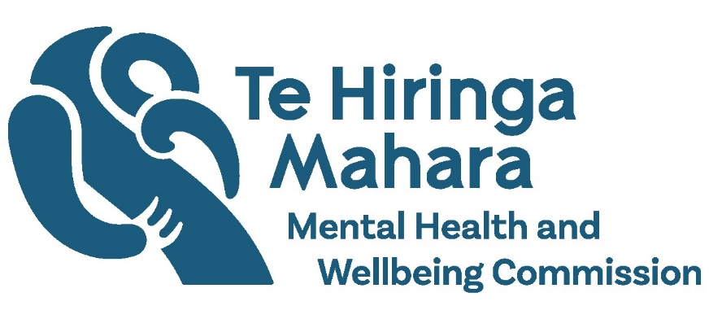

Kua Tīmata Te Haerenga | The Journey Has Begun
Adapted in 2024 by Accessible Formats Service, Blind Low Vision NZ, Auckland
TN: The logo on the top of the page is Te Hiringa Mahara | Mental Health and Wellbeing Commission.

Kua Tīmata Te Haerenga |
The Journey Has Begun

About Te Hiringa Mahara
- Te Hiringa Mahara – Mental Health and Wellbeing Commission is an independent crown entity and kaitiaki (guardian) of mental health and wellbeing in Aotearoa New Zealand.
- Te Hiringa Mahara monitors the wellbeing system, mental health and addiction services and advocates for improvements to services and the experiences of people who experience distress or addiction.

Monitoring access to mental health and addiction services
- This is a summary of our monitoring report.
- The monitoring report focuses on access to mental health and addiction services. We asked people through focus groups, interviews and online surveys to share their views and experiences of providing, accessing, or trying to access, mental health and addiction services in Aotearoa New Zealand.
- We also asked whether people could choose what services they access.
- What people told us, combined with data, provides an overview of why service use is changing in Aotearoa New Zealand.

Key findings

Access to primary and community services has increased and access to specialist services has decreased
- The Access and Choice programme has helped to increase access and provide more options for people with mild to moderate distress.
- The number of people accessing primary and community care has continued to increase over the last five years. Although we have seen a continued reduction in use of other primary mental health initiatives, such as telehealth services and Emergency Departments.
- We have heard that some people with higher needs (moderate to severe) have not been able to access services in a timely way. These people have needs that are just above the level that can be supported in primary care.
- We heard from many people about their difficulties with accessing specialist and crisis services.
- The number of mental health related calls to Police and Ambulance services has increased, although rates of Police attendance have decreased.

There is more pressure on specialist services due to more complex needs of people accessing services and workforce challenges
- The reason service use has changed is because of the increased pressure on the workforce from a high level of vacancies, and a focus on caring for those with more severe needs and changing needs.
- We also heard that there are more opportunities to provide support earlier through primary care, which makes a positive difference. This may be one of the reasons there is a slight decrease in referrals to specialist services.
- The workforce in primary and community care has grown through the Access and Choice programme, but significant workforce shortages continue in specialist services, non-governmental organisations (NGOs), and general practice. These shortages have constrained the responses of specialist services, which are needing to prioritise those with the highest needs.
- We heard that there is more demand for services and people are presenting with more complex needs, such as drug use, neurodiversity, and social issues such as housing instability.
- Primary and community providers are changing their behaviour in response to feedback from specialist services. For example, some feel that the threshold for accepting people into specialist services has become higher. Some referrers are reducing the number of referrals they make and are supporting people for longer in the community while waiting for access to specialist services.
- People shared some of the barriers they face getting early access to general practice and specialist services, which sometimes meant they were in crisis by the time they received specialist care.
- We heard that some people with moderate needs, who would have previously been referred to specialist services, are now receiving support without the need for specialist care.
- The New Zealand Health Survey shows that psychological distress has continued to increase.
- Changes in society, such as the increased cost of living and changes in people's expectations of the health system, have worsened people's distress.
- The COVID-19 pandemic has also impacted service use, service delivery models, the workforce, and people's expectations.

The system needs to be strengthened to meet the needs and aspirations of Māori
- The mental health and addiction system does not work well for many Māori.
- We heard from Māori that different parts of the system lack cohesion. They are calling for the system to be more holistic, culturally appropriate, affordable, and accessible to meet their needs.
- While many acknowledged some great examples, such as more Kaupapa Māori services, many say these services have a lack of reach across the motu (country).
- We heard there is a lot of frustration and disappointment after many failed attempts to access services through primary care and then ending up at acute services in crisis.
- Māori use of community specialist services has decreased. For many Māori, this has resulted in a loss of faith or trust in the system and difficulties in achieving a sense of wellbeing.
- Māori admission rates to inpatient services have increased while non-Māori rates have decreased.
- Over the last five years, Māori rates of mental health presentations to emergency departments have been higher than those for non-Māori.
- Māori report higher levels of psychological distress and experiences of mental distress and substance use, which links to what is happening in society.
- We want to see Te Tiriti o Waitangi being used to transform the mental health and addiction system. We are also advocating for more investment in Kaupapa Māori services and for all services to be cultural appropriate.

Young people need to be a priority
- Young people aged 15 to 24 years are still experiencing increasing levels of psychological distress, which are higher than the levels of other age groups.
- Young people report the highest rate of unmet need for health services, and they face barriers to accessing appropriate mental health and addiction support.

- Children and adolescents aged 0 to 18 years have the longest wait times for access to specialist services, and young people aged 19 to 24 years have higher ambulance and emergency department presentations than other age groups.
- Mental health and addiction service options for initial support for young people are improving. They are increasingly using telehealth and Access and Choice programme services, as well as other options available such as school-based services.
- Young people are now also receiving fewer mental health medications than the year before.
- It is also positive to see the number of young people admitted to adult inpatient units has started to decline over the last year.

Change needs to happen faster
- While workforce shortages, particularly in specialist services, are challenging toll, primary and community workforces have grown.
- There are good examples of services that are making a positive difference, such as primary care liaison, co-response teams, and earlier mental health responses for people who call 111.
- Acute community options are available in some areas; however, these options are not available across the whole country.
- We are seeing positive changes to address long-term issues. We need to see all of government, services, and people working together.
- We need to keep working towards a future where people have access to mental health and addiction services and supports when they need them, and have genuine choice in what services they use.
- Having a dedicated Minister for Mental Health presents many opportunities to drive change.
- We call on the Government to continue to focus on mental health and addiction speed up change and put people and whānau first.

What happens next
- Te Hiringa Mahara has published the full report on our website. We will share this report with government agencies and mental health and addiction services.
- You can read the full report on our website https://www.mhwc.govt.nz/our-work/mental-health-and-addiction-system/ or here http://tiny.cc/ltj6yz

Contact us
- For questions or more information about the report, please contact kiaora@mhwc.govt.nz
- If you need support or assistance, please call or text 1737. You can also visit our website for more information about support, https://www.mhwc.govt.nz/where-to-get-support/
End of Kua Tīmata Te Haerenga | The Journey Has Begun

