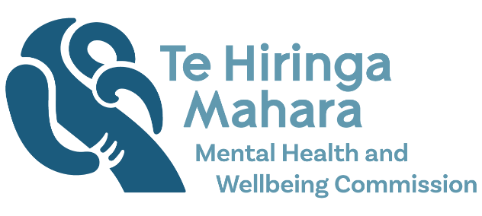
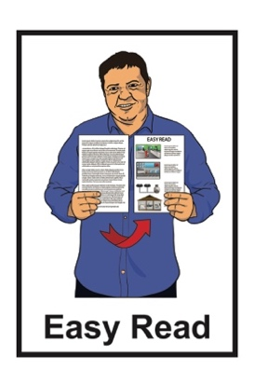

Kua Tīmata Te Haerenga

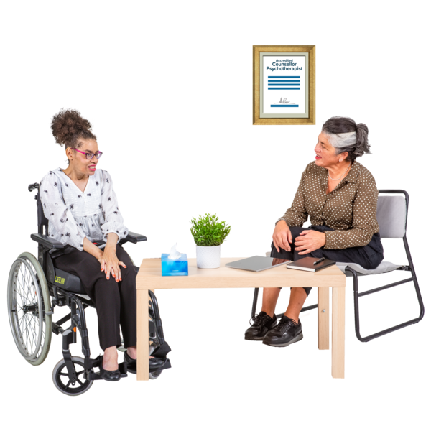
The Journey Has Begun
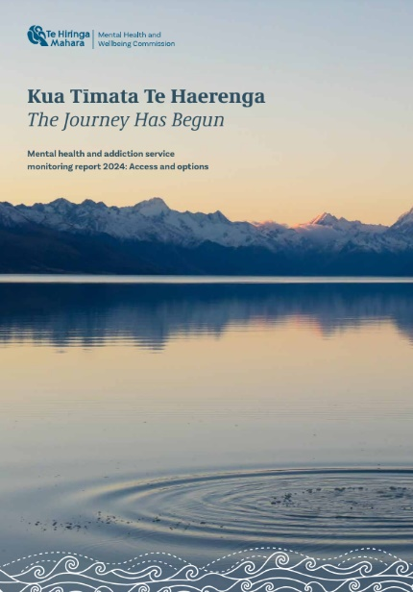

Monitoring report on access to
mental health and addiction services

Published: July 2024

What you will find in this document

Page number:


What this document is about 3

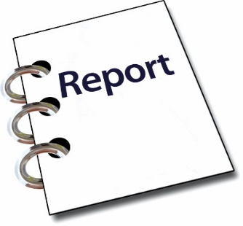

What is the report about? 7


What service access had
increased and decreased? 10

What are the problems with
specialist services? 16
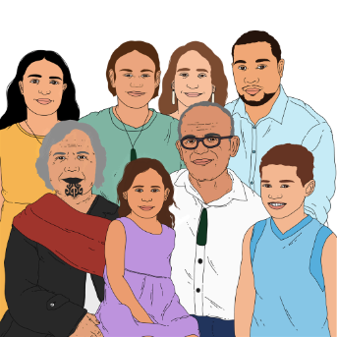

What needs to be done for
Māori? 23

Page number:
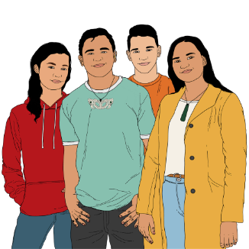

What needs to be done for young people? 30

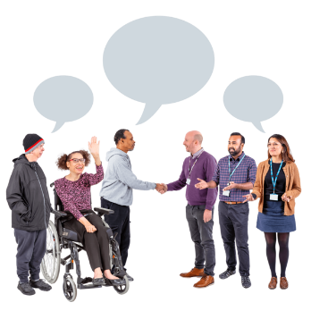
Things that are working well 33

Changes we want to see happen 34


What will happen next? 36

Where to get more information 37

What this document is about

This Easy Read document is a summary of Kua Tīmata Te Haerenga – The Journey Has Begun.


A summary is:
- shorter than the main document
- tells you the main ideas.

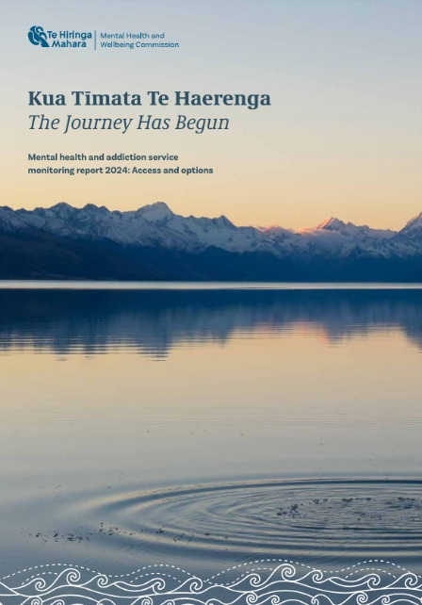
Kua Tīmata Te Haerenga – The Journey Has Begun is a monitoring report about the changing use of:
- mental health services
- addiction services.

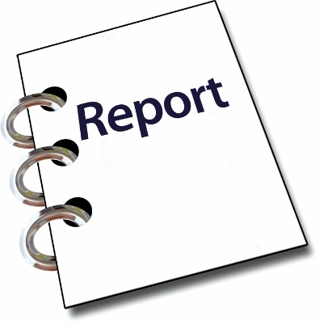

A monitoring report is a report that talks about:
- how well something is working
- the changes that happen over time.


Mental health is about how you feel.

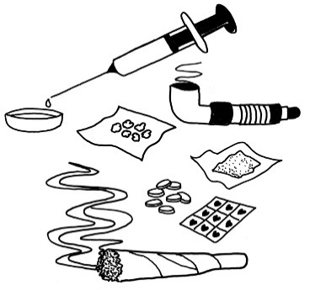
Addiction means not being able to stop yourself from using things like:
drugs
alcohol.

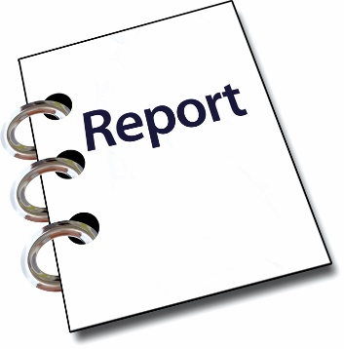
In this Easy Read document Kua Tīmata Te Haerenga – The Journey Has Begun will be called the report.

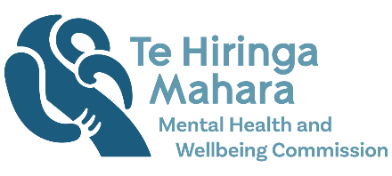
The report is written by Te Hiringa Mahara – Mental Health and Wellbeing Commission.


Te Hiringa Mahara – Mental Health and Wellbeing Commission:

- is a part of the government
- tells other agencies how to make things better for mental health and wellbeing.


Wellbeing means things like:
how you feel about yourself
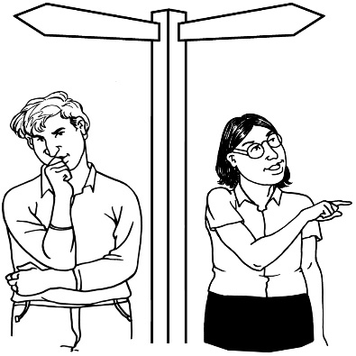
getting support when you are feeling sad or worried
feeling safe
being able to decide what is important to you.
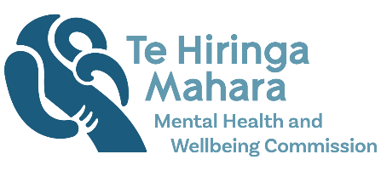
When you see we in this document it means Te Hiringa Mahara – Mental Health and Wellbeing Commission.

What is the report about?

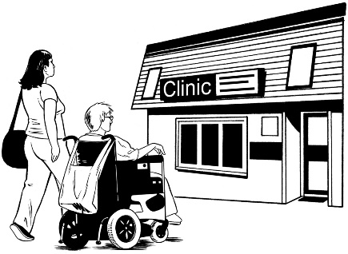
The report talks about how people in Aotearoa New Zealand access:
- mental health services
- addiction services.

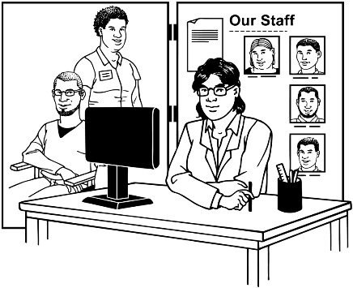
We wanted to know what people thought about:
- providing services
- accessing services.
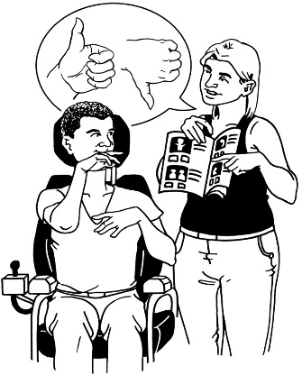

We also wanted to know if people could choose the services they wanted to use.

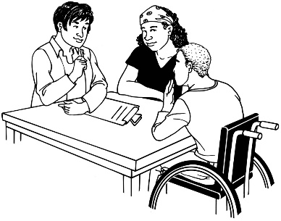
To get the information we asked people questions through:
- small groups of people we chose
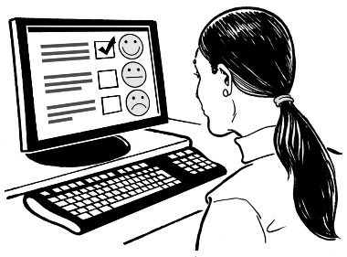
- interviews
- surveys on the internet.


We also used data.

Data is information that comes from places like:
- government agencies
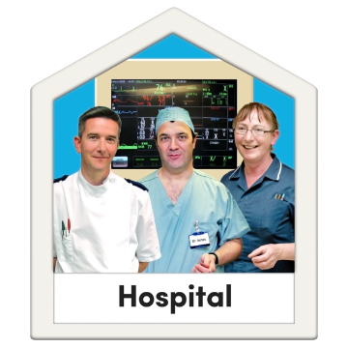
- mental health service providers
- health organisations.


We used all this information to write the report on why service use is changing in Aotearoa New Zealand.

What service access had

increased and decreased?


Increase means:
- a number getting bigger
- more people using a service.


Decrease means:
- a number getting smaller
- less people using a service.

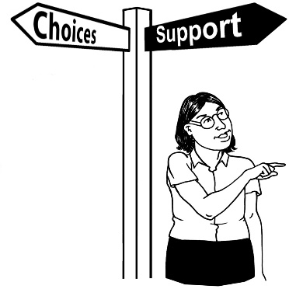
We found out that the Access and Choice programme had:
- supported increased access
- provided more options.
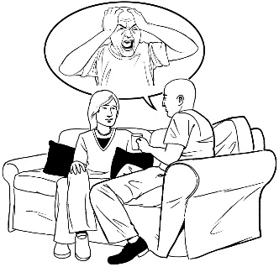
The Access and Choice programme works to improve access for people with mild to moderate distress to:


- mental health services

- addiction services.


There has been an increase over the last 5 years of people accessing:
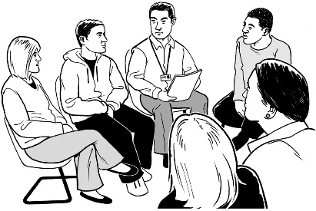
- primary care
- community care.

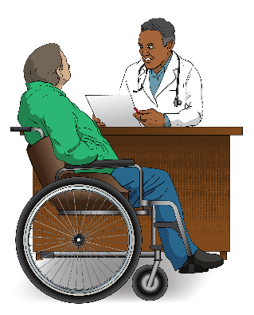
Here primary care means the first place you go when you need support for your mental health like your doctor.

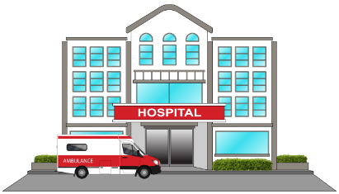
Community care for mental health means:
- services outside the hospital
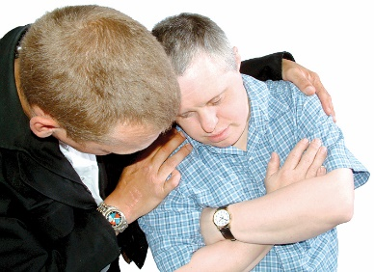
- support groups
- people you can get support from when you are feeling very bad.


There has been a decrease in people using primary mental health services like telehealth.

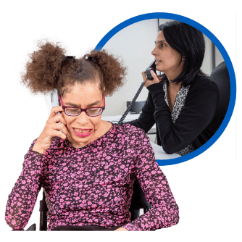
Telehealth is where you talk to someone on the phone about something to do with your health.

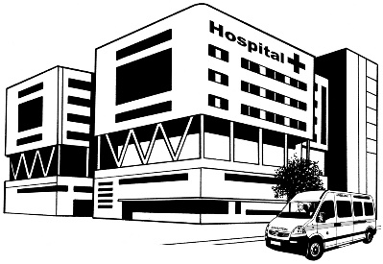
There has also been a decrease in people using mental health services at the emergency department.

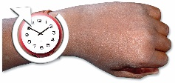
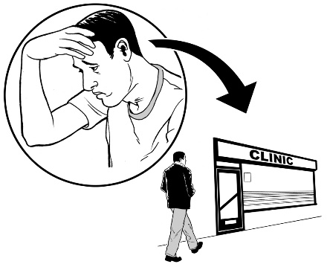
We found out that people with
higher needs have not been able access services in a good amount of time.

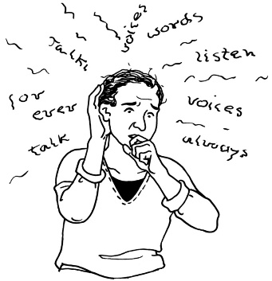
Here higher needs means people:
- with moderate to severe mental health problems
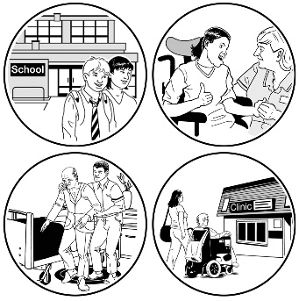
- who need a lot more mental health support.

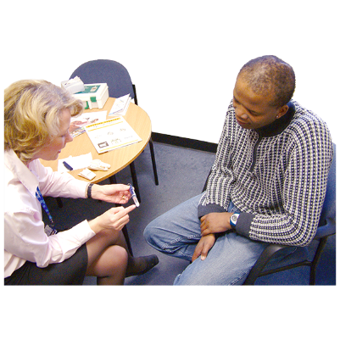
We found out many people had problems accessing:
- specialist services for mental health like a:
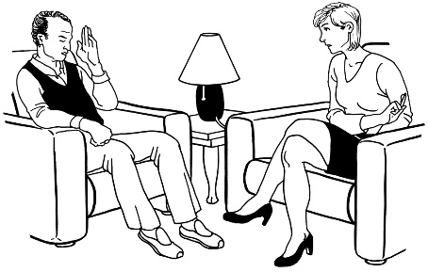
- psychiatrist who can give you medication
- psychologist who can talk to you about your problems
- crisis services.

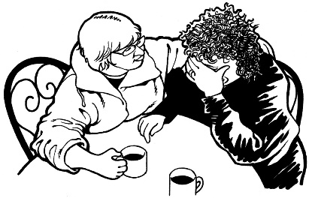
A crisis is when something very bad is happening.

When your mental health is very bad a person can use crisis services to:
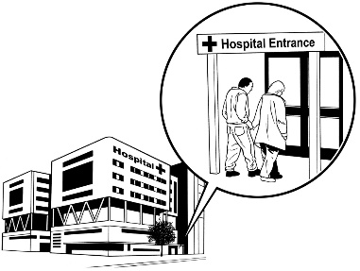
- see a mental health doctor straight away
- be taken to a mental health unit.
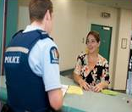
There has been an increase in the number of mental health calls made to:

- the Police
- ambulance services.

What are the problems with

specialist services?

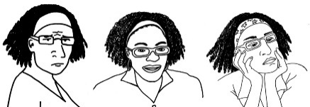
We found service use had changed because:

- people have complex needs
- there are not enough people to do all the jobs in mental health.

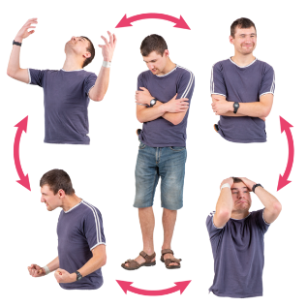
Complex needs means people who:
- may have more than 1 mental health problem
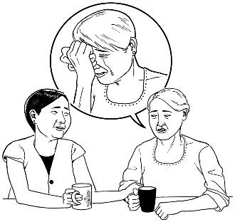
- might have lots of difficult things happening in their life.


We found out there were more ways to give support to people in primary care.

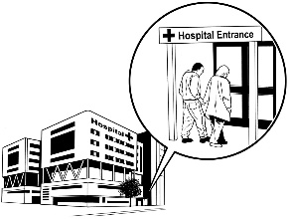

This might be a reason why there is a small decrease in people being sent to specialist services.


The Access and Change programme has supported more people to work in:
- primary care
- community care.

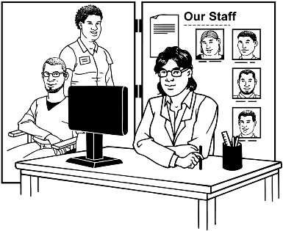
There are not enough people working in:
- specialist services
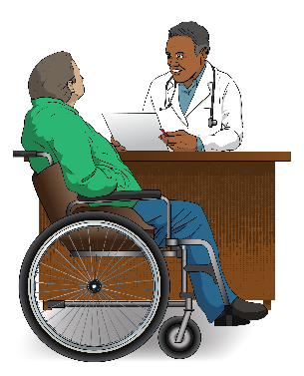
- non-governmental organisations / NGOs
- general practice like your local doctor.


This means specialist services are not supporting people with high needs very well.

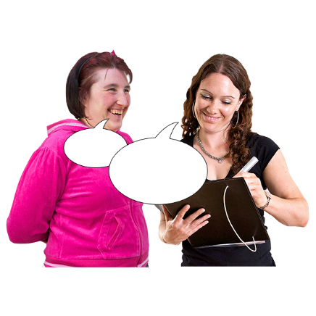
When people are not being seen by specialist services changes are being made by:
- primary providers

- community providers.

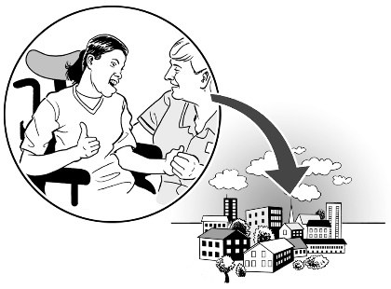
This means things like looking after people in the community for longer.

This is because they have to wait to get access to specialist services.

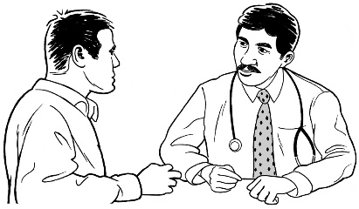
We found out about the barriers people face getting access to:
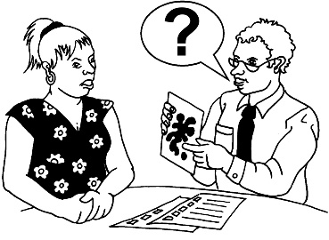
- their doctor
- specialist services.


A barrier is something that can stop you from doing something.

This includes if you have a disability.

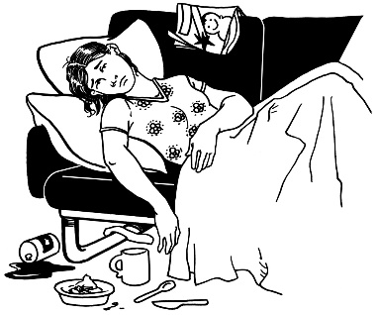
This sometimes meant they were in crisis by the time they got care from specialist services.


We found out some people with moderate needs are now getting support without the need for specialist care.


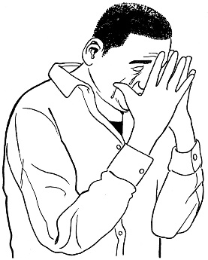
We found out the New Zealand Health Survey shows that psychological distress has been increasing.



People are more distressed because of things like:
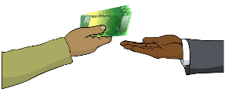
- how much money it costs to live like:
- buying food
- housing



- what people need the health system to do for them.


We found out the COVID-19 pandemic has changed mental health services like:
- how people use them
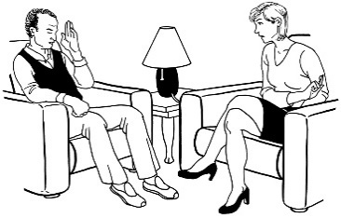
- how things are done

- how many people work there
- what people need.



COVID-19 is a type of virus that makes people sick.

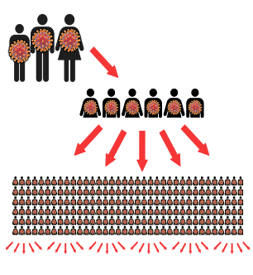
A pandemic is when many people around the world get the same sickness at the same time.

What needs to be done for Māori?

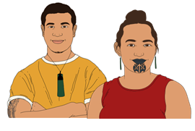
We know the mental health and addiction system does not work well for many Māori.

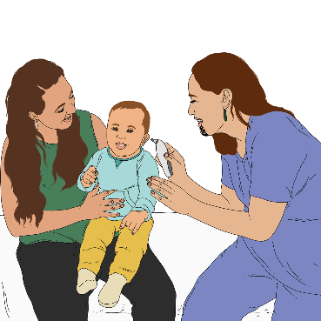
We found out Māori want the system to:
- work better with Māori ideas about health
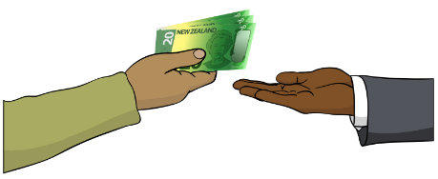
- work better with Māori culture
- not cost so much

- be accessible for their needs.

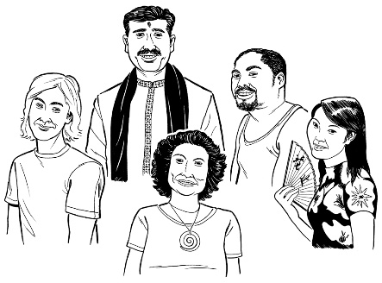
Culture is a way of:
- thinking that a group shares
- doing things as a group.


Māori said:
- there are some good services

but

- they are not available all across the motu / country.

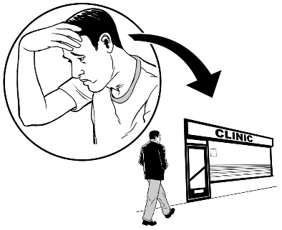
We found out many Māori are upset because they could not access services through primary care.

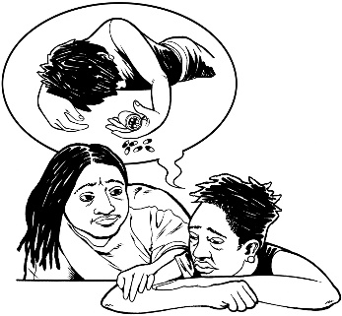
This meant they ended up having to use crisis services when their mental health problems got bad.


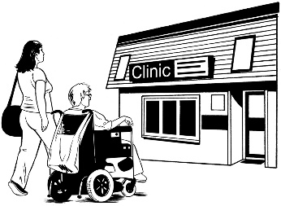
We found out there had been a decrease in Māori using community specialist services.

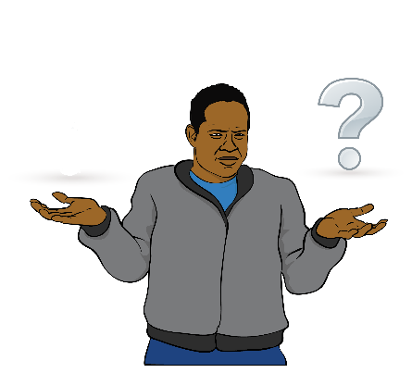
This meant Māori:

- could not trust the system
- found it difficult to get a good sense of wellbeing.


Getting admitted to inpatient services had:
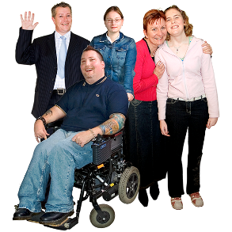
- increased for Māori
- decreased for non-Māori.

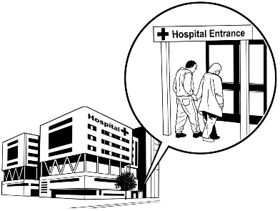
Inpatient services are when a person having bad mental health problems stays at a mental health unit.

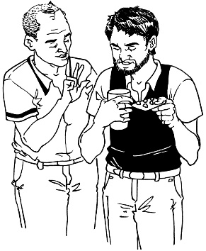
At the unit they can get things like:
- medication
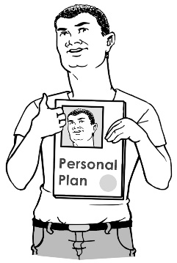
- care from doctors
- time to deal with their problem
- a plan to treat their problem.

Over the last 5 years Māori had gone to emergency departments with mental health problems more than non-Māori people.

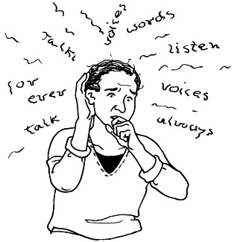
Māori say they have higher levels of:
- mental distress
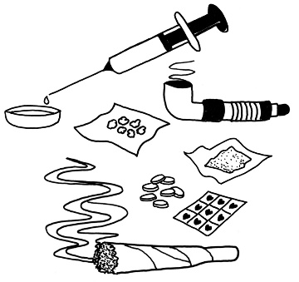
- substance use which is when someone uses things like:
- drugs
- alcohol.

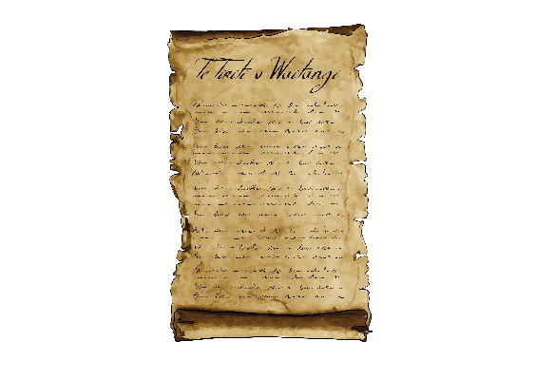
We want to see te Tiriti o
Waitangi / the Treaty of Waitangi used to change the mental health and addiction system.

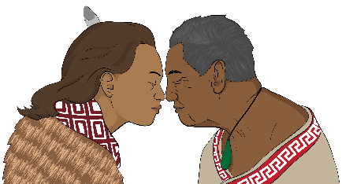
Te Tiriti o Waitangi / the Treaty of Waitangi is an important agreement between:
- Māori
- the Crown.

It affects all people in Aotearoa New Zealand.

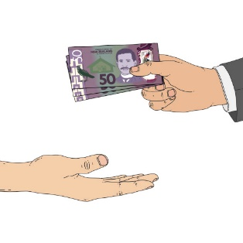
We want:
- more money put into Kaupapa Māori services
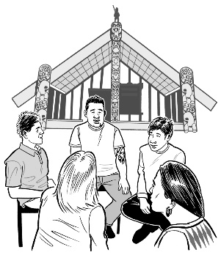
- all services to work well using Māori culture.


Kaupapa Māori is a way of doing things that work well for Māori.

It includes:
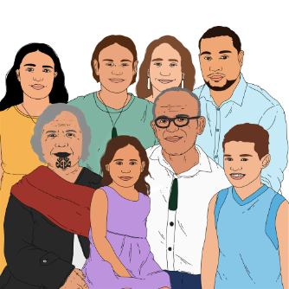
- whānau / families
- te ao Māori / how Māori see the world
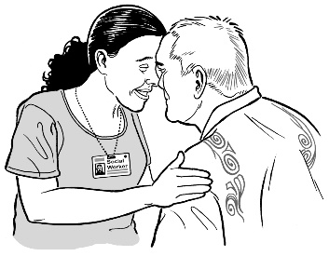
- tikanga / being connected to everyone around you.

What needs to be done for young people?

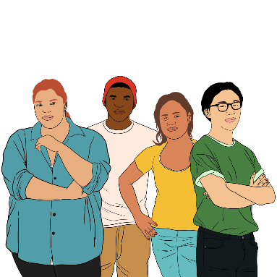
We found out that psychological distress in young people aged 15 to 24 years old is increasing.

This is higher than other age groups.

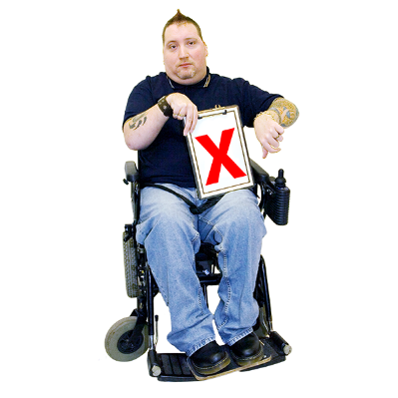
Young people who are under 24 years old:
- find it much harder than people who are older to get health services
- face barriers to accessing support for:
- mental health
- addiction.


Young people aged from birth to 18 years old have to wait the longest to access specialist mental health services.


More than any other age group young people aged 19 to 24 years old use:
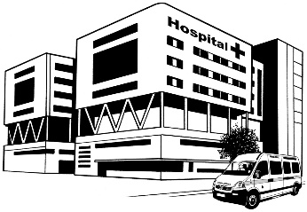
- ambulance services
- emergency department.


The first mental health options available for young people are getting better.

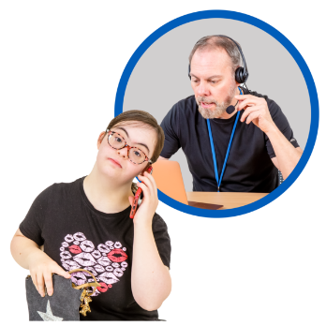
Young people are increasing their use of:
- telehealth
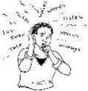
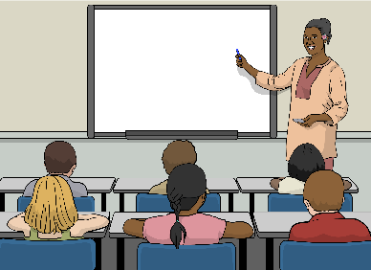
- the Access and Choice programme
- mental health services at school.



Young people are getting less mental health medications than the year before.


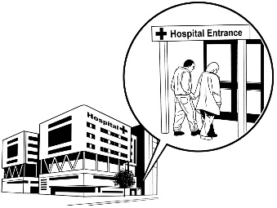
We think it is a good thing that the number of young people going to adult inpatient units has been decreasing over the last year.

Things that are working well

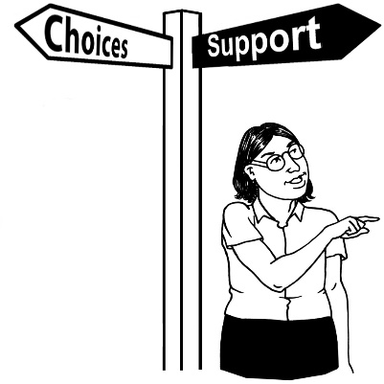
Services that are doing good things are:
- the Access and Choice programme
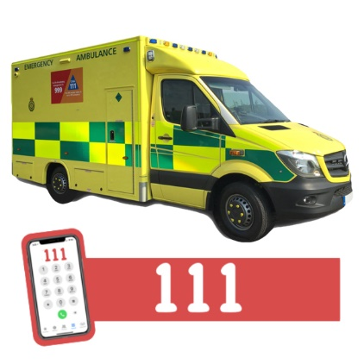
- teams who work together to give mental health care to someone
- those that give support faster to people who call 111.

Changes we want to see happen


The changes we want to see happen include:
- more people being able to access mental health services

- more people working in mental health services
- making services more welcoming for Māori
- people being able to choose which services they use
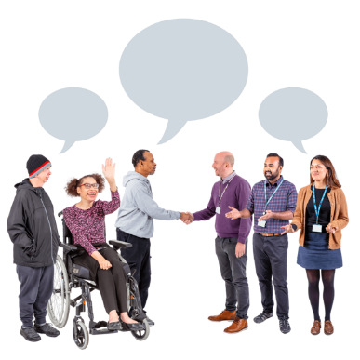
- services working well together
- getting better data so we can watch what is going on.


We think having a Minister for Mental Health would be a good idea to support change.

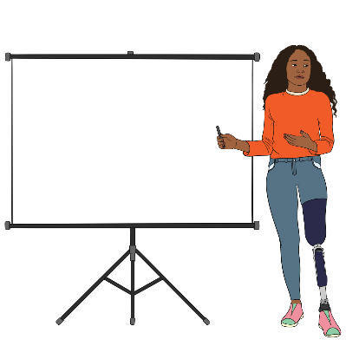
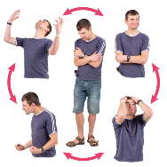
We ask the Government to keep working on:
- mental health
- addiction.

We also ask the Government to:
- make change happen faster
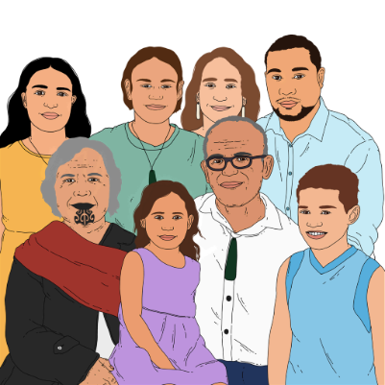
- put first:
- people
- whānau / families.

What will happen next?


We have published the full report of Kua Tīmata Te Haerenga – The Journey Has Begun.

We will share this report with:
- government agencies
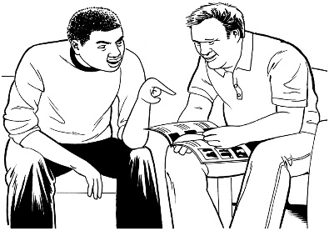
- mental health services
- addiction services.


You can read the full report on our website at:

tinyurl.com/2ssk6bhv


The full report is not in Easy Read.

Where to get more information


You can contact Te Hiringa
Mahara – Mental Health and Wellbeing Commission by email at:

kiaora@mhwc.govt.nz

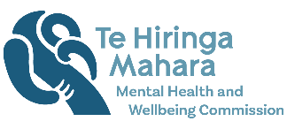
This information has been written by Te Hiringa Mahara – Mental Health and Wellbeing Commission.

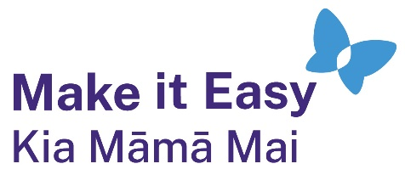
It has been translated into Easy Read by the Make it Easy Kia Māmā Mai service of People First New Zealand Ngā Tāngata Tuatahi.
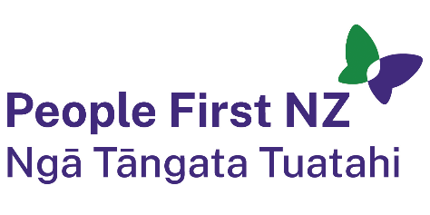
The ideas in this document are not the ideas of People First New Zealand Ngā Tāngata Tuatahi.
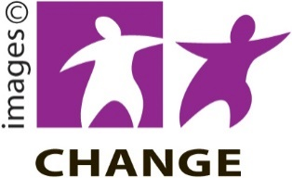
Make it Easy uses images from:

- Changepeople.org


            - Photosymbols.com



- SGC Image Works
- Huriana Kopeke-Te Aho
- T.Wood.

All images used in this Easy Read document are subject to copyright rules and cannot be used without permission.

