COVID-19 Impact Insights Paper #2

The wellbeing of older people in Aotearoa

December 2022
This paper is the second in a series of eight short, focused insights reports that will highlight key elements of the wellbeing impacts of the pandemic in Aotearoa.
In this paper, we look at how the COVID-19 pandemic has impacted the wellbeing of older people in Aotearoa.
Individually, we each have a sense that our wellbeing is made up of a great many factors – some concrete and material, some intangible but no less important. Taken together, as in our He Ara Oranga wellbeing outcomes framework {1}, we know that people need to have their rights, dignity and tino rangatiratanga fully realised, they need to feel safe, valued and connected to their communities and their cultures, and they need resources, skills, resilience, hope and purpose for the future. This understanding of wellbeing has guided the research and presentation of findings in this report.

The study
This paper lays out the impacts of COVID-19 on the wellbeing of older people in Aotearoa by bringing together:
- a rapid review of literature from Aotearoa and other jurisdictions;
- relevant data from large social surveys that act as population wellbeing indicators: the General Social Survey and Household Labour Force Survey;
- engagement with community and advocacy groups to ensure that older people’s voices, views and experiences are included.
For greater detail on the methodology and findings, please see our technical paper [2].

The findings
Older people were generally doing better than other groups during the initial lockdown and elimination phase of the Government response to the COVID-19 pandemic.
In 2021, older people were more likely to report greater wellbeing, social connectedness, a sense of belonging and life satisfaction, and less likely to report feelings of loneliness, psychological distress, discrimination and material hardship, than the total population. Older people continued to have trust in the Government, and many felt well supported and protected by the Government response to COVID-19.
Older people are an important and growing part of Aotearoa. When the COVID-19 pandemic began in 2020 there were 791,900 people aged 65 years and over, and there are likely to be 1 million older people by 2028.
Māori older people played a key role in community resilience, in the face of the challenges presented
While the Government response was generally viewed positively, Māori leaders were critical of the ‘one size fits all’ approach that was taken. The health and wellbeing of kaumātua was protected through hapū and iwi responses, which included kaumātua, and served to off-set some of the pre-existing inequities in support. Māori hauora (health) or social providers utilised marae to support Māori, and care packages for older people were prioritized.
Lockdowns presented significant challenges to tikanga Māori, including not being able to engage in formal activities on the marae or participate in tangihanga, and not having close contact with whānau. However, kaumātua collaborated with whānau to mitigate these and other impacts of COVID-19, and were at the centre of community resilience during lockdown. Kaumātua had frontline and leadership roles in the pandemic response, such as checkpoints intended to protect health of whole communities, and kaumātua were active in creating and delivering kai and care packs to others, and adapting tikanga.
Māori stories of the lockdown are ones of “action, leadership, organising, and of a community coming together to support each other. They are stories of positivity and resilience, with kaumātua at the centre” (Keelan et al, 2021, p.117)
However, older people were not doing as well as they had prior to the pandemic…
Older people were more likely to feel lonely in 2021 than they had prior to the pandemic starting and had less face-to-face contact with friends. Some factors appear to exacerbate the likelihood of loneliness, including living alone, geographical and social isolation, and tension in family and whānau relationships.
People aged 75 years and over experienced increases in anxiety, dissatisfaction with life and feeling that life is not worthwhile in September 2020 and March 2021. These months immediately follow those when cases of COVID-19 were recorded in the community and may, in part, reflect an increased worry on the part of older people about the implications of this.
“The uncertainty of how many years Covid will affect social connectivity, job security, effects on those who catch Covid long-term, the fact that you’re always wary of visiting friends and family, relationships are no longer natural and spontaneous, and you tend to always be balancing the risks against having fun or activities. It does narrow your world and your life compared with pre-Covid . . .” (Survey respondent, 2022)
These concerns are reflected in the dramatic increase in calls from older people to Depression, 1737 Need to Talk, Gambling, and Alcohol and Drug Services telephone helplines at the start of the pandemic. While the number of calls has fluctuated since then, the number has not returned to the lower pre-pandemic rate.
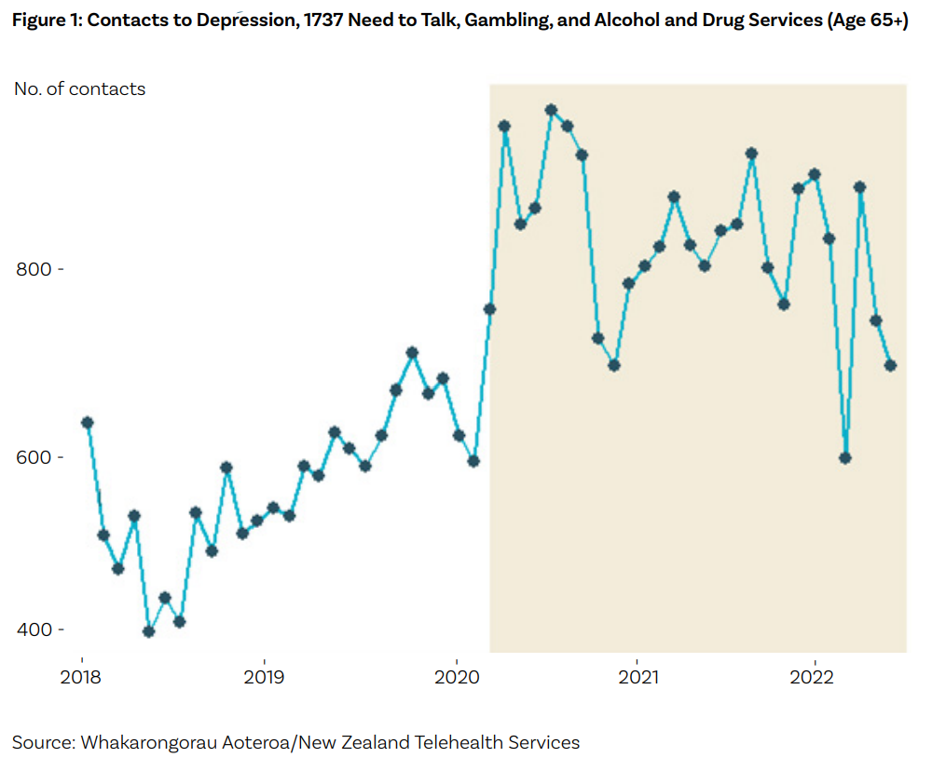
… and in some respects, older people are doing less well now, than they were earlier in the pandemic.
“... vulnerability and resilience were not distributed evenly during the early phase of the pandemic due to the pre-existing social determinants of health and wellbeing” (Allen et al., 2022c, p.22)
Communities and advocacy groups report that the freedom enjoyed by most people as safety measures have been removed is not experienced in the same way by older people. For a significant minority of older people there is a long tail of issues: feelings of anxiety and fear continue to be a challenge for older people; many are reporting anxiety about leaving the house, and a reluctance to socialise or be around others for fear of contracting COVID-19; some older people are voluntarily self-isolating due to existing health conditions.
Advocacy groups report worries about older people’s wellbeing and mental health, with increased anxiety and fear of leaving their homes, and concerns about increased isolation, alcohol harm, addiction, and suicide.
The pandemic has highlighted the resilience and contributions of older people, as they engaged in opportunities to improve wellbeing for themselves and others.
Older people were aware of the needs of others in their communities, and redistributed supplies to support others who had financial hardship, such as job loss due to lockdown restrictions.
“Fear and anxiety have driven the behaviour patterns of many seniors during the past two years. This fear and anxiety is still very present, with four in ten reporting to be more anxious now than at any other time during the pandemic” (Age Concern Wellington, 2022)
Older people worked hard to remain socially engaged, contributed to society’s efforts to get through the pandemic, and defied ageist stereotypes that portray them as fragile, vulnerable and weak.
Older people in Pacific, Chinese and Korean communities had frontline and leadership roles in the pandemic response. Older people developed their own solutions and strategies, with many experiencing fewer disruptions and economic impacts from the pandemic than other age groups. Indeed, many older people reported enjoying the initial lockdown time.
Most older people are successfully keeping in touch with family and friends through a range of means. Older people expressed a sense of connection and belonging through neighbourhood interactions and support from specific community groups, including Pacific and Asian church groups.
But those who had struggled before COVID-19 reached Aotearoa continued to struggle, and for some the struggle worsened.
“I notice older people a lot more now, and I check consciously that they are okay, or if they need help. They are on my radar a lot more than before because I feel that their age has made them more vulnerable than most to COVID.” (Survey respondent, 2021)
Residents in aged residential care, for example, struggled with social isolation and loneliness, with visiting restrictions and the lack of contact with family. Older people living with material hardship had increased anxiety and depression.
The impact of COVID-19 exacerbated existing inequities such as socioeconomic hardship in communities who were already struggling, including Māori and Pacific communities.
A range of challenges were faced by older people to have what is needed, including accessing food and necessities, and support and health services. Home-based care services were disrupted during the lockdowns, exacerbating an already stretched system and placing a great deal of stress on older people.
The support available to older people varied hugely, with community groups, family, friends and neighbours being important sources of support. Housing challenges that had existed prior to the COVID-19 pandemic continued, with additional pressure experienced as people entered into housing ‘bubbles’ through necessity and beyond their choice and control.
Discrimination increased over the course of the pandemic, which impacted on older people, particularly members of Māori, Pacific, Asian and other ethnic communities. Asian migrants in particular experienced discrimination directly related to COVID-19 and social exclusion.
The pandemic has increased ageism, with older people being largely framed in public discourse and the media as vulnerable, less adaptable and a burden on the rest of society. While older people appreciate the protective Government response, the framing as vulnerable and at risk has been a source of frustration for many, and ageism often intersects with other forms of stereotypes and prejudice, such as sexism, racism and ableism.
“When asked themselves who they viewed as vulnerable due to the pandemic, older people offered a decisively intersectional understanding. Interwoven with age and ethnicity, participants felt that situational factors such as economic deprivation and social isolation exacerbated vulnerability in the COVID-19 context.” (Morgan et al., 2022, p.11)

What this means
The COVID-19 pandemic and our responses to it have shone a light on the lives and experiences of older people, raising their visibility, and bringing about both positive and negative changes in attitude towards ageing and older people. Older people, advocacy groups and stakeholders, supported by evidence, point to the inequities that existed prior to the pandemic and served to make things worse for many older people. They also point to the resilience and agency of older people and the contribution that many made to the wellbeing of older people themselves and the community more broadly.
The resilience and creativity of older people and communities that support them does not lessen our collective responsibilities has to protect, respect and uphold the rights of older people. The pandemic experiences give us an opportunity to consider how best to support those rights and reinforce such resilience and creativity.
The experiences over the pandemic show us that what is better for older people, is often better for everybody. In short, we need to listen to older people and draw on their experiences and knowledge to improve not only their wellbeing, but the wellbeing of the wider community as a whole.
- Future planning, for the pandemic or any crisis, must ensure Māori can meaningfully participate and direct efforts from the base of their iwi and hapū, guided by tikanga and kawa. Given the role of kaumātua as guardians of tikanga, it is essential that they are involved in consultation and decision-making.
- The diversity of older people in Aotearoa must be recognised and respected. This includes recognising and consulting those groups who have poorer wellbeing outcomes, and including their community leaders and members in planning and decision-making. It also means looking at the unique challenges experienced by older people in different situations, and considering the broader context of older people’s lives.
- We need to move away from framing older people collectively and predominantly in terms of vulnerability and risk, to recognise their capacities and agency. This should be acknowledged and supported: older people can share their knowledge, networks and energy to help support older people and others in the community.
“The health and wellbeing of marae and communities directly springs from the health and wellbeing of kaumatua” (Dawes et al., 2021, pS34)
- Given the significant and rapidly increasing older population, research to better understand the experiences of older people needs to be prioritised. It is critically important to develop greater understanding of how best to promote wellbeing and mental health, recognising and drawing on the diversity of identities and experiences amongst older people. The lack of disaggregated data about the impact of the pandemic on older people in different communities makes it hard to understand and support them.

[1] https://www.mhwc.govt.nz/our-work/covid-19-insights/
[2] https://www.mhwc.govt.nz/our-work/covid-19-insights/

