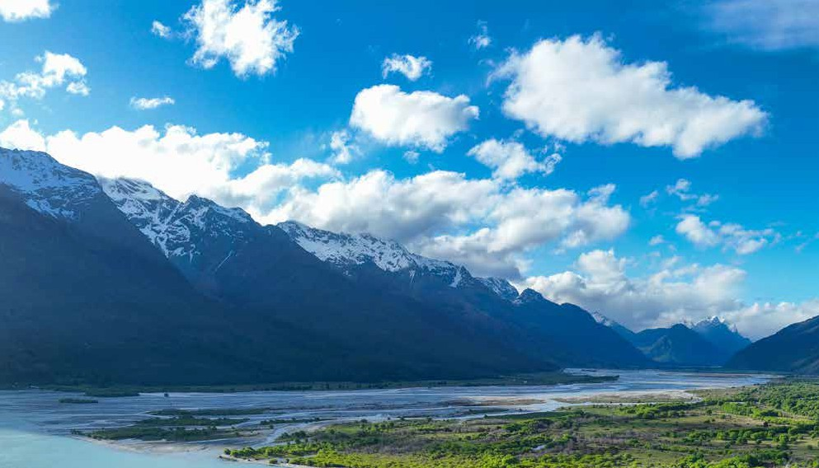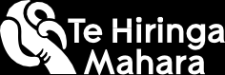

**Ngā ratonga Kaupapa Māori mō**

**te hauora hinengaro, waranga hoki**

*Te hōtaka Whai Wāhi, Kōwhiringa hoki 2025*

**Nā Te Hiringa Mahara i tuhi: Paengawhāwhā 2025**

**Ka whakaatu tēnei pārongo whakairoiro i ngā kitenga matua mai i tā mātau pūrongo o nā tata nei mō** [**te hōtaka Whai Wāhi, Kōwhiringa hoki**](https://www.mhwc.govt.nz/our-work/mental-health-and-addiction-system/access-and-chp/) **e pā ana ki te whakamahinga a Ngāi Māori i ngā ratonga Whai Wāhi, Kōwhiringa hoki. Ka raua atu ko ngā ratonga Kaupapa Māori matua mō te hauora hinengaro, waranga hoki ka whai pūtea i te hōtaka.**

Ko Te Hiringa Mahara (arā ko te Kōmihana Hauora me te Waiora Hinengaro), he mea whakature ki te arotake i ngā ratonga hauora hinengaro me te waranga, ā, kei te manawanui mātau ki te whakawhenua i tā mātau [**Tauāki ki Te Tiriti o Waitangi**](https://www.mhwc.govt.nz/assets/Who-we-are/Te-Tiriti-o-Waitangi-position-statement/Te-Tiriti-Doc-Te-Reo.pdf). Ka arotake mātau, ka akiaki hoki kia nui ake te tuku pūtea ki ngā ratonga Kaupapa Māori.

Ko ngā ratonga Kaupapa Māori, he ratonga e aro ana ki te whānau ka whakaratoa

I whai pūtea te hōtaka Whai Wāhi, Kōwhiringa hoki i te Tahua Pūtea Waiora i 2019 ki te tuku tautoko āpiti ki ngā matea hauora hinengaro, waranga hoki ‘e māmā ana, e āhua kaha ana’ kei ngā horopaki atawhai matua, hapori hoki.

E whā ngā momo ratonga o tēnei hōtaka – ngā ratonga Ngā Ratonga Mahi Tahi a te Hauora Hinengaro me te Waranga Matua (IPMHA), ngā ratonga Kaupapa Māori, Moana-nui-a-Kiwa, Rangatahi anō hoki.

atu e te Māori mō te Māori. He mea hoahoa ēnei ratonga ki te

whakawhiwhi atu i te tautoko koreutu, tāwariwari, hāngai hoki e aro ana ki te ahurea e rite ana ki a Ngāi Māori.

1. **Horopaki**

Nō te 30 o Pipiri 2024

**E ai ki te whakatau tata kua eke te tokomaha o Ngāi Māori ki Aotearoa ki te 922,600 tāngata**

**17.5 ōrau** o te taupori ā-motu.1

|  |  |
| --- | --- |
| Nō te 2023/24, tērā ko te 22.5 ōrau o Ngāi Māori e pakeke ake ana i te 15 tau **ka kī kua rongo rātau i te auhitanga hinengaro e āhua kaha ana.**2 | **22.5%** |

1. **Te Whakamahi i ngā ratonga Whai Wāhi, Kōwhiringa hoki**

Nō te 2023/24, he nui atu i te

**207,000**

## ngā tāngata i whakamahi i ngā ratonga Whai Wāhi, Kōwhiringa hoki.

E tata ana ki te hauwhā (**27 ōrau**) o ngā tāngata katoa i whakamahi i

ngā ratonga Whai Wāhi, Kōwhiringa hoki (hui katoa ngā ratonga katoa) i 2023/24, **he tāngata Māori**.

**27%**

**I whai wāhi a Ngāi Māori ki ngā momo ratonga katoa e meatia ana e te hōtaka. Ko Ngāi Māori tērā, ko te:**

**76% 35% 19% 11%**

**o ngā tāngata i whai o ngā tāngata i whai o ngā tāngata i whai o ngā tāngata i whai wāhi ki ngā ratonga wāhi ki ngā ratonga wāhi ki ngā ratonga wāhi ki ngā ratonga**

**Kaupapa Māori Rangatahi IPMHA Moana-nui-a-Kiwa**

**Tērā ko tōna 26,668 tāngata hou i whai wāhi ki ngā ratonga Kaupapa Māori 2023/24.**

**Māori 76%**

O tēnei hunga, **ko te 76 ōrau he Māori, ko te 24 ōrau he tauiwi**.

Tauiwi 24%

1 He mea tango mai i te Kaitoro Raraunga o Aotearoa i Huitanguru 2025.

2 He mea tango mai i te kaitoro raraunga ā-tau o te Rangahau Hauora o Aotearoa i Huitanguru 2025.



Ka kite koe tērā tētahi huinga raraunga e hāngai ana ki te ōrau o Ngāi Māori e whai wāhi mai ana ki ngā ratonga, kāore e eke ki te 100%, engari kei te 70, 60, 50 kē. He tohu tērā kei te hiahia a tauiwi ki tā mātau ratonga.

**Ripanga 1: Te ōrau me te nama o nga tāngata hou ā-iwi i kitea**3 **e ngā ratonga Kaupapa Māori (2023/24)**

**76% Māori**

20,313 tangata

**6% Moana- nui-a-Kiwa** 1,704 tangata

**4% Ngāi Āhia**

1,132 tangata

**13% Ko tētahi atu iwitanga** 3,519 tangata

Kaiwhakarato ratonga Kaupapa Māori



Mō ngā ratonga Kaupapa Māori, Moana-nui-a-Kiwa hoki, he rite tonu te noho mai o te tokomaha whanaunga ki te nohonga kotahi, engari ka tatauria tēnei hei tangata



I 2023/24:

**Neke atu i te 8,300**

(20 ōrau) ngā rangatahi (kei te 12-24 tau te pakeke) i whakamahi i ngā Ratonga Whai Wāhi, Kōwhiringa hoki, i whai wāhi mai ki ngā ratonga Kaupapa Māori.

+ +

I āwhina ngā ratonga Kaupapa Māori, Moana- nui-a-Kiwa, Rangatahi hoki i tōna **48,000** tāngata hemihemi.

kotahi i āwhinatia. Ka whai pānga pea tēnei ki te tatauranga o ngā tāngata hou ka āwhinatia, ka whakahuna

hoki i te tino kaute o ngā tāngata i āwhinatia.

Ko te toharite o ngā nohonga i whakaratoa atu e ngā ratonga Kaupapa Māori, i waenga i te kotahi ki te whā nohonga pea.

3 He mea homai te raraunga ki a mātau mā te iwitanga i tohua, kaua mā ngā momo iwitanga katoa, nō te mea kei te whakapūrongo mātau i ngā tāngata motuhake i kite ai mātau. Nā tēnei, ko ngā tāngata he maha ō rātau iwitanga ka tohua ki roto i te raraunga kia kotahi te iwi matua, ko te rārangitanga ko Ngāi Māori, ko ngā iwi o Te Moana-nui-a-Kiwa, ko Ngāi Āhia, ka mutu ko tētahi

atu iwitanga.

1. **Ko ngā panonitanga ka hua ake i ngā ratonga Kaupapa Māori**

He rerekē ngā tukanga kohikohi raraunga hua i tētahi ratonga me tētahi, he maha hoki ngā momo hōputu ka whakamahia pēnei i ngā taputapu ine hua, arā ko Hua Oranga, ko ngā pūrongo kōrero, ngā tauira rangahau, ngā mahi whakatakoto hua, ngā rangahau wheako, ngā puka arotake, ngā whakaahua me ngā ataata e whakamahi ana

i ‘te reo o te whānau’.

Kua whakamōhio mai ngā kaiwhakarato ratonga Kaupapa Māori i ngā pānga whai hua o ā rātau mahi ki ngā tāngata e whai wāhi atu ana ki ā rātau ratonga.



Ko te whakahono anō ki te kiritau taketake, koia ko te painga ki ngā whānau ahakoa e pēhea ana ōna āhuatanga. Ka ārahi te whānau i ngā kaimahi ki ērā wāhi.

Kaiwhakarato ratonga Kaupapa Māori



Tērā ētahi tāngata whaiora kua kōrero mai mō te panonitanga



ki te wairua katoa ina ka whai wāhi atu ki te whenua, kātahi rā te

hanga whakaora ... kāore e kitea tērā āhuatanga

i ngā ratonga huaora hinengaro whānui kei waho atu ngā ratonga Kaupapa Māori.

Nā, ka kawea ngā whānau ki te ngahere, ka āwhina i a rātau ki te hono anō ki a Papatūānuku, ka āwhina hoki i a rātau kia mōhio

ki ō rātau ake tikanga whakaora hei whakamahi mā rātau, me ngā mahi rongoā hoki, he mea āwhina katoa ēnei mahi.

Ko ngā kaimahi i konā

[i te hotaka], ka kite atu i te kaha o te rangatahi nei, arā kia noho hei tuakana, nā ka tautoko atu rātau i

a ia, ko te hua kua hoki atu ia ki te mātauranga.

1. **Te horahanga o ngā ratonga Kaupapa Māori**

Tae rawa mai ki 2023/24: **Kua hora atu ngā ratonga Kaupapa Māori ki ngā rohe**

**20 katoa, hui katoa e 32 ngā ratonga Kaupapa Māori.**

1. **Te kapamahi o ngā ratonga Kaupapa Māori**

|  |  |
| --- | --- |
| **92%** | **o ngā Kaimahi Ukiuki (FTE) (e 263.5 FTE o ngā 286.6 FTE i kirimanatia) i whai mahi i 2023/24, koia ko te pāpātanga teitei rawa o ngā momo ratonga Whai Wāhi, Kōwhiringa hoki.** |

1. **Ko te tuku pūtea ki ngā ratonga Kaupapa Māori**

I te tau tuatahi o te kaupapa Whai Wāhi, Kōwhiringa hoki, i whai wā mātau ki te hoahoa ngātahi i ngā ratonga Kaupapa Māori me Ngāi Māori (whānau, hapū, iwi, whakahaere Māori, me ngā tāngata whaiora Māori). Nā te tukanga

Tae rawa ki te 30 o Pipiri 2024, **neke atu**

**i te $83 miriona** (nō roto i te $664 miriona)

**i tukuna ki ngā ratonga Kaupapa Māori**.

**$**

Ko te **20 ōrau** o te pūtea kaupapa Whai Wāhi, Kōwhiringa ka pūmau ināianei **te tuku atu kia whakaratoa atu ngā ratonga Kaupapa Māori.**

whakakirimana nei, me ngā pānga hoki o

te Mate Kowheori-19, ka takaroa ai te kōkiri, ka iti iho te tuku pūtea ki ngā ratonga Kaupapa Māori i tā mātau i mahara ai i

ngā tau tuatahi o te hōtaka.

# Whakaahua 1: Ko te pūtea kua tohaina, kua whakapūmautia ki ngā ratonga Kaupapa Māori, 2019/20 – 2023/24

40

35.5

28.4

20.3

21.0

17.7

13.1

5.3

2.0

35

30

37.3

25

Ngā tāra ($m)

20

15

10

5

0

2019/20 2020/21 2021/22 2022/23 2023/24

Kua tohaina Kua whakapūmauita

**Te neke whakamua**

Kei te hiahia a Te Hiringa Mahara kia kohia, kia whakarārangitia ā-motu ngā raraunga hua mā ngā taputapu rangahau hua ka whakaaetia ngātahitia e ngā ratonga me ngā tāngata whaiora, otirā ō rātau whānau,

e whakamahi ana i ngā ratonga Kaupapa Māori. Kei te hiahia hoki mātau kia whai i tētahi tukanga ōrite

ā-motu mō te kohikohi raraunga e pā ana ki ngā tāngata whaiora me ō rātau whānau e ai ki ō rātau wheako i ngā ratonga. Hei whakakapi ake, kei te hiahia mātau kia kitea, kia whakaatatia hoki te tokomaha o ngā whānau ka āwhinatia i ngā nohonga ki roto i ngā tatauranga whai wāhi.

# Ngā raraunga

Ko ngā kitenga ka whakapūrongotia ki konei, he mea tiki mai i:

* **Ngā raraunga hōtaka Whai Wāhi, Kōwhiringa hoki:** he mea tuku mai nā Te Whatu Ora me te Manatū Hauora
* **Ngā raraunga auhitanga hinengaro:** tā te Manatū Hauora Te Rangahau Hauora o Aotearoa, 2023/24
* **Ngā raraunga taupori:** tā Tatauranga Aotearoa, Kaitoro Raraunga Aotearoa
* **Raraunga inekounga:** he mea kohikohi i ā mātau wānanga ki ngā kaiwhakarato Kaupapa Māori.

Nā Te Hiringa Mahara i tuhi. Paengawhāwhā 2025.

He mea tiaki te pūrongo nei e te manatā o Te Hiringa Mahara. He mea raihana ēnei kōrero manatārua kia whakamahia anōtia i raro i te raihana Creative Commons Attribution 4.0 Raihana ā-Ao. Ko te tikanga,



ka taea e koe te tārua, te tohatoha, te panoni hoki i ngā kōrero nei, engari me tautapa nā Te Hiringa Mahara ngā kōrero nei, me ū hoki ki ērā atu tikanga o te raihana. Kia tirohia te tārua o te raihana, me toro atu ki [**https://creativecommons.org/licenses/by/4.0/legalcode**](https://creativecommons.org/licenses/by/4.0/legalcode).