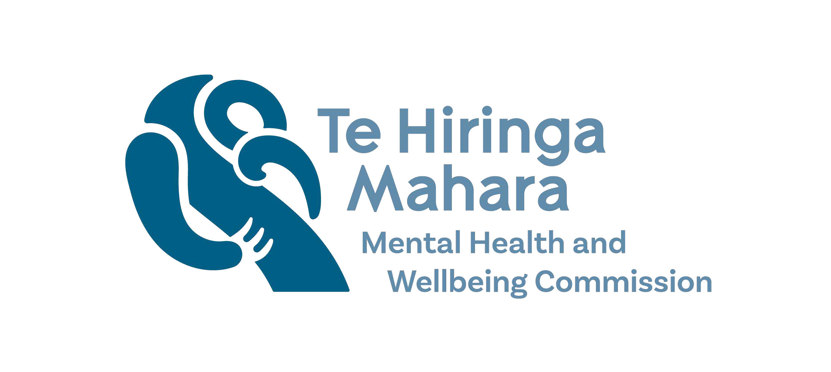
May 2024

This paper summarises measures we are discontinuing from the measure set for He Ara Āwhina monitoring.
In May 2023, we published the He Ara Āwhina methods and measures phase 1 summary. This 2023 report set out the measures we use to monitor against the He Ara Āwhina framework and how we developed these measures.
This short paper is a supplement to this report and outlines subsequent changes we have made to the He Ara Āwhina measure set.

Background
Our first monitoring report, Te Huringa, was released in March 2022 using the former Mental Health Commissioner’s framework. The second, Te Huringa Tuarua, was released in May 2023 using He Ara Āwhina for the first time.
Te Huringa Tuarua 2023 included a set of 86 measures to monitor against the He Ara Āwhina framework (HAĀ). 56 of these measures were carried over from the former Mental Health Commissioner’s monitoring reports, and 30 new measures were included from the methods and measures phase 1 project (this project was completed in November 2022, and published in May 2023).

Changes to measures
From 2024, we have removed 18 of the 86 measures used in our 2023 monitoring. This will apply to the 2024 update of the He Ara Āwhina dashboard, and the measures related to the Access and Options domain in our monitoring report Kua Tīmata Te Haerenga | The Journey Has Begun.
The rationale for removing these measures is based on three criteria:
      - Not well aligned, 10 measures are removed as these were assessed as not relevant to He Ara Āwhina monitoring. These include measures on complaints and serious adverse events. These measures are deficit-based which do not align to the aspirational framing of He Ara Āwhina. Further, there are technical limitations to these measures. With the complaints data there are significant cultural differences in reporting complaints. For serious adverse events, the data can not be used to distinguish whether changes in adverse events over time is due to changes in reporting practices or changes in incidents (or both).
We will continue to keep a watch on these measures but will not report on them as part of the He Ara Āwhina measure set. Other agencies in the sector (Health Quality & Safety Commission and the Health and Disability Commissioner) report on these measures.
      - No future data, 6 measures sourced from Mārama RealTime Feedback are removed as this data is no longer collected. We will continue to include these measures on our He Ara Āwhina dashboard to highlight the importance of these measures, but there will be an ended time series of 2021/22.
The absence of any national tāngata whaiora reported experience measures for mental health and addiction is a significant concern. Experience measures are critical to enable services to understand and improve experiences of people using services and to monitor lived experience participation and leadership. We plan to continue advocating for data improvements on tāngata whaiora and whānau experience measures, along with other key data advocacy areas.
      - Too small for reporting, 2 measures are removed as the data is too small for any time series or disaggregated analysis (such as by ethnicity or age groups). These two measures relate to the length of time detained under the Substance Addiction (Compulsory Assessment and Treatment) Act. The Ministry of Health reports on these measures.

Future monitoring and reporting
The full application of monitoring against He Ara Āwhina is significant and it will take time to develop our full suite of methods and measures. The measure list of the He Ara Āwhina framework is intended to be ‘living’, as we continue to evolve the measure list over time so it remains relevant and current. An important part of our continual refinement of the He Ara Āwhina measure set is to improve monitoring against the Te Ao Māori domains of the framework.
We will continue to improve our measure set, and publish any future changes made.

