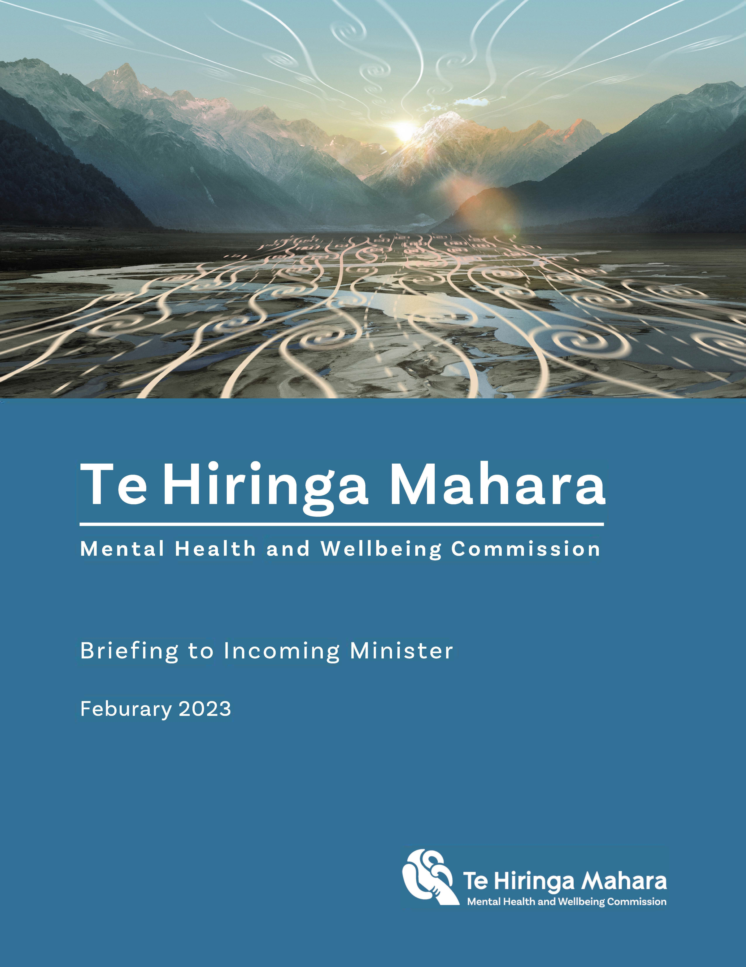

Briefing to Incoming Ministers Minister of Health and Minister for Mental Health
November 2023

Welcome from the Chair
Congratulations on your appointments as Minister of Health and Minister for Mental Health.
Te Hiringa Mahara, the Mental Health and Wellbeing Commission, provides system oversight and leadership for mental health and wellbeing, through independent monitoring and advocacy for improved mental health and wellbeing.
Mental health and addiction outcomes for many people are poor, inequitable, and worsening. Demand for supports and services has grown in recent years, outstripping the capacity of our mental health and addiction system to provide these services.
There is urgent need for new approaches that support overall wellbeing of people, enabling people to self-determine their recovery, and providing accessible and appropriate services at the right time.
Working at the margins will be insufﬁcient to provide the improved mental health and wellbeing outcomes called for by people with lived experience and people seeking support (tāngata whaiora), and the whānau, families and communities that support them. Transformation, in the way we provide mental health and addiction services, and in the priority and attention we give to wellbeing more broadly, is essential.
Your commitment to addressing mental health challenges is welcome and needed. This brieﬁng outlines the key areas where you can drive improvement by bringing a clear focus on mental health and wellbeing alongside broader health outcomes; by providing accessible services, particularly for Māori, rangatahi and young people; by reducing the use of compulsory treatment; and by making it easy for communities to support their wellbeing.
Alongside these, we highlight a few actions you could take immediately, to signal your focus and support for the transformation, by:
- introducing the Member’s Bill Pae Ora (Healthy Futures) (Improving Mental Health Outcomes) Amendment Bill as a Government Bill, to include a mental health and wellbeing strategy in the Act.
- including a mental health target in the suite of proposed health targets, focused on improving access to mental health and addiction services.
- allocating funding and commissioning a phased prevalence survey of mental health and wellbeing starting with children and young people.
Te Hiringa Mahara is here to work with you and we look forward to meeting with you at your earliest convenience.
Hayden Wano Board Chair

Contents

Welcome from the Chair | 1
Part 1 – Summary and our role  As Minister, you have an opportunity to make meaningful improvement to mental health and wellbeing outcomes | 3
Te Hiringa Mahara is here to help, to lead, and to shine a light | 4
The mental health and addiction system in Aotearoa needs ongoing transformation | 6
Part 2 - The mental health and addiction system  Many priorities for improvement in mental health and addiction services are clear | 7
You can make a meaningful difference to mental health and addiction outcomes | 11
Part 3 - Priority areas for improving wellbeing  A focus on the relationship between determinants and mental health and wellbeing is required | 13
You can make a meaningful difference to wellbeing outcomes | 15
Appendices
Appendix 1: Our legislation | 17
Appendix 2: Mental health and addiction targets | 18
Appendix 3: Board and leadership team proﬁles | 20
Appendix 4: He Ara Awhina (Pathways to Support) Framework | 23
Appendix 5: He Ara Oranga wellbeing outcomes framework | 24

As Minister, you have an opportunity to make meaningful improvement to mental health and wellbeing outcomes
- Work to improve both mental health and wellbeing outcomes has begun, but there is much to do.
- Te Hiringa Mahara was formed in response to the 2018 Government Inquiry – He Ara Oranga, which envisioned a mental health and addiction system with people at the centre. We bring our independent voice and roles of system leader, monitor and advocate for achieving equitable wellbeing outcomes for people to this purpose.
- In this brieﬁng, we lay out the shape of transformation which will require signiﬁcant shifts in the way government supports mental health and wellbeing and provides services that meet the needs and aspirations of tāngata whaiora (person seeking health), beyond the steps already taken to improve services.
- This advice is provided ﬁrst in a brief outline of our role, then a focus on the mental health and addiction system, and ﬁnally on broader wellbeing. Within that, we identify key areas where you can push for action now, to improve mental health and wellbeing outcomes for many people in Aotearoa New Zealand. You can make real change by:
  - Providing dedicated leadership and ensuring your agencies maintain a focus on mental health and wellbeing.
  - Making equity for Māori a mental health and wellbeing priority.
  - Championing the shift from coercive to choice-based treatment, and expanding appropriate services, including for rangatahi and young people.
  - Growing the mental health and addiction workforce, including an expansion of roles.
  - Ensuring communities, rangatahi and young people in particular, are heard, resourced, and trusted to support their wellbeing.

Te Hiringa Mahara is here to help, to lead, and to shine a light

We monitor mental health system performance and shine a light on what works for improving wellbeing
- Through the Mental Health and Wellbeing Commission Act 2020, Parliament gave Te Hiringa Mahara responsibility for oversight and leadership in relation to mental health and addiction services and charged us with responsibility to assess and report on mental health, and wellbeing more generally. As such, we:
  - monitor and advocate for improvement to mental health and addiction services in Aotearoa, to create a system that is more people-centric, more equitable, and supports greater mental health outcomes for all.
  - assess and report on peoples’ mental health and wellbeing, the factors that affect them, and the effectiveness of the approaches to support them.
- Our system and population monitoring is guided by our two related frameworks:
  - Our He Ara Āwhina (Pathways to support) monitoring framework (appendix 4) shows what an ideal mental health and addiction system looks like. We use He Ara Āwhina to monitor mental health and addiction system and services.
  - Our He Ara Oranga wellbeing outcomes framework (appendix 5) provides a picture of what holistic wellbeing looks like, and a way to measure whether wellbeing outcomes are improving.

Our role and independence provide the ability to be a critical friend for monitoring system performance and wellbeing outcomes
- Te Hiringa Mahara is an independent Crown entity operating under the Mental Health and Wellbeing Commission Act 2020. The Act requires us to uphold Te Tiriti o Waitangi and have particular regard for the experience of, and outcomes for Māori to achieve better and equitable mental health and wellbeing outcomes.
- We report to the Minister of Health, with the Ministry of Health as the monitoring agency and with the Social Wellbeing Agency as advisors to the Ministry of Health. Proﬁles of our Board members and leadership team are included as appendix 3.
- We have a very broad statutory mandate, with 20 full-time equivalent permanent staff and funding of around $5m per annum through an appropriation within Vote Health. To deliver our legislated functions (Appendix 1), we have four enduring priorities, which guide this advice:
  - Advancing mental health and wellbeing outcomes for Māori and whānau
  - Achieving equity for priority populations

  - Advocating for a mental health and addiction system that has people and whānau at the centre
  - Addressing the wider determinants of mental health and wellbeing.
- To deliver on our enduring priorities, our immediate focus areas are wellbeing and improving services for rangatahi and young people, increasing Kaupapa Māori services and reducing coercive practices supported by expansion of the choice of services.
- We have established strong working links with key government agencies, particularly Manatū Hauora, Te Aka Whai Ora, and Te Whatu Ora in the health sector.
- We are building relationships with government agencies to better target system settings and existing investment, and to align and consolidate measurement of wellbeing.
- We engage with mana whenua and over 50 organisations and representative bodies across our listed priority populations, to understand their needs and inform our work.
- We have work currently underway to monitor the mental health and addiction services and system, including a focused paper on access and options. We are beginning work to monitor progress of Kia Manawanui Aotearoa: Long Term Pathway to mental wellbeing, including to improve mental health and wellbeing outcomes; and to report on mental health and wellbeing for young people and rangatahi, and Paciﬁc peoples. We would welcome the opportunity to brief you on these and seek your views.
- We met regularly with the previous Ministers of Health, and the Associate Ministers with Māori and Paciﬁc health portfolios. We also engage with the Cross-Party Mental Health and Addictions Wellbeing Group.
- We look forward to meeting regularly with you also, to continue progress on the recommendations of He Ara Oranga and raising mental health and wellbeing outcomes.

The mental health and addiction system in Aotearoa needs ongoing transformation
- You are aware of the scale of the mental health and addiction challenges faced in Aotearoa. Each year around one in ﬁve of us experience mental illness or signiﬁcant mental distress. The last Mental Health Survey (2006) showed that ﬁfty to eighty percent of people in Aotearoa will experience mental distress or addiction challenges or both in their lifetime. Evidence provided to the Government Inquiry into Mental Health and Addiction showed the prevalence of mental distress among Māori is almost 50% higher than among non-Māori, and Māori are 30% more likely than other ethnic groups to have their mental illness undiagnosed.
- Many people cannot access the level of support they need in a way that works for them. When people access mental health and addiction services, they often ﬁnd services are not provided in an integrated way that adequately meet individuals’ and whānau and family needs and preferences.
- These challenges were recognised and explored in the 2018 He Ara Oranga: Report of the Government Inquiry into Mental Health and Addiction and remain evident, as shown in our monitoring reports1. The need for transformation through a continued focus on improving mental health and addiction, and broader wellbeing outcomes is greater than ever.
- Achieving these aims requires a broad view of both mental health and wellbeing, based on people and their experiences. It means ensuring people can access services that are appropriate and available, in the ways that matter to them to improve their wellbeing.
- In practice, this requires growth in kaupapa Māori and other culturally appropriate services, peer-led services, early support, and intervention options, and strengthened specialist services. It will mean a focus on mental health promotion, and genuine recognition of the role of community members and entities in service design and delivery. Importantly, it will also mean promoting and supporting greater wellbeing, by addressing the determinants of wellbeing as a coordinated effort across agencies and portfolios, as explored further in part 3.

¹ https://www.mhwc.govt.nz/our-work/mental-health-and-addiction-system/te-huringa/

Many priorities for improvement in mental health and addiction services are clear

We need to build on the strengths of the system and its people
- There has been substantial investment into mental health and addiction services and promising increases in access to primary and community services. The Access and Choice programme is starting to transform the landscape of primary mental health and addiction services, but the programme addresses only some of what is needed. We encourage ongoing focus and investment across the continuum of services.
- There have been positive steps to broaden service options with the growth in Kaupapa Māori services, Paciﬁc services and youth services. These services have increased the options for responding to mild to moderate mental health and addiction need, which is important. However, there remains an urgent need to provide more options for people experiencing acute mental distress. Investment in this part of the system will be critical to improve services and outcomes.
- While mental health and addiction service use has increased over the last 5 years, our last monitoring report showed a decrease in access to almost all mental health and addiction services in the year ending 30 June 2022. This ﬁnding was surprising given what we know about increasing need for mental health and addiction support. Our current monitoring work is exploring this issue further, and we will report on our ﬁndings by June 2024.
- Structural change alone will not meet the needs of those who are underserved nor address persistent inequities that exist within the system. System change needs a focus on the right priorities, with clinical and lived experience expertise at the decision-making table, alongside the communities impacted by those decisions.

The system needs to make equity for Māori a priority
- The entrenched, systemic inequities Māori experience have impacted on their mental health and wellbeing outcomes. Colonisation, racism and discrimination have negatively impacted Māori and their outcomes we see today. Overcoming these challenges will require commitment to equity as an expressed priority for Māori, and a signiﬁcant and sustained focus.
- Everybody should be able to access the right care for them, when and where they need it. For many Māori in need of support from the mental health and addiction system, this means accessing Kaupapa Māori services. Where these services are available, responses have been positive. We need to see an expansion of the range and scope of Kaupapa Māori services, and greater cultural capability in all services, to provide appropriate care, to reduce inequitable outcomes, and to meet the

Crown’s te Tiriti o Waitangi responsibilities to uphold tino rangatiratanga and protect oranga (health and wellbeing).
- In 2019, 20% of the Access and Choice services funding was allocated to Kaupapa Māori services, however, it remains that less than 11% of the investment into mental health and addiction services is allocated to Kaupapa Māori services. This needs to change, with the expansion of Kaupapa Māori across other services.

The system needs to increase choice of services and reduce coercive practices
- All people accessing health and disability services have the right to make an informed choice and give informed consent to treatment, to the extent possible with their decision-making skills at the time, and with the support of their family and whānau. However, approximately 11,000 people are subjected to compulsory mental health treatment every year, irrespective of their capacity to make decisions about their care and treatment. Our report2 into compulsory community treatment showed that the number of people subjected to a Compulsory Community Treatment Order under the Mental Health Act increased by 8% between 2017 and 2021: in 2021, almost 7,000 people were under compulsory treatment in our communities.
- The work underway to repeal and replace the Mental Health Act offers a unique opportunity to transform the mental health and addiction system for people who experience distress and those who support them. We want to see substituted decision making based on ‘mental disorder’ replaced with supported decision making – meaning affected individuals are supported to make decisions about their own care. We want to see the new legislation grounded in Te Tiriti o Waitangi and human rights, and see it put into action through alternative acute options available in all localities.
Compulsory community treatment orders (CCTOs) can lead to people being medicated without consent and have their freedom of movement curtailed. Māori are 1.8 times more likely than Pacific people and four times more likely than other populations to be subject to a CCTO, and this number and inequity is growing.
- Alongside this legislative change, there is practical and effective change that could take place now to ensure the voices of tāngata whaiora, people with lived experience of distress and their family and whānau are heard. This includes sharing (clinical) information in plain language, more time for decision-making, involving

² https://www.mhwc.govt.nz/news-and-resources/lived-experiences-of-cctos-report/

whānau, family, and other supporters in planning with tāngata whaiora, and supporting tikanga in court hearings.

The system needs to provide accessible services for rangatahi and young people
- Rates of distress, anxiety and depression have increased signiﬁcantly over the past decade for rangatahi and young people. Rates of psychological distress among people aged 15-24 years have more than quadrupled in the last 10 years.
- Where mental health and addiction services are needed, rangatahi and young people must have access to early, accessible, and culturally- and age-appropriate services. Recent performance measures for Te Whatu Ora show concerning increases in waiting times for young people to access specialist mental health services. The majority of districts showed an increase in the proportion of young people not accessing services within three weeks. We have identiﬁed two areas of need that can and must be addressed:
  - the system must expand access to youth mental health and addiction services in all localities; and
  - the system must reduce the number of rangatahi and young people admitted to adult in-patient mental health services to zero.
- Our reports show that more young people have accessed services in recent years.. Around 24,000 young people made up 21% of users of Access and Choice mental health services in 2021/22. Of these, 35% are rangatahi Māori. If young people access the services at the same rate as other age groups, we would expect the programme to support 55,000 people aged 12–24 years each year when its rollout is complete. However, there is more work to do to roll out Access and Choice services.
- While there has been a decrease in the last decade, over 150 rangatahi and young people are still admitted to adult units each year. Rangatahi and young people we spoke to told us the negative impacts of admission to adult services (e.g., being around extremely distressed adults, losing hope for recovery, having their rights overridden, losing access to education) outweigh any potential positive aspects (e.g., earlier intervention, or receiving care closer to home).
- Rangatahi and young people want youth-speciﬁc acute response services. This includes more community residential alternatives to child and adolescent hospital inpatient mental health care, and kaupapa Māori services. Young people told us that, for services to meet their needs when experiencing acute distress or crisis, services need to be co-designed with rangatahi and young people who have lived experience of mental distress. Often, this looks like services co-located with other social, health or educational services rangatahi and young people access. Exemplar

organisations and providers are already doing this, in patches, across Aotearoa. These should be scaled, replicated and learned from.

The system will need a well-planned workforce with a broader variety of roles
- The mental health and addiction sector has a strong, highly skilled and committed workforce. The workforce is under pressure, and tāngata whaiora and people with lived experience of distress tell us that accessing support has been a challenge during and since the pandemic.
- Workforce remains a signiﬁcant challenge for the wider mental health and addiction sector, and for the Access and Choice programme speciﬁcally – there will be a signiﬁcant stretch for all services to recruit to the estimated required workforce over the next two years.
An estimated additional 264 clinical, 470 non-clinical, and 81 cultural staff are required for the Access and Choice programme between June 2022 and June 2024 (and then ongoing).
Peer support positions increased by 18% from 361 FTE
in 2018 to 425 FTE in 2022 but has not increased as a proportion of the total mental health and alcohol and drug workforce (at 3.4% of the workforce).
- Te Whatu Ora recently released a broad 2023/24 health workforce plan. A mental health and addiction service focused strategy and roadmap is also needed.
- A workforce roadmap cannot rely on attracting staff from overseas. This is not sustainable in the long-term and is unlikely to meet the full range of needs of people accessing services.
- Similarly, the roadmap cannot rely too heavily on making existing roles more attractive. Sixty percent of Health Improvement Practitioners and 40% of Health Coaches were previously employed in mental health or addiction services – so funding alone is unlikely to expand the overall mental health and addiction workforce as effectively as required.
- A redesign of the workforce is needed, in which the current workforce is resourced and supported to work to the top of their scope, complemented by, and working alongside, a larger peer support, lived experience and cultural workforce.

You can make a meaningful difference to mental health and addiction outcomes

The system requires dedicated leadership and attention, to match the scale of the challenge
- As you shape the future structure of the health system, it is imperative that the Government ensures that mental health and addiction services, and the voices of our communities, remain a focus, despite the many other pressing issues.
- Alongside the priority areas detailed in this brieﬁng, there are a few immediate actions you could take, to show your focus on lifting mental health and wellbeing outcomes.
  - You could introduce the Member’s Bill Pae Ora (Healthy Futures) (Improving Mental Health Outcomes) Amendment Bill as a Government Bill, to include a mental health and wellbeing strategy under the Act. We would, in principle, support such an addition, and of the requirement for Te Hiringa Mahara to be consulted, but at this stage would likely advise against adding the Mental Health and Wellbeing Commission to the list of health entities in the Act. We would be happy to provide you further advice on this, and the impacts of the proposed changes.
  - You have made a commitment to set targets for the health system. There is an opportunity to include a mental health target within the suite of key targets. We recommend a sixth priority target focused on improving access to mental health and addiction services (attached as Appendix 2).
  - There is a gap in our collective understanding of the prevalence of mental health and wellbeing of all people in Aotearoa. You could allocate funding and instigate the work to address this gap, by commissioning a phased prevalence survey starting with children and young people, as outlined further in paragraphs 72 – 74, below.

Equity for Māori should be a priority for the system and your agencies
- There needs to be equitable funding for kaupapa Māori services, and commissioning models that enable high trust, ﬂexibility, and sustainability for kaupapa Māori and other culturally relevant services. These services require a workforce that understands and can deliver te ao Māori healing practices, philosophies and processes.
- Further, with the planned disestablishment of Te Aka Whai Ora, it is critical that the focus and momentum of recent years is strengthened and improved. Your agencies will need to make clear the responsibilities for the monitoring of Kaupapa Māori services; develop a plan to retain the knowledge, work, and progress that has

been created so far; and undertake monitoring of the mental health and wellbeing impacts and outcomes of the structural changes. We can support these steps, and provide further advice.

A shift from coercive to choice-based treatment is needed
- Change to the Mental Health Act is underway. Delivering the intended shift will require a broader range of services options, including culturally responsive options, that support people to make positive choices early that work for them.
- In the meantime, the system could deliver real improvement to mental health and wellbeing outcomes through supporting communities, providers, clinicians, and people with lived experience to enact changes that minimise compulsory treatment and reduce inequities for Māori and Paciﬁc peoples.
- We have prepared further advice on increasing the choice of services and reducing coercive practices, and would appreciate the opportunity to discuss this with you as soon as practical.

Appropriate services for rangatahi and young people should be expanded
- In line with the needs and advice of rangatahi and young people outlined above, a greater range of appropriate options are needed, accessible across all of Aotearoa.
- You could set an expectation that the number of rangatahi and young people admitted to adult inpatient units should reduce to zero. This will require a targeted plan, including investing in residential alternatives to hospital based inpatient mental health care, including Kaupapa Māori services and peer support options, and short-term respite care.

Your agencies should grow the workforce through an expansion of the number and variety of roles
- To deliver improved services, and the priorities above, the mental health and addiction system requires a larger and more diverse workforce. Your agencies need to urgently develop a mental health and addiction service workforce plan, which supports, builds on, and complements the existing workforce. This should be a priority of the new workforce taskforce set up by Te Whatu Ora.
- The plan must identify the services needed, as outlined above, and outline a workforce pipeline in which recruiting from overseas and training more psychologists are two small parts, alongside expansion of a range of peer, cultural and community support roles.

A focus on the relationship between determinants and mental health and wellbeing is required
- Individual and family or whānau wellbeing is inﬂuenced by several economic, social, cultural, political and environmental factors or determinants. Determinants of wellbeing have a greater impact on outcomes experienced by people than services do. As such, it will take more than structural reform, and more than a health system focus, to address persistent and longstanding inequities and improve wellbeing outcomes for all people in Aotearoa.
- For the health sector, the expectations for improved outcomes are currently described, or are being developed, through the range of health strategies required under the Pae Ora (Healthy Futures) Act 2022. That Act also requires a Government Policy Statement (GPS), which is currently in development and will set out how the Government will give effect to the strategies.
- Unless the Government requires collaboration across departments and portfolios to improve the determinants of wellbeing for populations that face existing inequities, it will continue to be peripheral at best. The mechanisms to enable such cross-government collaboration are currently weak or not used, hindered by separate funding appropriations, accountability structures, and competing priorities.
- Te Hiringa Mahara has a role to report on the determinants of mental health and wellbeing and where possible the impact of determinants on mental health and wellbeing. We also have a wellbeing system leadership role across government to promote collaboration, alignment and communication across entities that are responsible for delivering on improved mental health and wellbeing. As we recommended in our 2021 “Te Rau Tira Wellbeing Outcomes Report”3, improvement in wellbeing will require a plan that brings together all relevant government agencies with the private sector and communities.

Better outcome and wellbeing data is needed to enable evidence-based decision making
- Our He Ara Oranga wellbeing outcomes framework contains a set of outcomes that describe what holistic wellbeing looks like. We have also developed a set of proxy wellbeing measures to monitor whether wellbeing is improving for people over time. Delivering our legislated role to monitor wellbeing outcomes requires better data that is readily available, particularly to understand and support groups who experience inequities in mental health and wellbeing outcomes including Māori, Pasiﬁka, children and young people, older people, rural populations,

³ https://www.mhwc.govt.nz/news-and-resources/te-rau-tira-wellbeing-outcomes-report/

migrants, veterans, and ethnic communities, and people at the intersection of these communities.
- Without this critical outcome data, as well as more up-to-date and robust research to understand baseline prevalence of mental health and wellbeing, government is not in the best position to make evidence-based policy and investment decisions.
- Improved systematic wellbeing data collection, analysis and decision-making also need to be informed by the priorities and worldviews of the communities it describes. This is especially important for Māori to ensure we are investing in initiatives that meaningfully improve wellbeing from a Māori perspective.

Community efforts are at the heart of supporting wellbeing outcomes
- Challenges and external shocks, such as natural disasters, economic downturns, the pandemic, and a cost of living crisis, threaten wellbeing and exacerbate the causes of mental stress and distress – particularly for communities already experiencing inequities. While major events may not be predictable, the needs they exacerbate are not new, and these have not been sufﬁciently addressed.
- As we have seen through the pandemic4, recent severe weather events, and in the face of economic challenges, communities across Aotearoa pull together to support one another, and lift or protect wellbeing. These communities came together based on location, culture, shared identity and shared experience, and showed that local knowledge, community connections, trust and passion are vital tools in supporting community and therefore family and whānau wellbeing.
- What these communities often lack is the resources – whether ﬁnancial, personnel or information – to provide support at the scale wanted or needed. Where communities can access the resources of the state, their impacts are greatly ampliﬁed. In turn, where government can tap into these local networks and expertise, they are able to make meaningful change with the resources they have available and reach people who they otherwise would not.
- For Māori this includes recognising the value of having and exercising rangatiratanga (authority and leadership), and giving iwi, hapū and whānau the freedom and resources to act in the way that best meets their wellbeing needs, or to guide government decision-making and commissioning, informed by tikanga (protocol) and mātauranga Māori (Māori knowledge).

Improving wellbeing for rangatahi and young people needs action
- As noted previously, rates of distress, anxiety, and depression have increased signiﬁcantly over the past decade for rangatahi and young people. As a group,

⁴ https://www.mhwc.govt.nz/our-work/wellbeing/covid-19-insights/

rangatahi and young people tend to have fewer resources and less power with which they can support wellbeing. A focus on the needs of rangatahi and young people is required, to support their wellbeing and to avoid stress and distress.
- Rangatahi and young people themselves have identiﬁed key wellbeing challenges they face relating to uncertain futures, racism and discrimination, social media, and safety online, and the need for better whānau and intergenerational connections5. Each of these areas need action, and due to the broad nature of these barriers, cross-government leadership will be necessary, with the involvement of rangatahi and young people. Rangatahi should be supported to wānanga solutions they see in addressing the speciﬁc cultural, spiritual and intergenerational connections.

You can make a meaningful difference to wellbeing outcomes
- You have the opportunity to focus attention and drive change in wellbeing system leadership by raising and setting expectations. Your 100-day plan outlines several policies, including an intent to improve housing stability, and to support cyclone and ﬂooding recovery, which would have wellbeing, mental and physical health impacts. These wider impacts should be considered in all government policy and action, and as senior Ministers, you have considerable inﬂuence on how a range of government action supports wellbeing outcomes.

You can drive a focus on wellbeing in all cross-government action
- It is critical, that your Government Policy Statement (GPS) provides a clear requirement for government departments to work together across traditional government and departmental boundaries. Guided by the health strategies and the GPS, Manatū Hauora’s Kia Manawanui Aotearoa – Long-term pathway to mental wellbeing could be built on to become the required plan for delivering these requirements.
- Our He Ara Oranga wellbeing outcomes framework is a key tool to monitor and drive improved wellbeing outcomes across government. This framework, through a common understanding of wellbeing and a way to track outcomes over time, gives tangible focus to real wellbeing improvement that will be supported by your leadership, and an expectation that, through it, your agencies are clear on what they mean when they seek to ‘improve wellbeing’.
- Having a focus on wellbeing will reinforce the importance and beneﬁts of non- mental health initiatives to mental health and addiction outcomes. You could reinforce and support the importance of government action to reduce inequities in determinants such as housing and incomes, and cross-agency work to provide

⁵ https://www.mhwc.govt.nz/our-work/wellbeing/youth-wellbeing-insights/

wrap-around early support, whānau-based, or ‘one-stop shop’ social services that reach people where they are.
- One focus for cross-agency work you could lead to deliver improved outcomes, across a range of areas, is alcohol and other drug law reform that prioritises human rights, wellbeing, and equity. The recommendations in He Ara Oranga for laws that take a health approach to drug use have not been implemented, and a variety of levers (including those identiﬁed by the Law Commission’s Report on the regulatory framework for the sale and supply of liquor) are available to reduce the harm caused by alcohol. Coupled with increased access to range of addiction supports and services, your government could draw on these reports to make meaningful improvements to the wellbeing of people who use or misuse drugs and alcohol, and their wider communities.

You can support decision-making, with better data
- A focus on wellbeing should be supported by prioritising and resourcing efforts to collect and use wellbeing data, which will support government decision-making to best address need and deliver value for money. As part of this, and as noted earlier, we strongly support action to improve data on prevalence of mental health and wellbeing. A phased approach to the investment in a population survey (for example starting with children and young people) is more feasible.
- Te Hiringa Mahara has a strong interest in the development of a prevalence survey given our role to assess and report on the mental health and wellbeing of all people in Aotearoa. Work has commenced to understand the need and potential approaches to a prevalence survey, and Te Pou, who are working with us on this, will be brieﬁng you separately.
- We are well positioned to support the coordination across multiple agencies to ensure alignment on data collection for mental health and wellbeing using our existing measurement frameworks. We have developed further advice on options to improve outcome data collection, which we can provide as required.

Your agencies should work more closely with communities to ensure they are heard, resourced, and trusted
- Communities and community-based providers described how swift and responsive funding and resourcing from government during the pandemic enabled them to provide support where it was needed, pivoting as necessary and repurposing funding to meet identiﬁed needs. These approaches will work outside the pandemic too, but this will require agencies to recognise and consult those groups who often have poorer wellbeing outcomes and include their community leaders and members in planning and decision-making.

Appendix 1: Our legislation
The Mental Health and Wellbeing Commission Act was introduced in 2020, and the Commission was established on 9 February 2021.
Objective
Our objective is to contribute to better and equitable mental health and wellbeing outcomes for all people in New Zealand
Functions
  - to assess and report publicly on the mental health and wellbeing of people in New Zealand; and
  - to assess and report publicly on the factors that affect people’s mental health and wellbeing; and
  - to assess and report publicly on the effectiveness, efﬁciency, and adequacy of approaches to mental health and wellbeing; and
  - to make recommendations to improve the effectiveness, efﬁciency, and adequacy of approaches to mental health and wellbeing; and
  - to monitor mental health services and addiction services and advocate improvements to those services; and
  - to promote alignment, collaboration, and communication between entities involved in mental health and wellbeing; and.
  - to advocate for the collective interests of people who experience mental distress or addiction (or both), and the people (including family and whānau) who support them.

Appendix 2: Mental health and addiction targets

Context
In the lead up to the election, the National Party indicated it would reintroduce health sector targets. The ﬁve major target areas that were announced were shorter stays in emergency departments, faster cancer treatment, immunisation, shorter wait times for ﬁrst specialist assessment, and shorter wait times for surgery. There was no speciﬁc mental health and addiction target announced.
There is a large body of evidence that shows targets in certain circumstances can be highly effective at improving health outcomes (e.g., the child immunisation target in the early 2010s was successful in lifting child immunisation rates). However, targets can also lead to unintended consequences, “gaming” behaviours, inequitable distribution of beneﬁts, and reduced focus on other areas.

Our Advice
Introduce a speciﬁc mental health and addiction service target
We recommend a speciﬁc mental health and addiction target as part of the proposed suite of targets to be introduced. This will ensure that mental health and addiction remains a priority and there is public reporting on progress in improving mental health and addiction services.
Focus the mental health and addiction target on access to primary services
We recommend focusing a mental health and addiction target on access to services because people are still experiencing issues in accessing the right services when and where they need.
We speciﬁcally suggest access to primary mental health and addiction services because this is a critical area to provide early intervention to people experiencing mental distress or substance use harm. Access to specialist services is important to support people with acute or more complex needs. However, a combined target on both access to primary and specialist services will not be as effective in driving performance improvements. Targets work best when focused on speciﬁc service areas. There are other existing mechanisms, including health performance reporting, to monitor access to specialist services.
We advise engaging with the mental health and addiction sector in developing the target to specify the scope of primary care services within the target, the speciﬁc measurement, and the performance threshold:
  - The scope could encompass services within General Practice, primary mental health initiatives, Access and Choice services within and beyond General Practices, and school-based services.

  - The diversity of data collection practice and infrastructure across the primary care landscape will provide challenges in measurement. However, setting this target will incentivise improved data collection, quality, and availability.
An access to primary care target could be accompanied by two balancing measures (that monitor any unintended consequences of focusing on the target area), namely, quality of care and choice in services.
As part of our monitoring function, we are currently undertaking further investigation into access to mental health and addiction services, and options available to people.
Include an explicit equity component to all health targets
In setting targets we recommend an explicit equity component for Māori be included. For example, “95% of two-year-olds to get their full age-appropriate immunisations, including 95% of Māori tamariki”. It is crucial to our Te Tiriti o Waitangi obligations that we do not set targets that increase the equity gap. Without this explicit equity component, targets can improve outcomes for the people who are easier to reach and miss those who would beneﬁt the most.

Appendix 3: Board and leadership team proﬁles

Board proﬁles
The Te Hiringa Mahara Board is chaired by Hayden Wano. The board members are Kevin Hague (Deputy Chair), Professor Sunny Collings, Taimi Allan, Dr Barbara Disley, Tuari Potiki and Alexander El Amanni.

Board member | Position
Hayden Wano | Chair
 | Hayden is of Te Atiawa, Taranaki, and Ngāti Awa descent and has over 40 years health sector experience in mental health, community, and medical services, including 25 years as CEO of Tui Ora. Hayden is a member of a range of governing Boards.
Kevin Hague | Deputy Chair
 | Kevin is the Chair of the Public Health Advisory Committee, the West Coast PHO, and Takiwā Poutini (the West Coast Locality). Kevin was a Member of Parliament for eight years and has been Chief Executive of a number of organisations, including the West Coast DHB.
Professor Sunny Collings | Board member
 | Sunny is Chief Executive of the Health Research Council, following nine years as Dean and Head of Campus at the University of Otago Wellington. Sunny practiced as a Consultant Psychiatrist for over 25 years and has broad expertise as a researcher, manager, and senior leader in the clinical mental health sector, in health academia, and in suicide prevention.
Taimi Allan | Board member
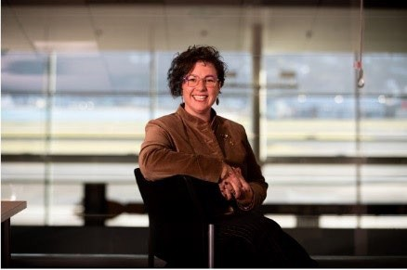 | Taimi Allan, newly appointed as the Mental Health Commissioner of South Australia, continues to hold a concurrent role as a Board Member for Te Hiringa Mahara. Taimi was previously Tumu Whakarae (Director) of Ember Innovations, and CEO of Changing Minds.

Board member | Position
Dr Barbara Disley | Board member
 | Barbara is the former CEO of Emerge Aotearoa and was a member of the Government Inquiry into Mental Health and Addiction. Barbara is Chair of the IIMHL/IDL (Global Leaders Exchange) and Board member of TheMHS. Barbara has held a number of senior public sector positions including chair of the ﬁrst Mental Health Commission and Deputy Secretary, Ministry of Education.
Tuari Potiki  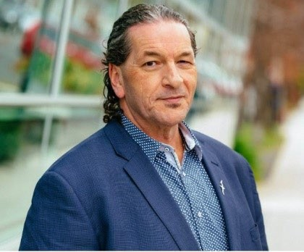 | Board member
 | Tuari is of Kāi Tahu, Kāti Mamoe and Waitaha descent. He has more than 30 years’ experience in Māori alcohol and drug and mental health services, as both a clinician and manager. Tuari was previously the former Director of Māori Development at the University of Otago and Board member for the Southern District Health Board. He is Chair of the New Zealand Drug Foundation, Chair of Needle Exchange Services Trust (NEST), and is a Board member of Te Rau Ora.
Alexander El Amanni  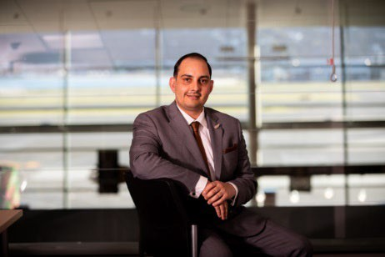 | Board member
 | Alexander has lived experience of mental health, addiction, justice, and social development services. Alexander works across the mental health and addiction sector with roles in clinical practice, education, research and consumer advocacy.

Leadership team proﬁles
The team includes Chief Executive, Karen Orsborn, and four Directors.

Leadership team | Position
Karen Orsborn | Tumu Whakarae | Chief Executive
 | Karen has held various leadership roles in the health sector. Previously, Karen was Director Health Quality Improvement and Deputy Chief Executive at the Health Quality and Safety Commission (HQSC) and Group Manager Funding at Manatū Hauora. Karen also held leadership roles at the former Hawkes Bay District Health Board.

Leadership team | Position
Maraea Johns (nee Tutuwhenua)  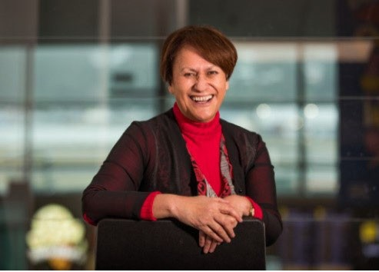 | Kaitohu Māori l Director Māori
 | Maraea is of Ngai Tūhoe descent. She has many years of experience in marae, whānau, hapū and iwi health and social development. Maraea formerly held both funding and leadership roles within the Mental Health and Public Health Directorates of the Ministry of Health and Whatu Ora (LDHB & BoP DHB). She was previously a Limited Statutory Manager for the Ministry of Education and a Community Magistrate with the Department of Courts.
Tanya Maloney | Kaiwhakahaere Hauora Hinengaro, Waranga l Director Mental Health and Addiction Leadership
 | Tanya originally qualified as a clinical psychologist and has held mental health management roles in NGOs and DHBs, including General Manager of Mental Health for Counties Manukau DHB. She was formerly Executive Director Strategy, Investment and Transformation with Waikato District Health Board and has held other executive leadership roles in public health, women’s and children’s health, and service planning and commissioning.
Dr Ella Cullen | Kaiwhakahaere Pūnaha Toiora Arataki | Director of Wellbeing System Leadership, Data and Insights
 | Ella is of Ngāi Tūhoe, Te Arawa and Albanian descent and has held a variety of roles across the public sector with experience in measuring wellbeing outcomes, and implementing data and evidence based approaches. Ella leads cross-government wellbeing system leadership, monitoring, and advocacy to address determinants of mental health and wellbeing outcomes.
Wayne Verhoeven | Kaiwhakahaere Rātonga Rangatōpū l Director Corporate Services
 | Wayne is a Chartered Accountant who has held leadership roles in both the government and private sector. His previous roles have included General Manager Corporate Service and Chief Finance Ofﬁcer at WorkSafe, General Manager Corporate Services at Education New Zealand, Chief Finance Ofﬁcer at the Families Commission and Chief Finance Ofﬁcer at NZ on Air.

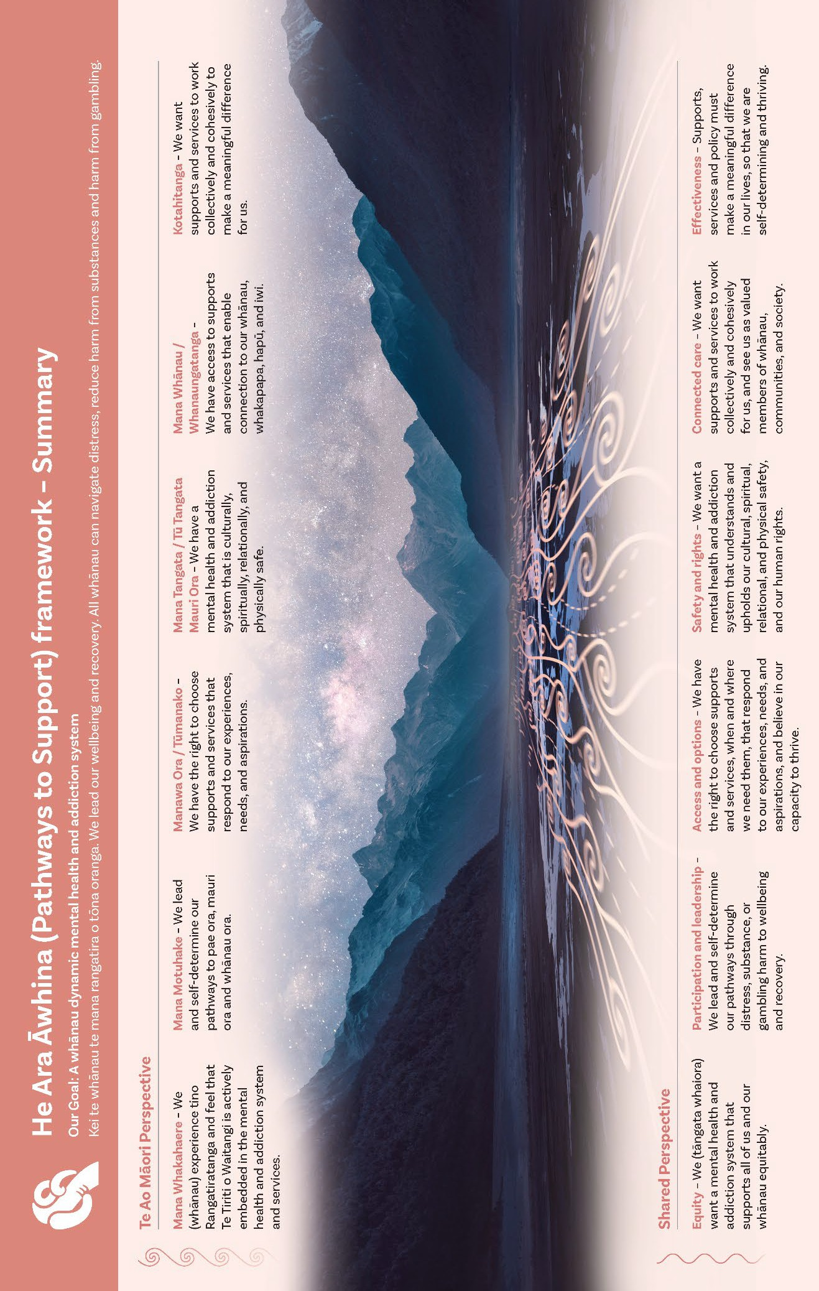
Appendix 4: He Ara Awhina (Pathways to Support) Framework

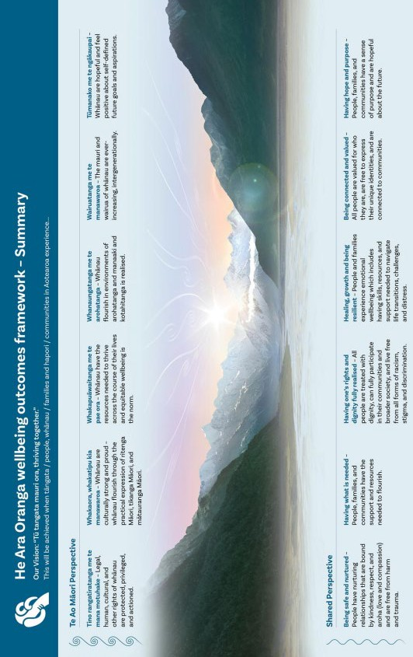
Appendix 5: He Ara Oranga wellbeing outcomes framework

